Name: ____________________________ Date: _________
Grade 4 - Unit 1: Place Value, Addition and Subtraction to One Million

1 | 2 | 3 | 4 | 5 | 6
Targets
A = Achieved Target
NA = Nearly Achieved Target
D = Did Not Meet Target

-----------------------------------------------------------------------T 1-----
1.) Mario fills out an information card. His ZIP code is 83628. His area code is 208. Which statement about the value of the 2 in 83,628 and 208 is true?

- It is the same in both numbers.
- It is 10 times as great in the ZIP code than it is in
the area code.
- It is 10 times as great in the area code than it is in
the zip code.
D. It is 100 times as great in the area code than it is
in the ZIP code.

2.) Gomez needs to order 2,400 sheets of paper for art projects. The paper is sold in packs of 100 sheets. How many packs of paper should he order?

3.) Compare the values of the underlined digits.

2,000 and 200

The value of 2 in _______________ is ________ times the
value of 2 in _________________.
4.) On Monday, a music site sold 96,527 downloads of the new song by a popular band. What is the value of the digit 6 in 96,527?

5.) Fill-in the table with the number being described.

Thousands | Hundreds | Tens | Ones | What Number?
seven | eight | nineteen | two
twenty | thirty | four | fourteen
nine | sixteen | three | one
one hundred | ten | ten | ten

------------------------------------------------------------------------------T 2 ---------

6.) An office supply store sold 410,309 pencils last year. What is the expanded form of 410,309?

7.) Write the number.

a.) fifty-six thousand, one hundred one
_______________________

b.) nine hundred twelve thousand, thirty seven
________________________

c.) nine hundred thousand, nine hundred nine
________________________

d.) eighty thousand, six hundred forty four
_________________________

8.) Use the clues to create the number.

The number is written by using each of the digits 3,4,5,6,7,0 only once.
The number has a 6 in the hundred thousands place.
The number has 0 hundreds.
The number has 4 ones and 3 tens.
The number has a 7 in the thousands.
The number has a 5 in the ten thousands.

What is the number? __________________________________________

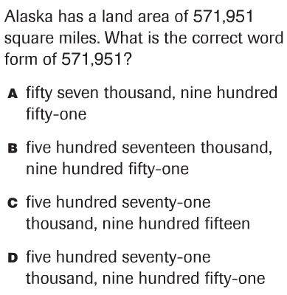
9.)

10.) Circle all the math sentences that are true.

125 + 125 = 200 + 40 + 5 + 5

6 thousand + 6 thousand = 12 hundreds

30 thousand + 100 thousand = 65 thousand + 65 thousand

16 tens = 100 + 6

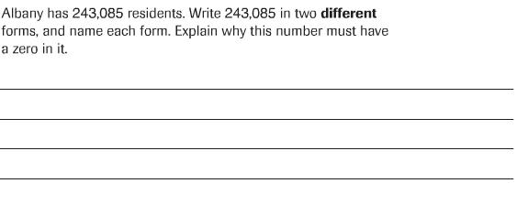
11.)

------------------------------------------------------------------T 3 ---------
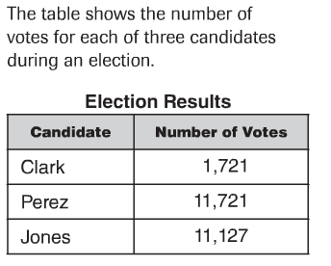
12.)

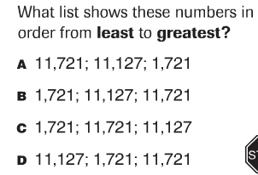

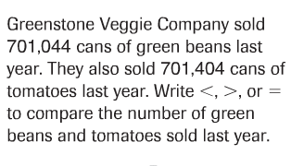
13.)

---------------------------------------------------------------T4--------------
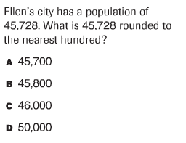
14.)

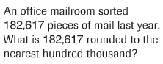
15.)

16.) Fill in the chart below by rounding each number to the
nearest 100.
Number | Rounded to the nearest 100
391
8,901
61,720
44,750
103,989

------------------------------------------------------------------- T5 ---------

17.) Solve.

4,437 2,883 1,967 + 3,842 + 3,911 + 3,405

18.) Solve.

4,762 7,800 8,224 - 2,174 - 592 - 1,259

19.)
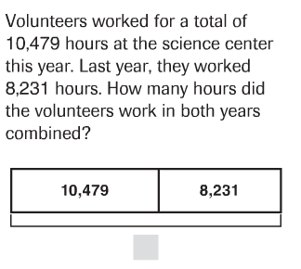

20.)
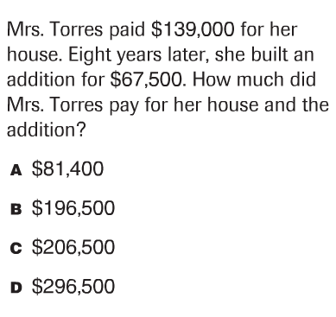

21.)
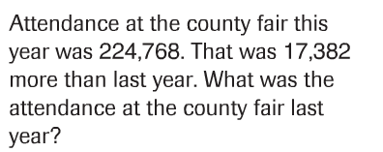

22.)
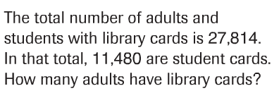

---------------------------------------------------------------------T6--------
23.) Draw a bar diagram to represent and solve this problem.

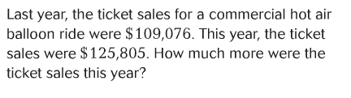

24.) Draw a bar diagram to represent and solve this problem.

