Name: ____________________________ Date: _________
Grade 5 - Unit 1: Place Value, Multiplication, and Expressions

Targets
A = Achieved Target
NA = Nearly Achieved Target
D = Did Not Meet Target
1 | 2 | 3 | 4 | 5 | 6 | 7 | 8

-------------------------------------------------------------------------------- Target 1 --------------
Complete the sentence.

1.) 800 is 10 times as much as _______________.

2.) 40,000 is 1/10 of _______________.

3.) 600 is ___________ times as much as 6.

4.) 60,000 is ___________ times as much as 600.
--------------------------------------------------------------------- -----------Target 2 -----------
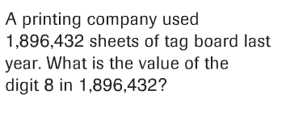
5.)

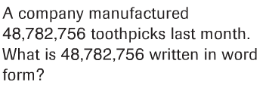
6.)

7.) Write in two other forms. 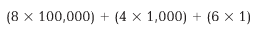

8.) Write in two other forms. 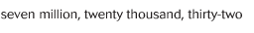

---------------------------------------------------------------------Target 3-------------

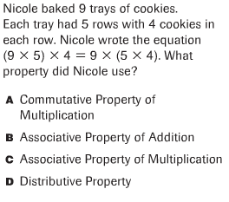
9.)

Explain how you know.

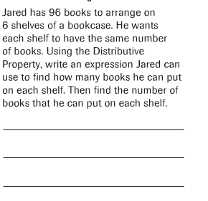
10.)

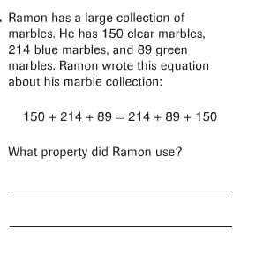
11.)

Explain how you know.

-----------------------------------------------------------------Target 4 ----------------
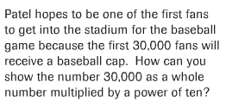
12.)

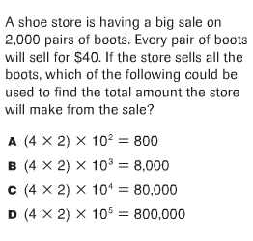
13.)

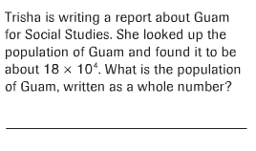
14.)

---------------------------------------------------------------------Target 5 ------------

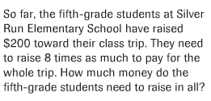
15.)

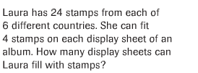
16.)

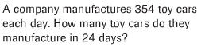
17.)

18.) Estimate and then find the product.
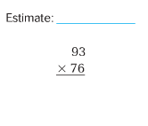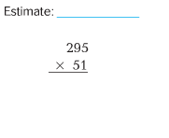
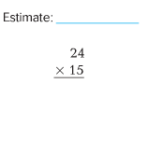

--------------------------------------------------------------------------Target 6 -------

19.) Use multiplication and the Distributive Property to find each quotient.

--------------------------------------------------------------------------Target 7 -------

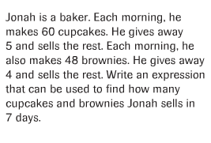
20.)

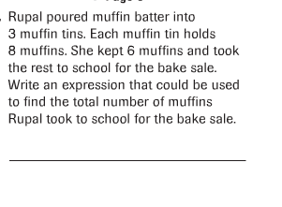
21.)

22.) Write a word problem for an expression that is 4 times as great as
(24+8). Then write the expression.

----------------------------------------------------------------------Target 8 ----------
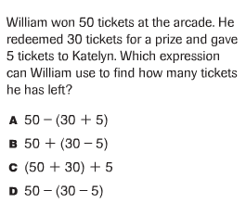
23.)

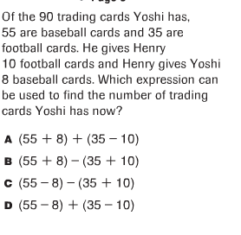
24.)

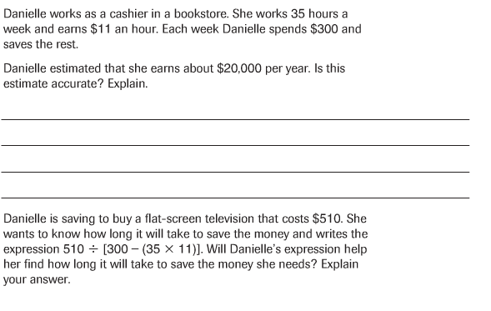
25.)

