Name: ____________________________ Date: _________

Grade 5 - Unit 2: Dividing Whole Numbers

Targets

A = Achieved Target

NA = Nearly Achieved Target

D = Did Not Meet Target

|  |  |  |
| --- | --- | --- |
| **1** | **2** | **3** |
|  |  |  |

**Show or explain your work on this test.**

-------------------------------------------------------------------------------- Target 1 --------------

1.) 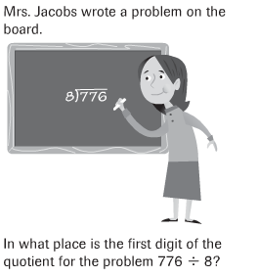

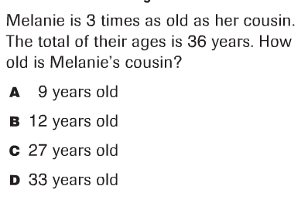--------------------------------------------------------------------------------------------

2.)

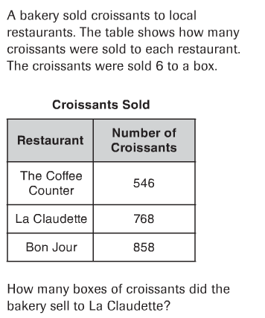3.)

--------------------------------------------------------------------------------------

4.) 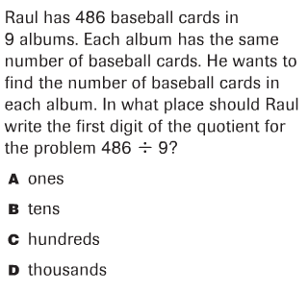

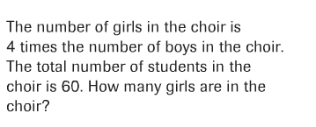5.)

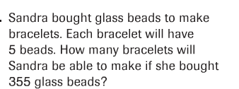

6.)

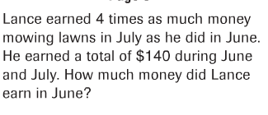7.)

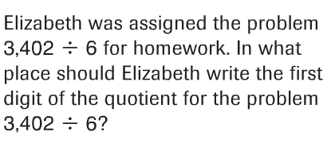8.)

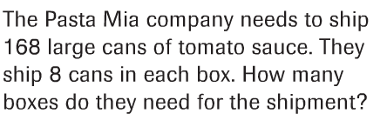

9.)

--------------------------------------------------------------------------- Target 2 -----

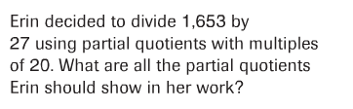10.)

11.) 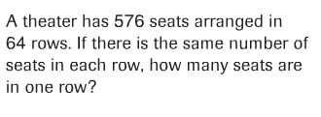

12.) 

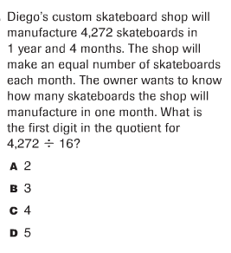13.)

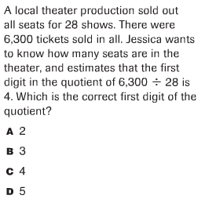

14.)

15.) 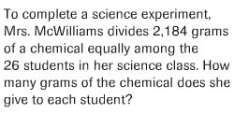

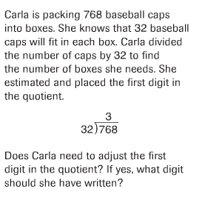

16.)

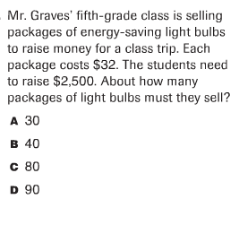17.)

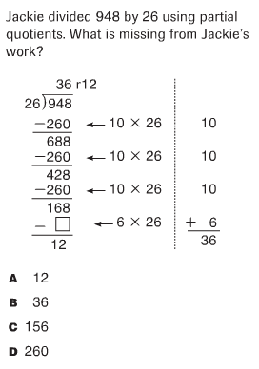18.)

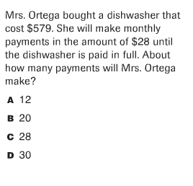19.)

----------------------------------------------------------------------Target 3 -----------

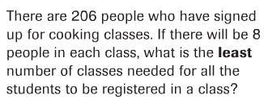

20.)

21.) 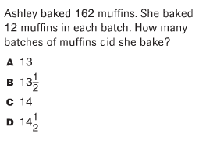

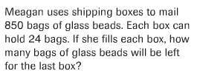

22.)

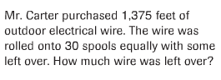

23.)

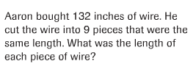24.)

25.) 