Name: ____________________________ Date: _________

Grade 5 - Unit 4: Multiply Decimals

Targets

A = Achieved Target

NA = Nearly Achieved Target

D = Did Not Meet Target

|  |  |
| --- | --- |
| **1** | **2** |
|  |  |

**Show or explain your work on this test.**

-------------------------------------------------------------------------------- Target 1 --------------

Complete the pattern.

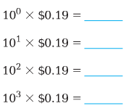1.) 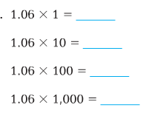 2.)

3.) 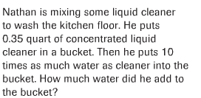

4.) 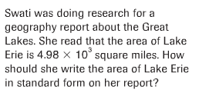

5.) 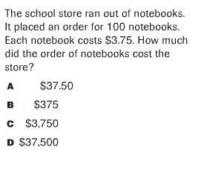

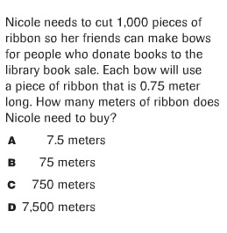6.)

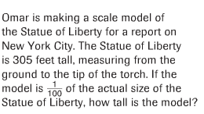

7.)

---------------------------------------------------------------------Target 2 ------------

8.) 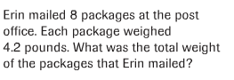

9.) 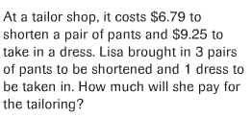

10.) 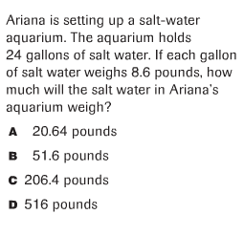

11.) 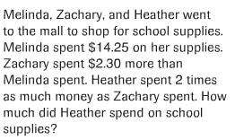

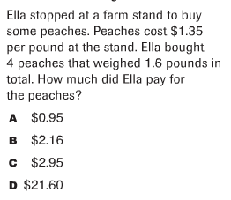12.)

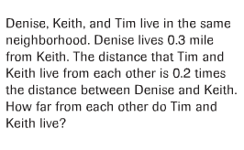13.)

14.) 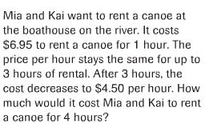

15.) 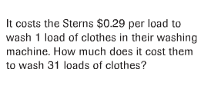

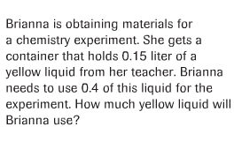

16.)

17.) 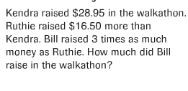

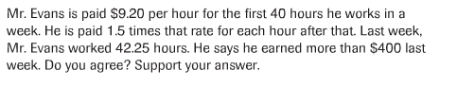18.)

19 & 20)

