Name: ____________________________ Date: _________
Grade 5 - Unit 6: Add and subtract fractions with unlike denominators

Targets
A = Achieved Target
NA = Nearly Achieved Target
D = Did Not Meet Target
1 | 2

Show or explain your work on this test.
-------------------------------------------------------------------------------- Target 1 --------------
1.) Find the sum or difference. Write your answer in simplest form.

2.) Find the sum or difference. Write your answer in simplest form.

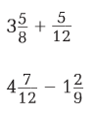
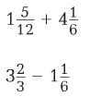

3.) Write the first four terms of each sequence.

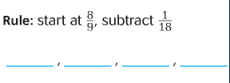

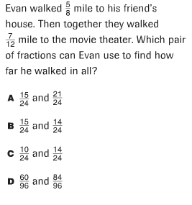
4.)

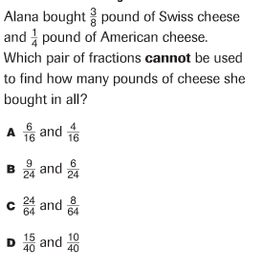
5.)

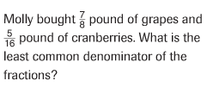
6.)

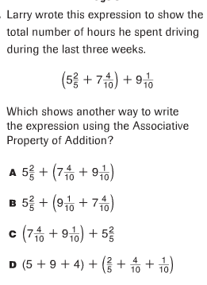
7.)

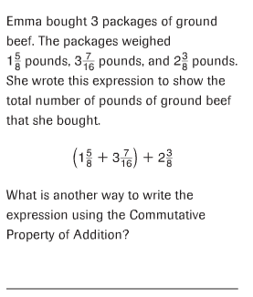
8.)

------------------------------------------------------------------------- Target 2 -------

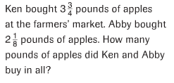
9.)

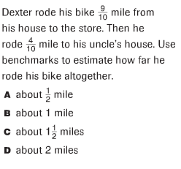
10.)

Explain how you chose that answer.

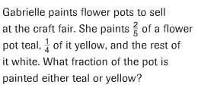
11.)

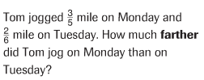
12.)

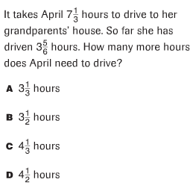
13.)

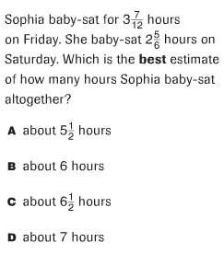
14.)

Explain how you chose this answer.

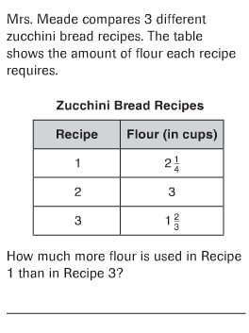
15.)

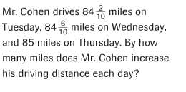
16.)

17.)

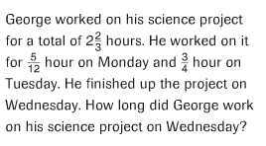
18.)

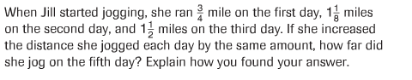
19.)

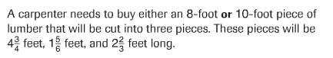
20.)

A.)

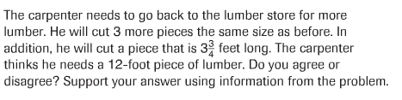
B.)

