Name: ____________________________ Date: _________

Grade 5 - Unit 8: Divide Fractions

Targets

A = Achieved Target

NA = Nearly Achieved Target

D = Did Not Meet Target

|  |  |
| --- | --- |
| **1** | **2** |
|  |  |

**Show or explain your work on this test.**

-------------------------------------------------------------------------------- Target 1 --------------

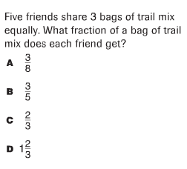

1.)

2.) 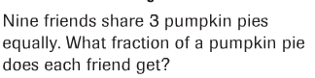

3.) 

4.) 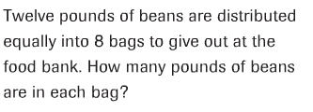

5.) 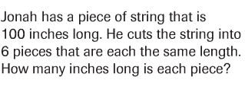

----------------------------------------------------------------------------Target 2 -----

6.) 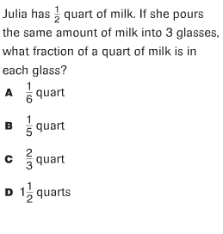

7.) 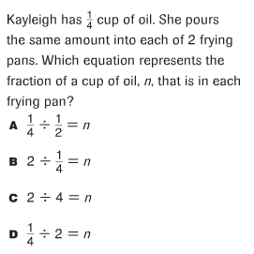

8.) 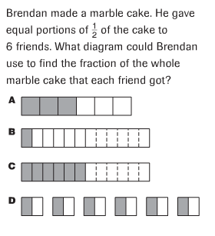

9.) 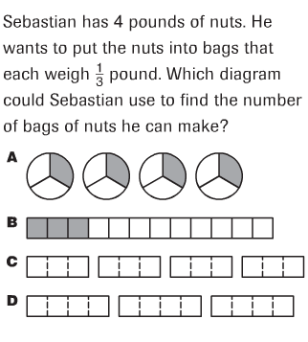

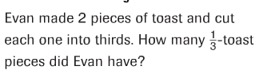10.)

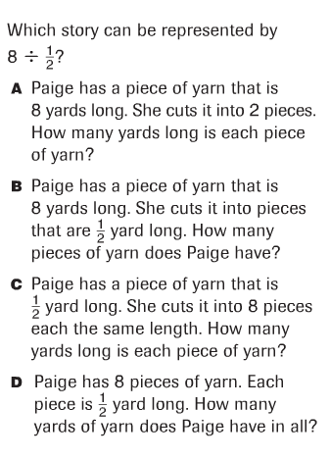11.)

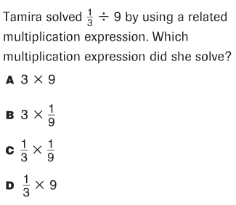12.)

13.) 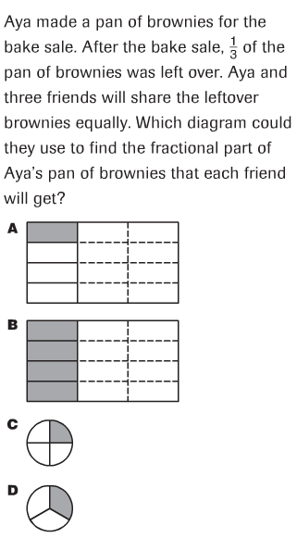

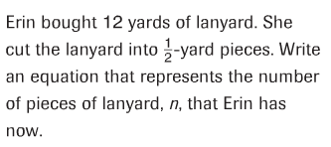

14.)

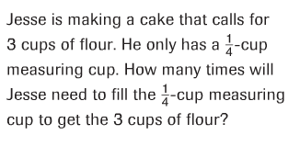15.)

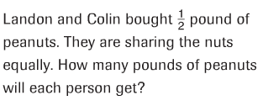

16.)

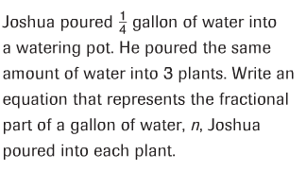17.)

18.) 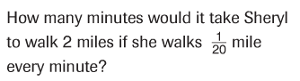

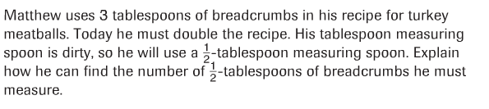

19.)

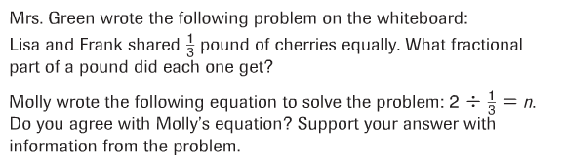20.)

