Name: ____________________________ Date: _________
Unit 2: Multiply by 1-Digit Numbers

1a | 1b | 2a | 2b | 3
Targets
A = Achieved Target
NA = Nearly Achieved Target
D = Did Not Meet Target

-------------------------------------------------------------T1a--------------
1.)
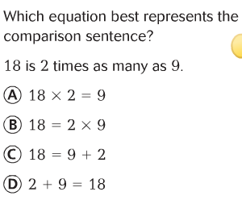

2.)
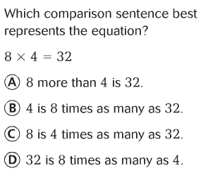

-----------------------------------------------------------------------T1b----
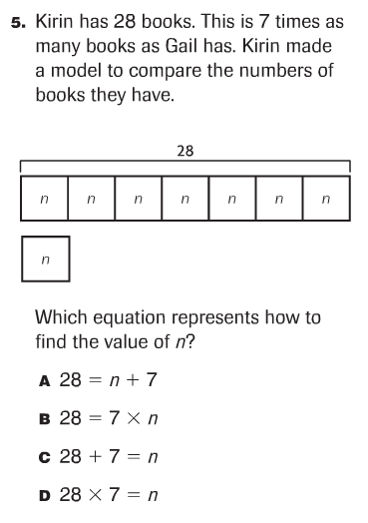
3.)

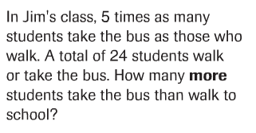
4.)

------------------------------------------------------------------T2a---------
5.) Solve.
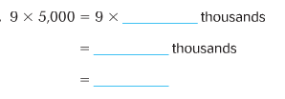
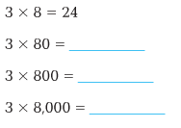
(standard form)
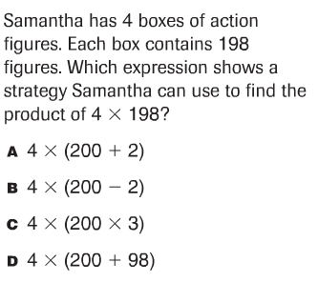
6.)

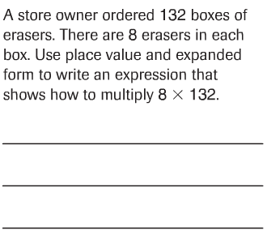
7.)

8.) Use place-value and partial products to solve these problems.

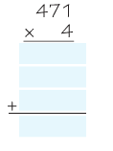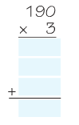
9.) Which of the following shows a strategy to use to find
3 X 198?

10.) Solve these problems by regrouping.

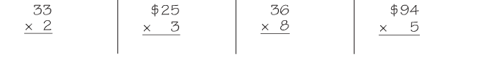

11.) Solve these problems by regrouping.

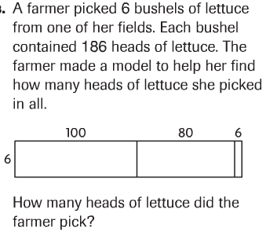
12.)

-----------------------------------------------------------------T2b--------
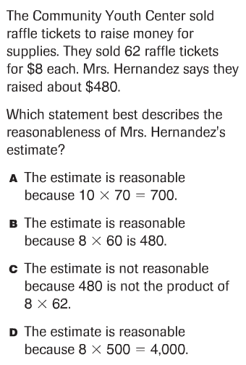
13.)

14.) Estimate the product by rounding.

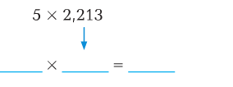
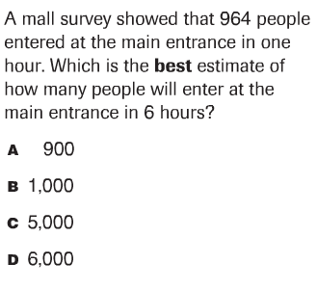
14.

---------------------------------------------------------------T3---------

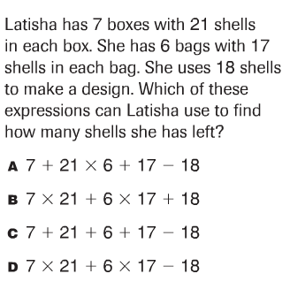
15.)

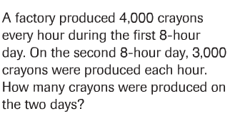
16.)

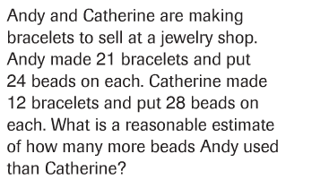
17.)

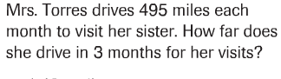
18.)

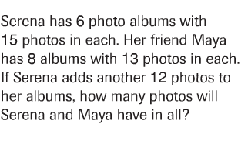
19.)

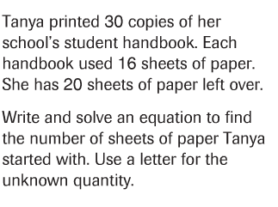
20.)

