Name _____________________ Date ________________

**Grade** 1 **Unit** 1 Addition Concepts

Targets

A = Achieved Target

NA = Nearly Achieved Target

D = Did Not Meet Target

|  |  |  |  |
| --- | --- | --- | --- |
| **1** | **2** | **3** | **4** |
|  |  |  |  |

-------------------------------------------------------------------------------------------------- **T1**

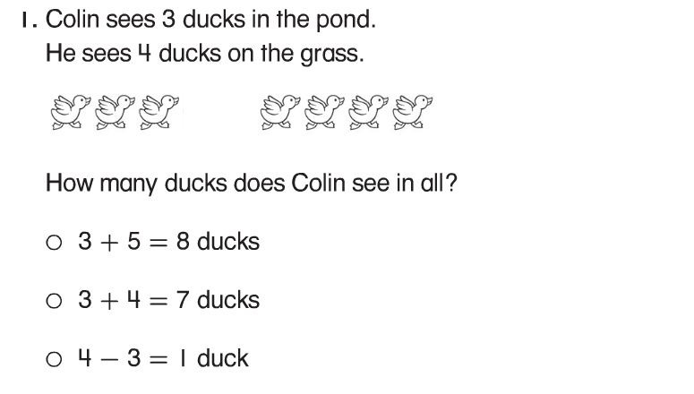

**2.**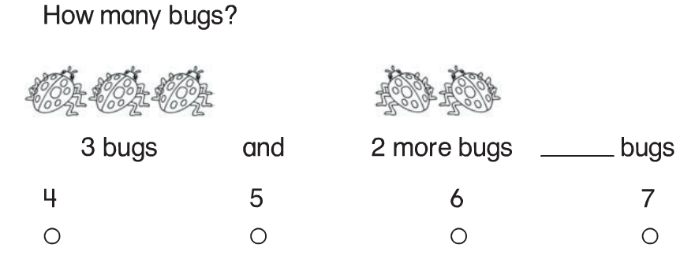

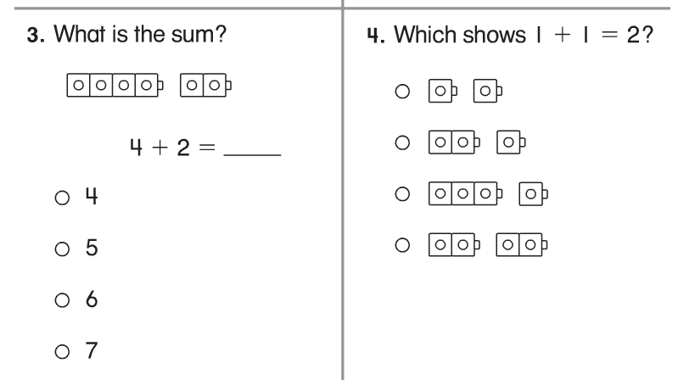

**5.**

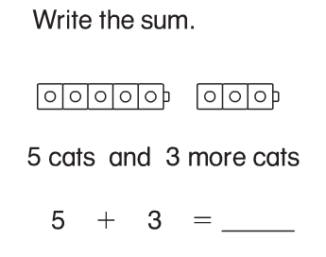

**6.**

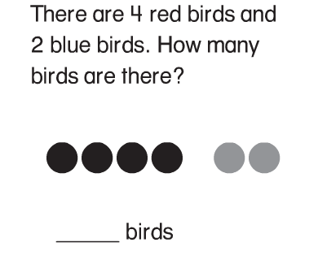

**Problems 7-8**

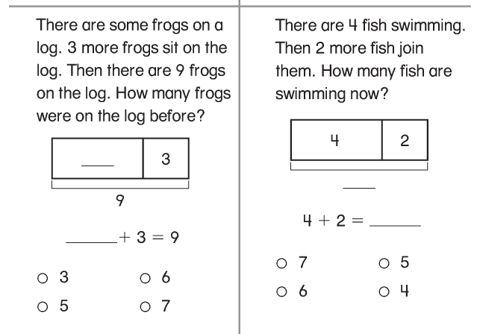

**---------------------------------------------------------------------------------------------------------T2**

**problems 9 - 11**

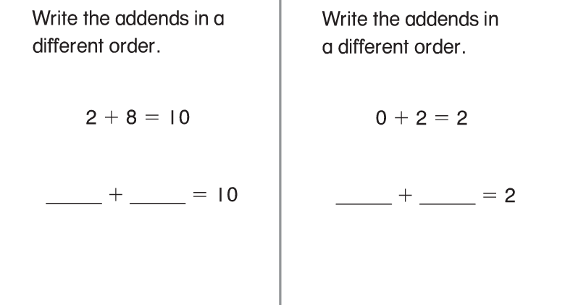

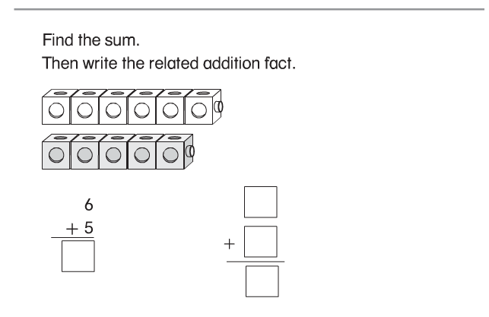

**----------------------------------------------------------------------------------------------------T3**

**12.**

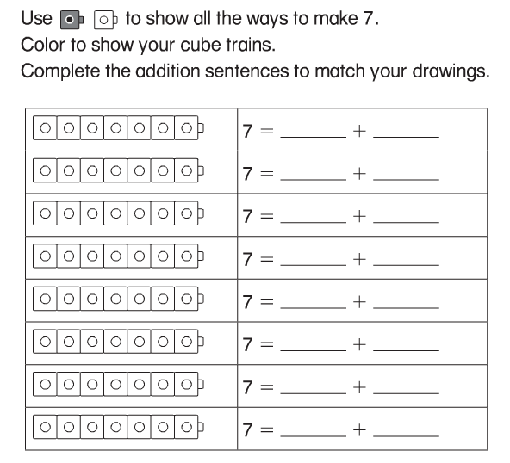

**Problems 13-15**

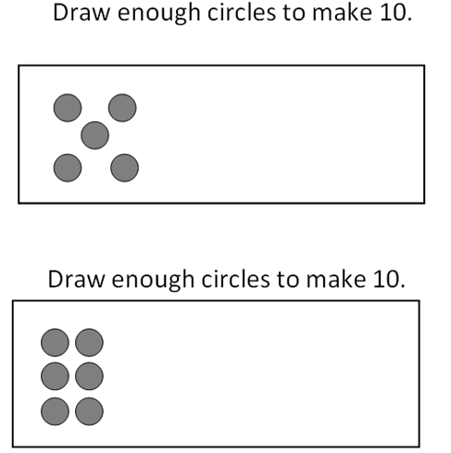

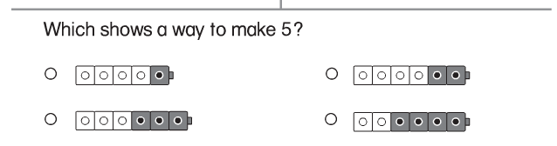

**-----------------------------------------------------------------------------------------------T4**

