Name ________________________________________Date ________________

**Grade** 1 **Unit 10** Two and Three Dimensional Geometry

Targets

A = Achieved Target

NA = Nearly Achieved Target

D = Did Not Meet Target

|  |  |  |
| --- | --- | --- |
| **1** | **2** | **3** |
|  |  |  |

-------------------------------------------------------------------------------------------------- **T1**

**1.**

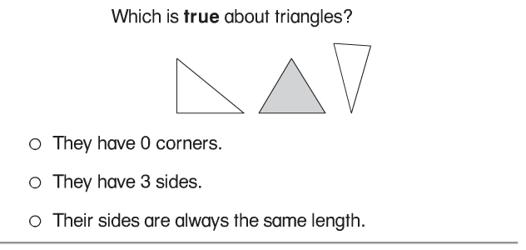

**2.**

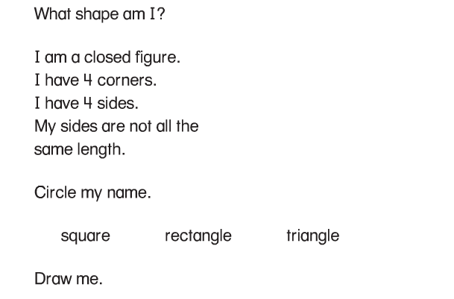

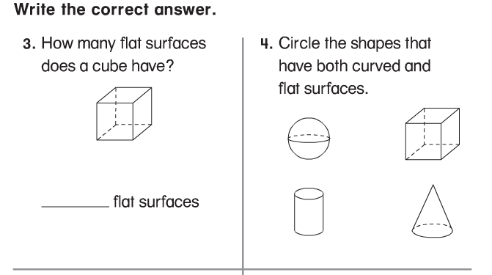

**5.**

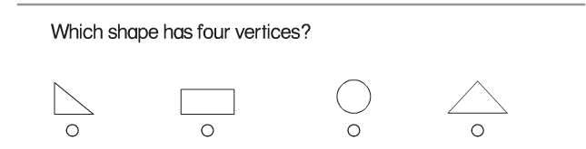

**6.**

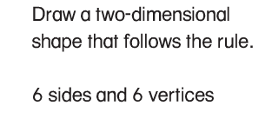

**Problems 7 and 8**

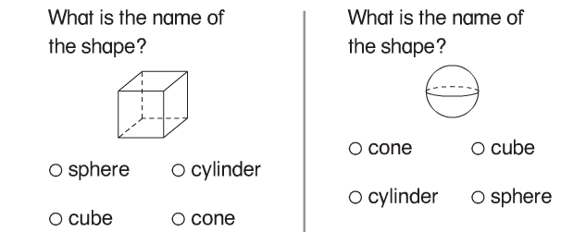

**--------------------------------------------------------------------------------------------------T2**

**9.**

**Draw lines to match the group of shapes that can be put together to make each shape on the right.**

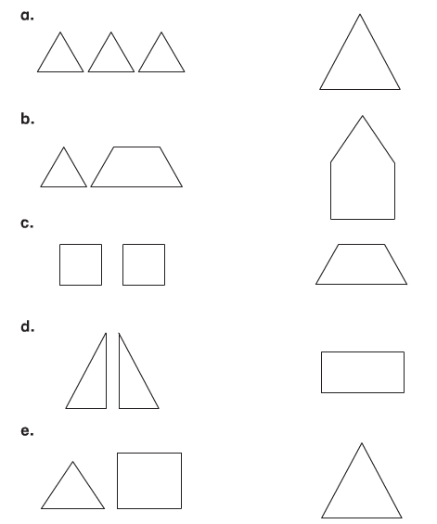

**10.**

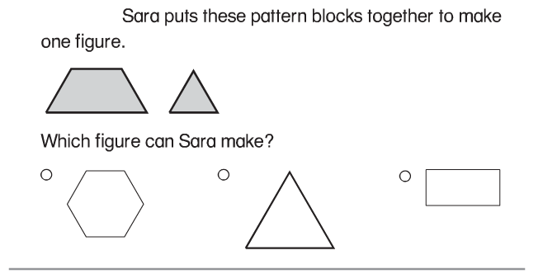

**11.**

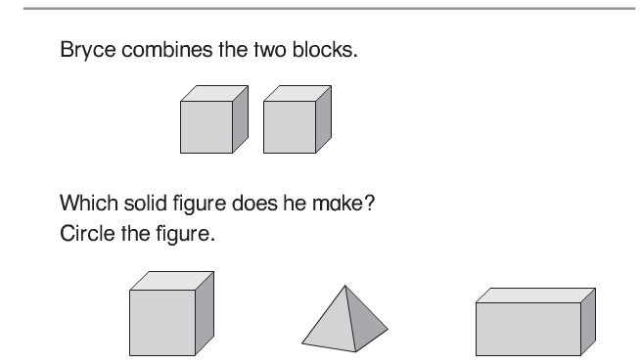

**12.**

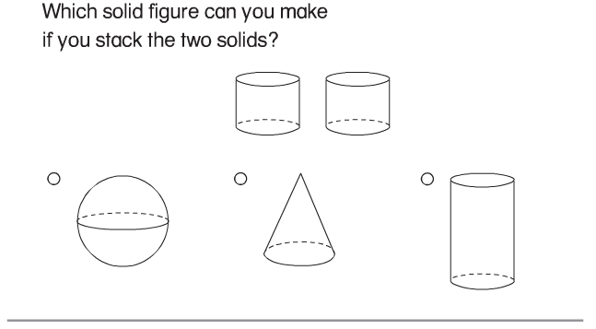

**13.**

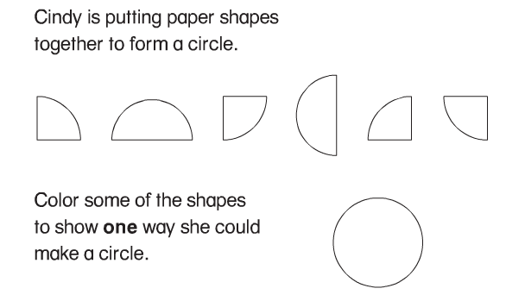

**Problems 14 and 15**

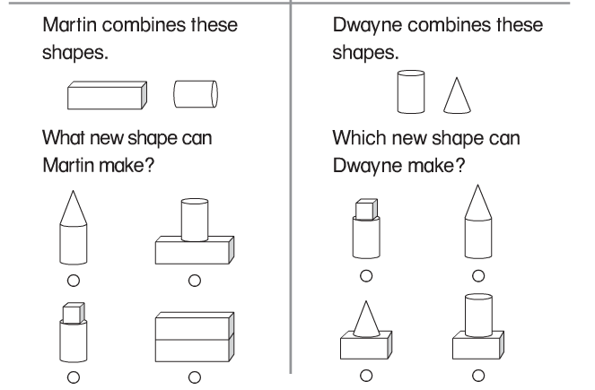

**Problems 16 and 17**

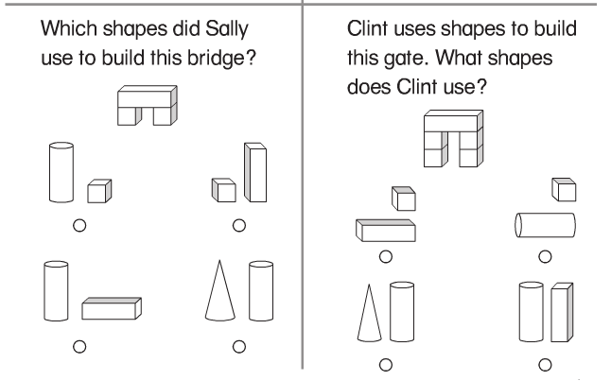

**Problems 18 and 19**

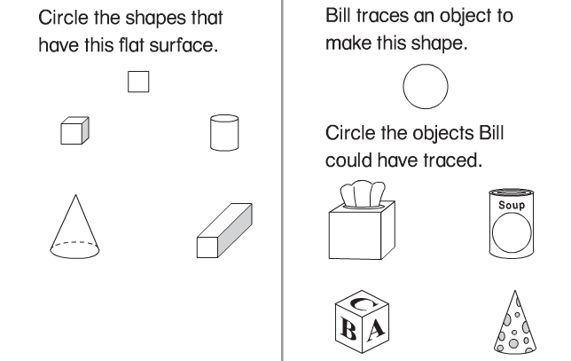

**Problems 20 and 21**

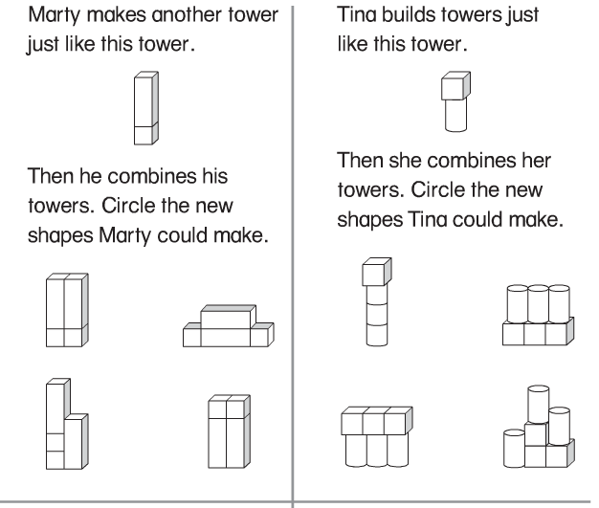

**Problems 22 and 23**

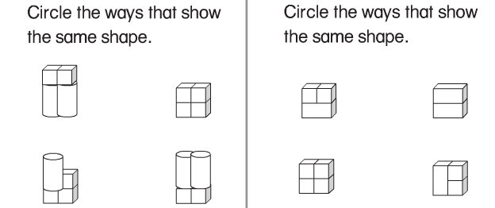

**-------------------------------------------------------------------------------------------------T3**

**Problems 24 and 25**

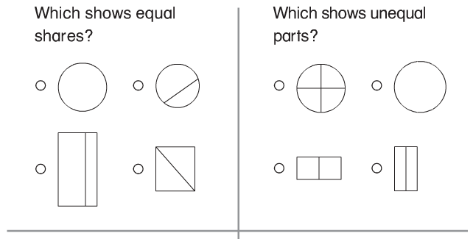

**26.**

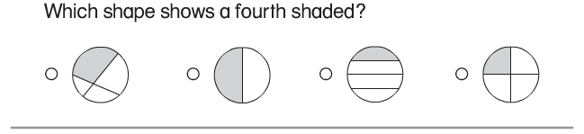

**27.**

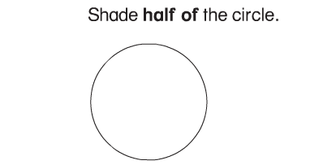

**28.**

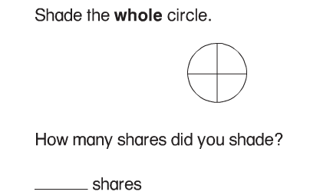

**29.**

