Name ________________________________________Date ________________

**Grade** 1 **Unit 2 Subtraction Concepts**

Targets

A = Achieved Target

NA = Nearly Achieved Target

D = Did Not Meet Target

|  |  |  |  |  |  |
| --- | --- | --- | --- | --- | --- |
| **1** | **2** | **3** | **4** | **5** | **6** |
|  |  |  |  |  |  |

-------------------------------------------------------------------------------------------------- **T1**

**1. Directions: Look at the pictures. Listen to the story. Cross out the ones you are taking from. Write how many there are now.**

**C:\Users\diana\AppData\Local\Microsoft\Windows\Temporary Internet Files\Content.IE5\WZ80KV70\MC900281692[1].wmfC:\Users\diana\AppData\Local\Microsoft\Windows\Temporary Internet Files\Content.IE5\WZ80KV70\MC900281692[1].wmfC:\Users\diana\AppData\Local\Microsoft\Windows\Temporary Internet Files\Content.IE5\WZ80KV70\MC900281692[1].wmfC:\Users\diana\AppData\Local\Microsoft\Windows\Temporary Internet Files\Content.IE5\WZ80KV70\MC900281692[1].wmfC:\Users\diana\AppData\Local\Microsoft\Windows\Temporary Internet Files\Content.IE5\WZ80KV70\MC900281692[1].wmfC:\Users\diana\AppData\Local\Microsoft\Windows\Temporary Internet Files\Content.IE5\WZ80KV70\MC900281692[1].wmfC:\Users\diana\AppData\Local\Microsoft\Windows\Temporary Internet Files\Content.IE5\WZ80KV70\MC900281692[1].wmf**

**7 bears 4 crawl away ____ bears now**

**2. Directions: Listen to the story. Draw the pictures. Cross out the ones you are taking from. Write how many there are now.**

**9 balls 6 roll away ____ balls now**

**3. Mark the correct number sentence for the story.**

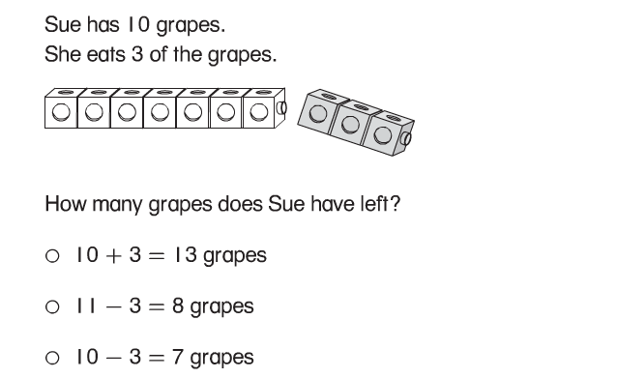

**--------------------------------------------------------------------------------------------------- T2**

**Problems 4 and 5. Solve.**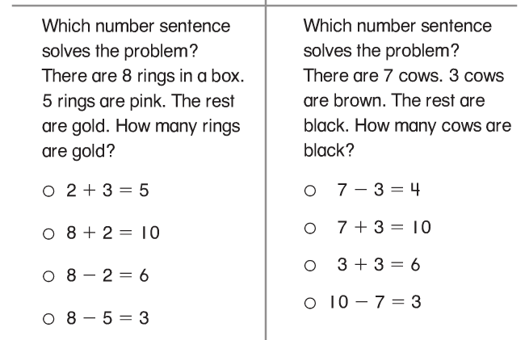

**Problems 6 and 7. Solve using a model drawing.**

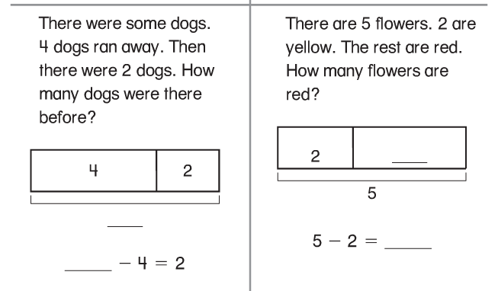

**8. Use to solve. Draw to show your work. Write the number sentence and how many.**

**There are 6 dogs. 5 are spotted. The rest are black. How many are black?**

**_____ are black ______ ______ = ______**

**---------------------------------------------------------------------------------------------T3**

**9.** 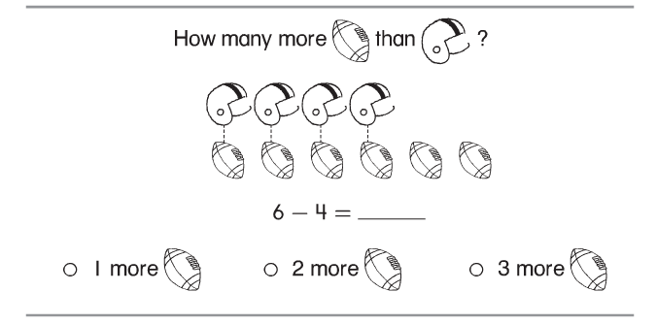

**10.** 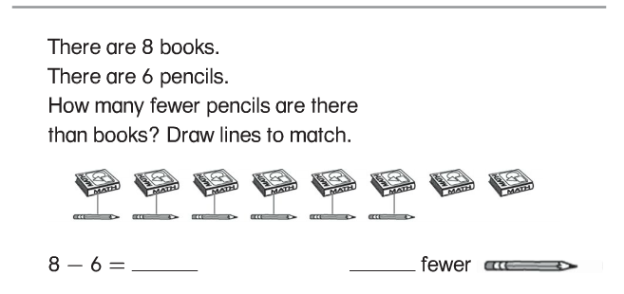

**11. Solve.**

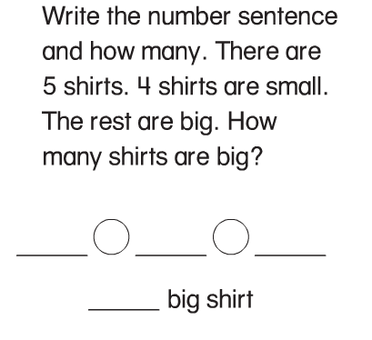

**-----------------------------------------------------------------------------------------------------T4**

**12.**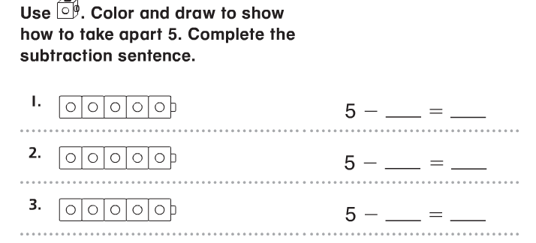

**13.**

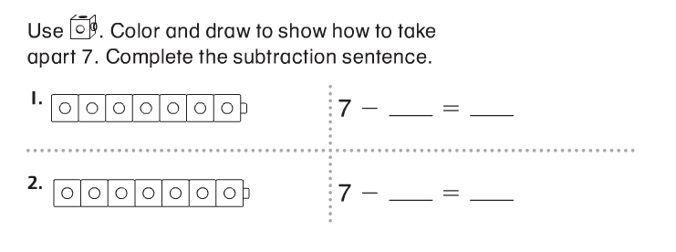

**---------------------------------------------------------------------------------------------------------T5**

**Find the difference.**

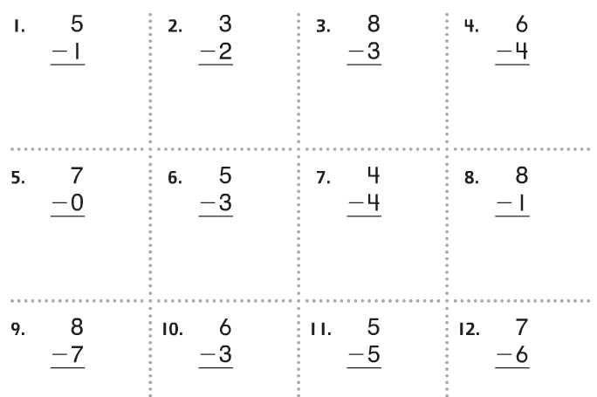

**------------------------------------------------------------------------------------------------T6**

**14.**

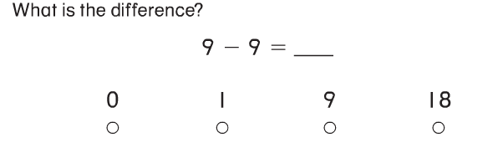

**15. Write the number that completes the equation.**

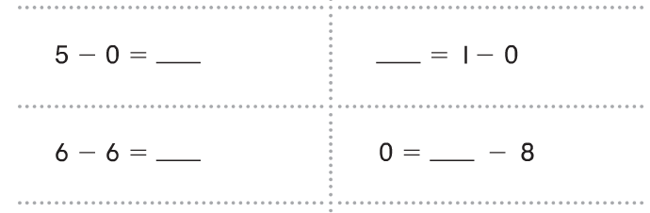

**16. Draw a picture. Write the equation. Solve the problem.**

**7 flowers are in the yard. 7 are yellow the rest are blue. How many flowers are blue?**

** ______ blue flowers**