Name _________________________________________Date ________________
Grade 1 Unit 3 Addition Strategies
A = Achieved Target
NA = Nearly Achieved Target
D = Did Not Meet Target
Targets
1 | 2 | 3 | 4 | 5 | 6
-------------------------------------------------------------------------------------------------- T1
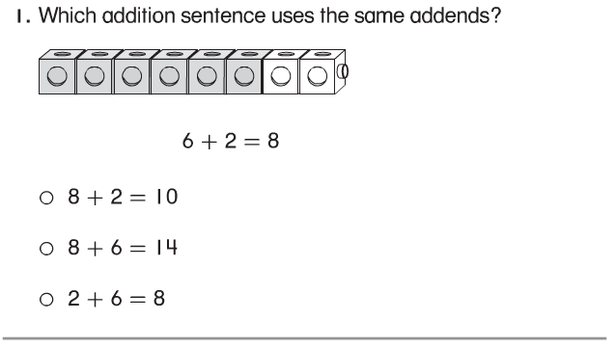
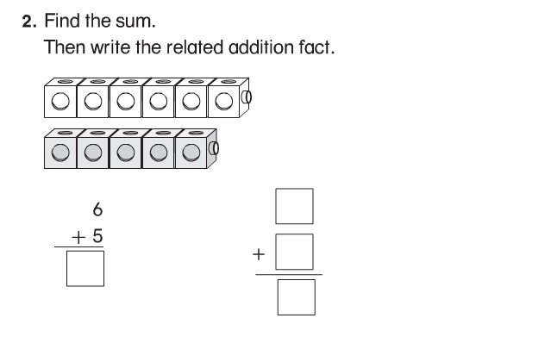
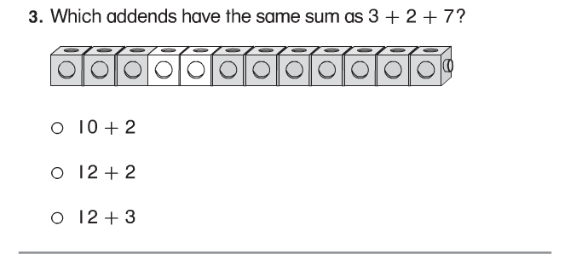

-----------------------------------------------------------------------------------------------T2
4.
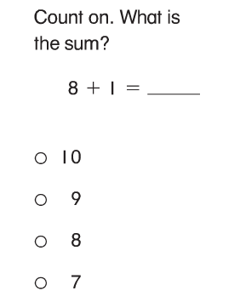
5.
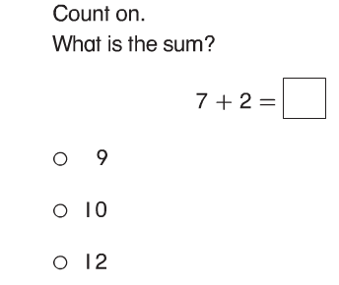

6.
7. 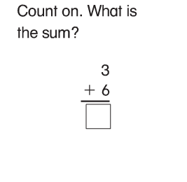
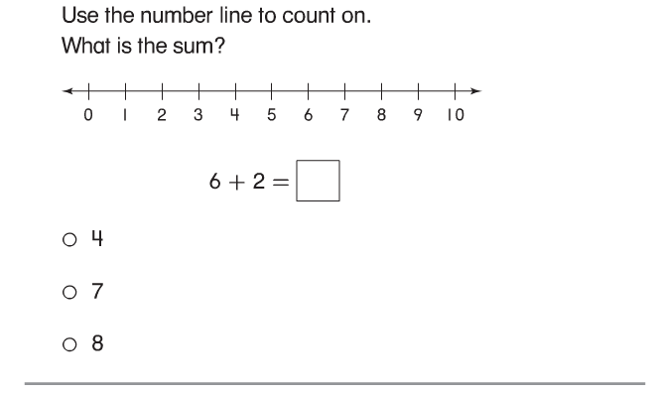
8.
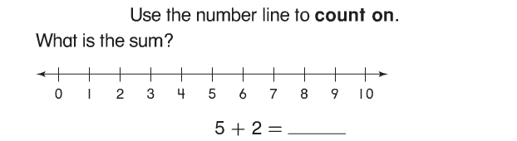
------------------------------------------------------------------------------------------------T3
Problems 9 and 10.
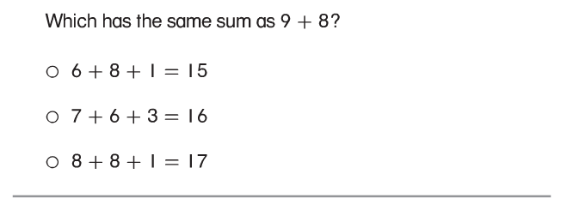

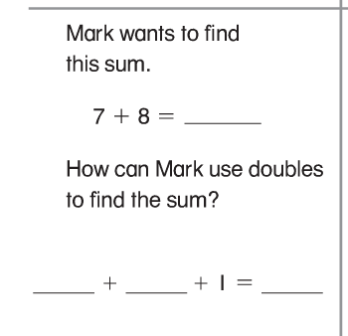

Solve the doubles facts. (11-16)
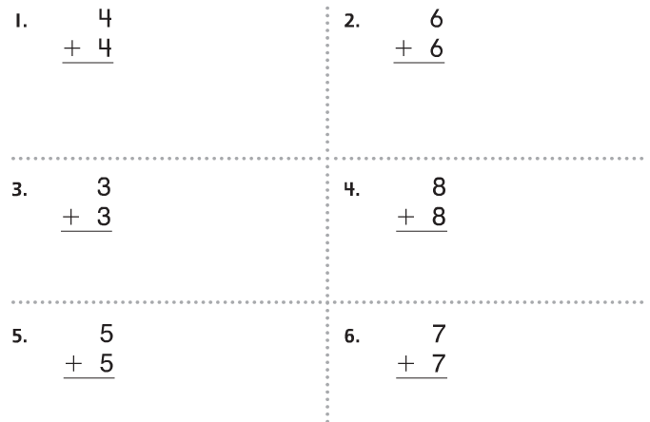

17. Write a doubles fact to solve.
Ben has 18 pencils. Some are yellow and some are green. The number of yellow pencils is the same as the green pencils.

________ + ________= ________

------------------------------------------------------------------------------------------------T4
18.
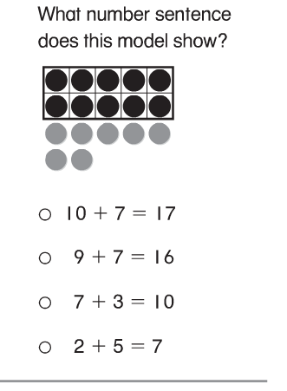
19.
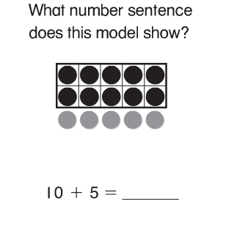

20. Draw red and yellow to solve. Write the equation.
Sue has 10 fish.
She gets 2 more.
How many fish does Sue have now? 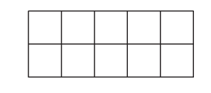
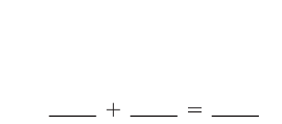

---------------------------------------------------------------------------------------------------T5
21.
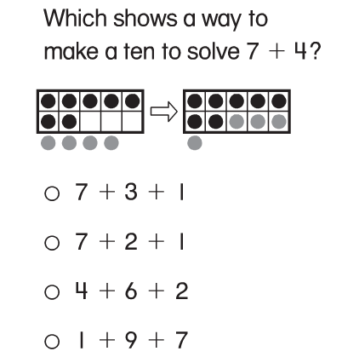
22.
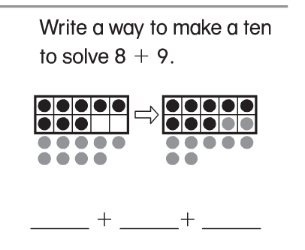
23. Use make a ten to solve.
Jim has 9 books.
Cam has 4 books.
How many books to they have all together?

_______ books

----------------------------------------------------------------------------------------------------T6
24. Draw a picture to solve.
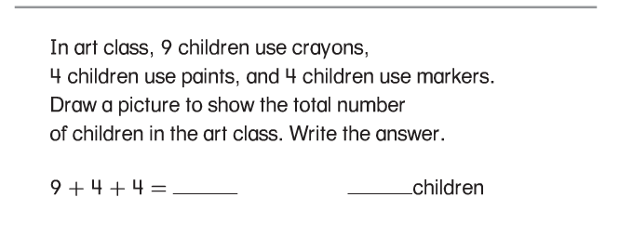

25. Draw a picture to solve. Write the equation.

Bill has 6 blocks. Sam gives him 5 more. Then he finds 2 more. How many blocks does he have now?

________ blocks

