Name _______________________________________Date ________________
Grade 1 Unit 4 Subtraction Strategies
Targets
A = Achieved Target
NA = Nearly Achieved Target
D = Did Not Meet Target
1 | 2 | 3 | 4

-------------------------------------------------------------------------------------------------- T1
1.
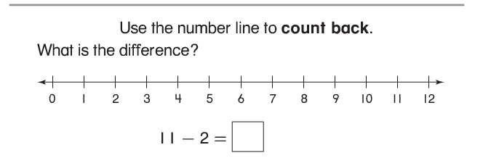
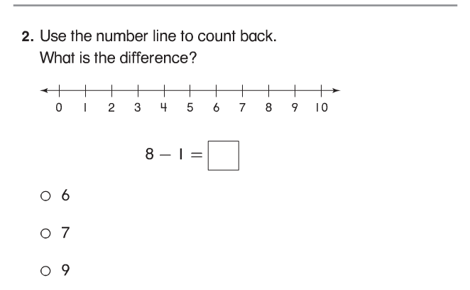

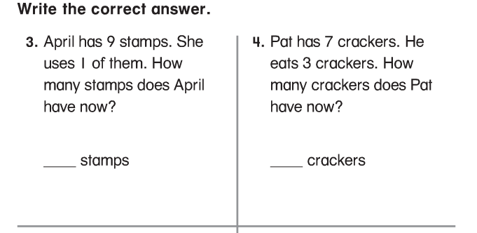

-------------------------------------------------------------------------------------------------------T2
Problems 5 and 6
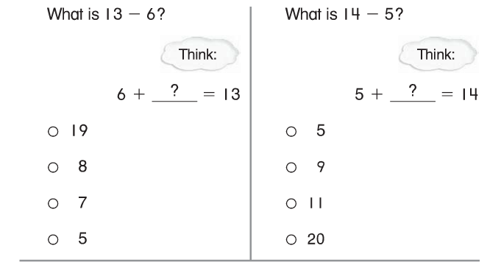
Problems 7 and 8
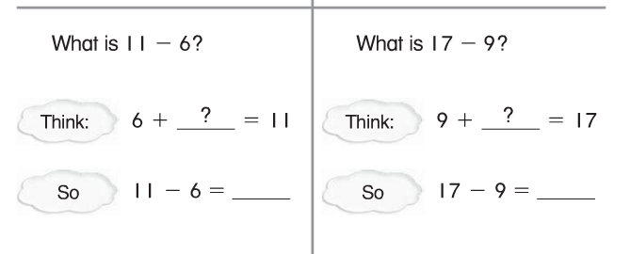

Problems 9 and 10
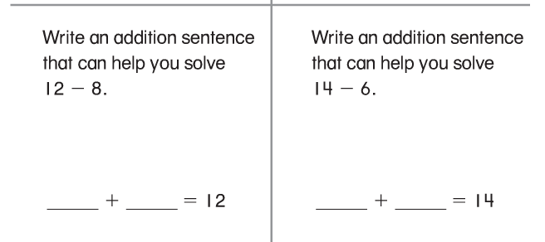

11.
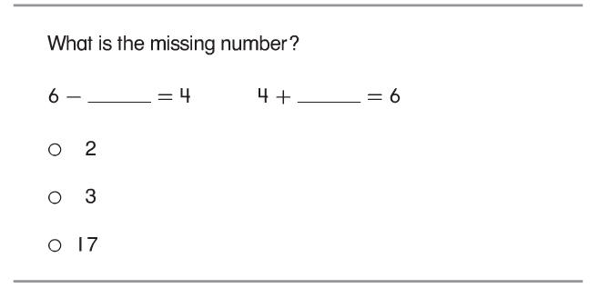

---------------------------------------------------------------------------------------------------T3.
12.
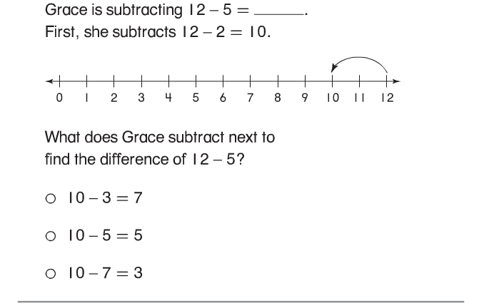
13.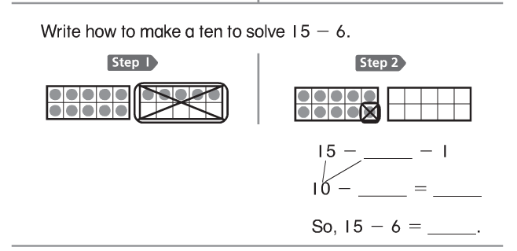

Problems 14 and 15
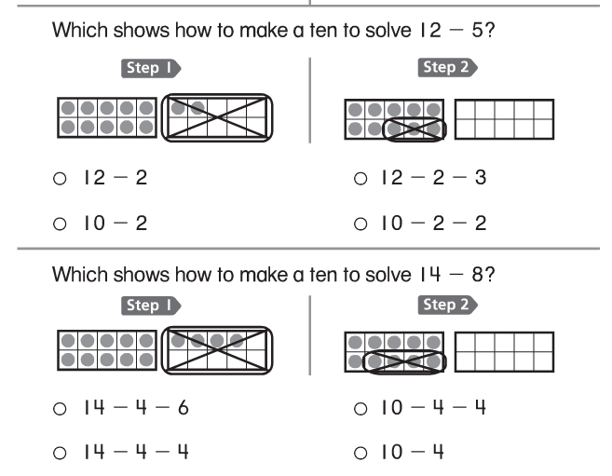

Problems 16-17
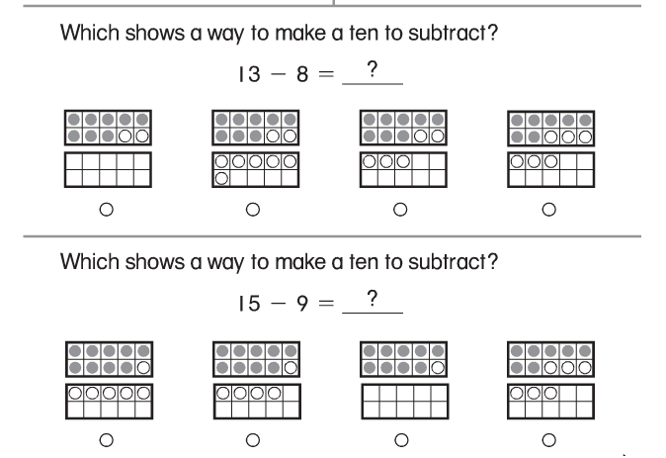

------------------------------------------------------------------------------------------------------T4
Problems 18 and 19. Solve by drawing a picture or using objects to act it out.

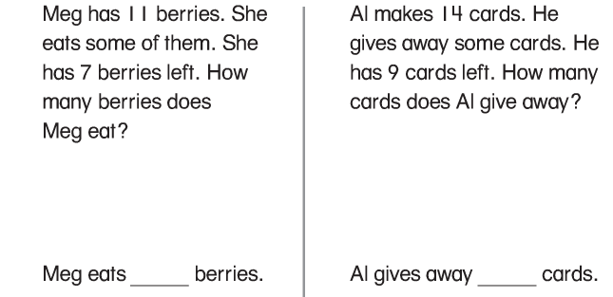

Problems 20 and 21. Solve by drawing a picture or using objects to act it out.

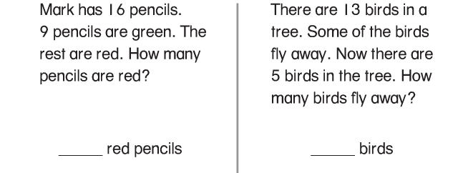

Write the subtraction sentence Write the subtraction sentence

