Name _______________________________________Date ________________
Grade 1 Unit 5 Addition and Subtraction Relationships
A = Achieved Target
NA = Nearly Achieved Target
D = Did Not Meet Target
Targets
1 | 2 | 3 | 4 | 5
-------------------------------------------------------------------------------------------------- T1
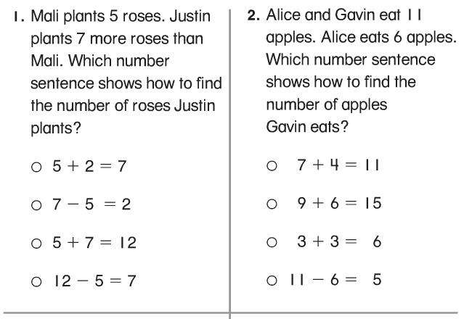

Problems 3 and 4
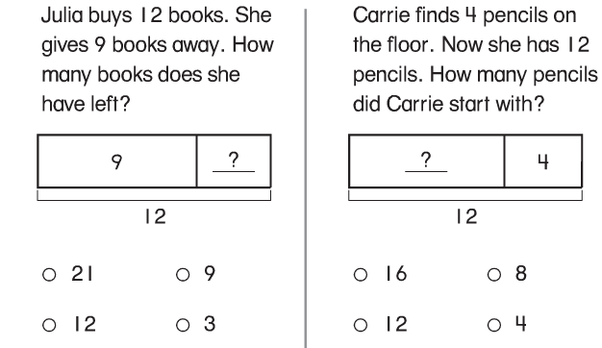

5.
Rosie sees 5 children on the swings. Some children are on the slide. There are 11 children in all. How many children are on the slide? Write an equation to solve the problem.

_______ _______ = _______

Solve with a drawing or model and an equation.
6. Sam has 10 shirts. Dan has 8 shirts. How many more shirts does Sam have than Dan?

7. Ann has 12 buttons in her box. She puts in
7 more. How many buttons are there in the
box now?

------------------------------------------------------------------------------------------T2
Problems 8 and 9
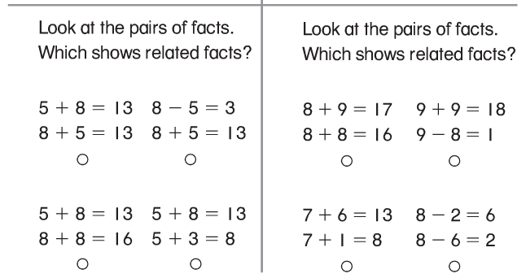
Problems 10 and 11
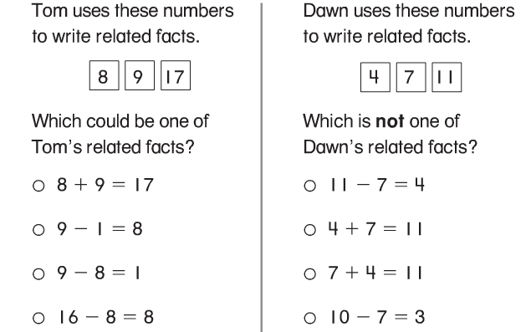
12.
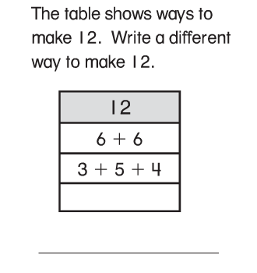
13.
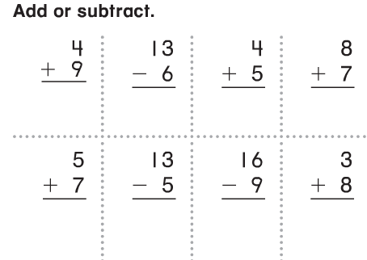

14. Fill-in the missing space to make this true.

2 + 8 = 6 + ____

-------------------------------------------------------------------------------------------T4
Problems 17-19 Complete each fact family.
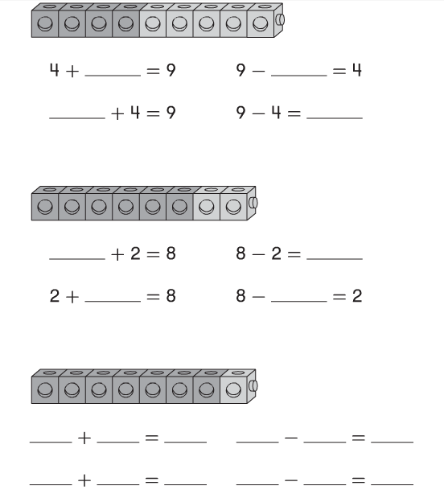

Problems 20-21
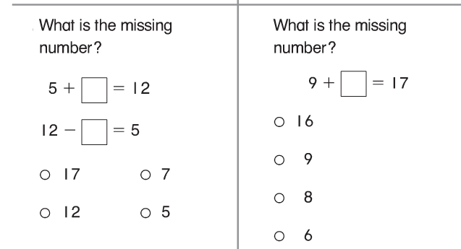

22.
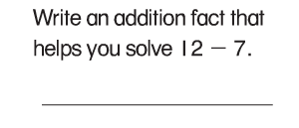

23.
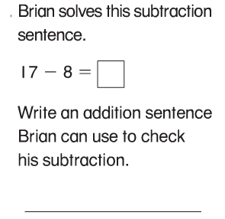
-----------------------------------------------------------------------------------------------------T5
Problems 24-25
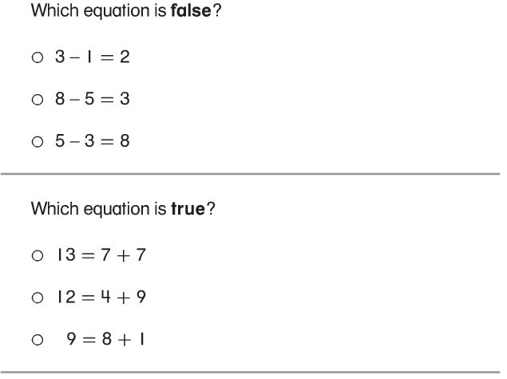

26.
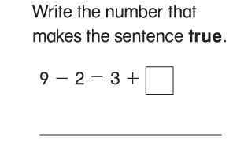

27.
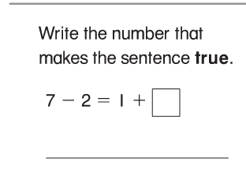

-----------------------------------------------------------------------------------------------------T3
15. Fluency Assessment
Flash each fact and allow three seconds only to determine automaticity.

9 -3 = _________ 7 – 4 = ________

10– 5 = ________ 3 – 2 = ________

8 – 6 = ________ 1 – 1 = ________

10 – 0 = _______ 6 – 3 = ________

9 – 5 = ________ 8 – 4 = ________

16. Fluency Assessment
Flash each fact and allow three seconds only to determine automaticity.

4 + 4 = _____ 5 + 4 = ______

2 + 2 = ______ 6 + 4 = ______

3 + 2 = _____ 8 + 1 = ______

3 + 3 = ______ 8 + 2 = ______

