Name ________________________________________Date ________________
Grade 1 Unit 6 Count and Model Numbers
Targets
A = Achieved Target
NA = Nearly Achieved Target
D = Did Not Meet Target
1 | 2 | 3 | 4 | 5 | 6 | 7

-------------------------------------------------------------------------------------------------- T1
1.
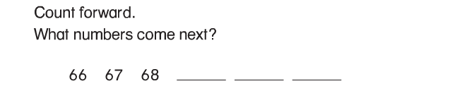
2.
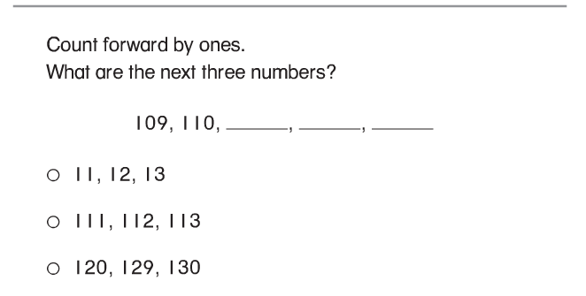

3.
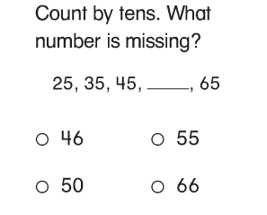
----------------------------------------------------------------------------------------------T2
4. Count by fives. What are the next 3 numbers?
85, 90, ____, _____, _____, 110

5. Count by fives. What are the next 3 numbers?
10, 15, _____, _____, _____, 35

-

-----------------------------------------------------------------------------------T3
Problems 6-8. Use and to show the number. Write the number.
10 tens and 7 more

_______

10 tens and 1 more

_______

8 tens and 4 more

_______

Problems 9-11. Write the number.
-----------------------------------------------------------------------------------------T4
12.
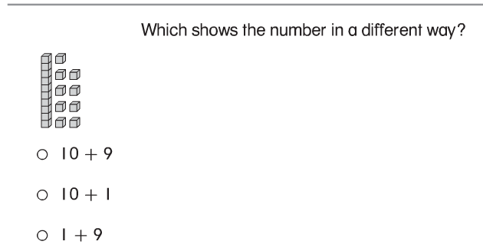

13. Use the model. Write the number shown 3 different ways.
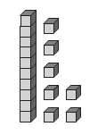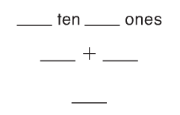

14. Use the model. Write the number shown 3 different ways.
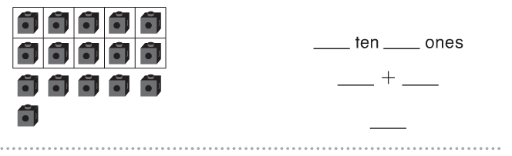

Problems 15-17
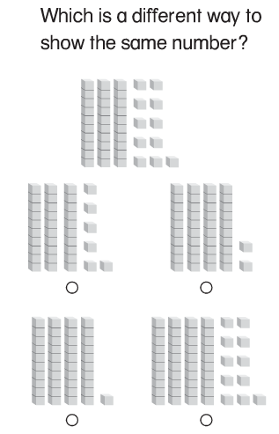

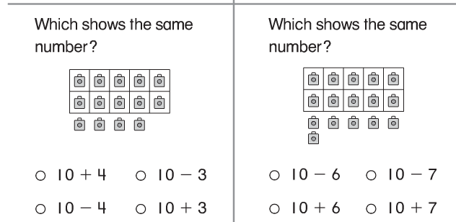
----------------------------------------------------------------------------------------------T5
18.
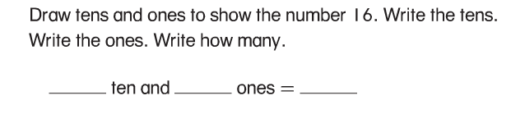

19.
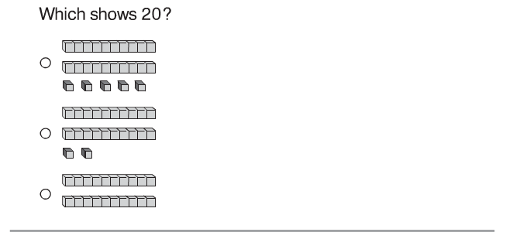

Problems 20-23
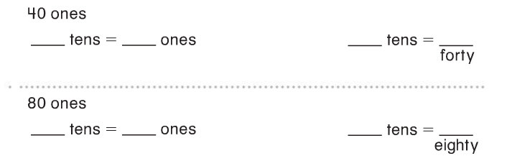

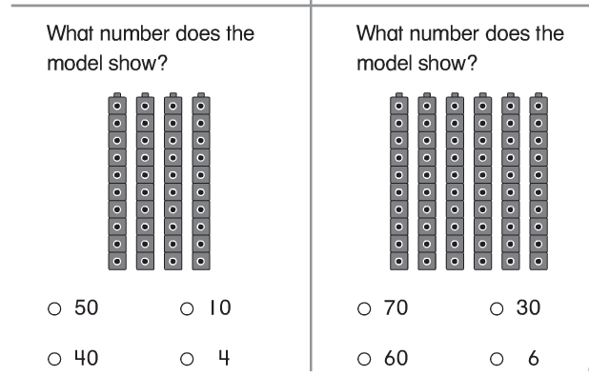

-------------------------------------------------------------------------------------------T6
Problems 24-27. Write the numbers.
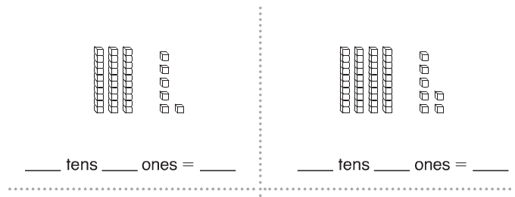
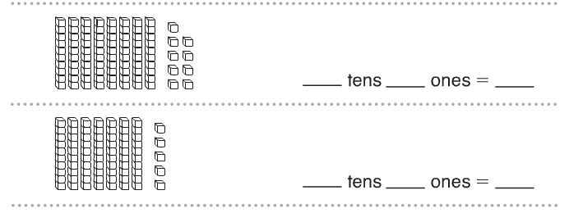
28-29 What number does the model show?
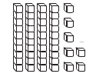 _______ 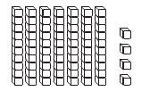_______

-------------------------------------------------------------------------------------------------T7
30.
