Name ______________________________________Date ________________
Grade 1 Unit 7 Compare Numbers
Targets
A = Achieved Target
NA = Nearly Achieved Target
D = Did Not Meet Target
1 | 2 | 3
-------------------------------------------------------------------------------------------------- T1
1.
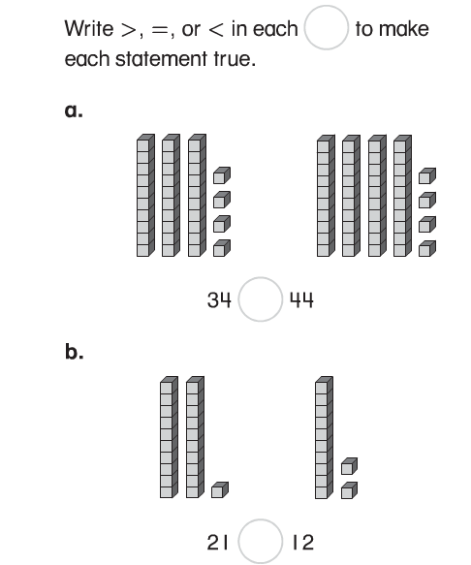

2.
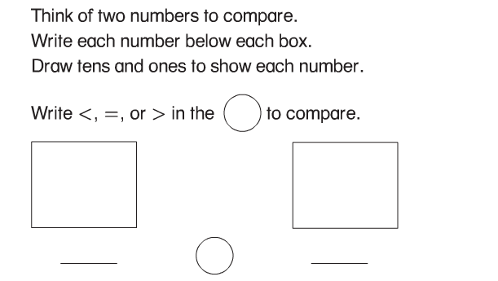

3. Which symbol can you use to compare the numbers?
<, >, =

Problems 4 and 5
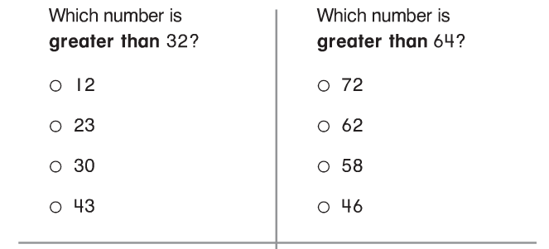
Problems 6 and 7
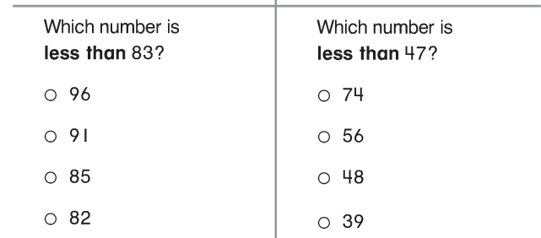

Problems 8 and 9
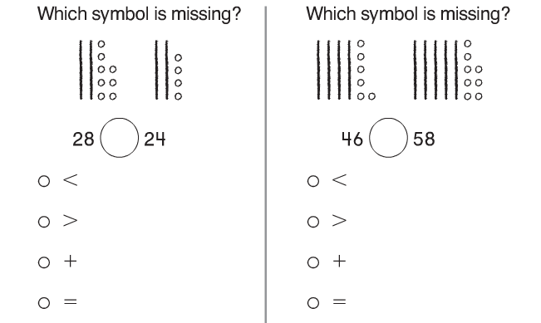

10. Add the correct symbol to compare the numbers. <, >, =
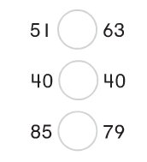

11.
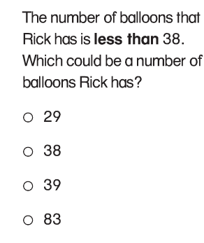
12.
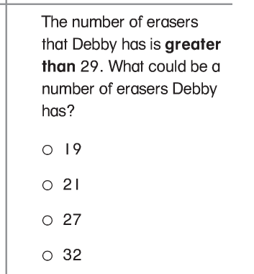

---------------------------------------------------------------------------------------T2
Problems 13 and 14
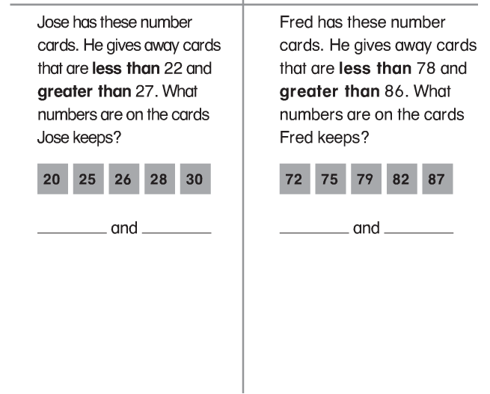

----------------------------------------------------------------------------------------T3
15. Complete the chart.
10 Less |  | 10 More
 | 19
 | 53
 | 80

Problems 16 and 17
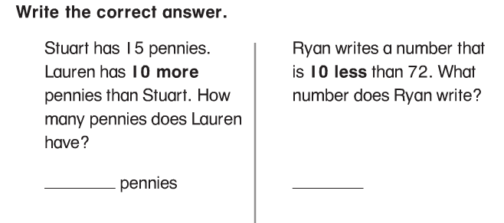

17.
