Name _______________________________________ Date ________________
Grade 1 Unit 8 Two Digit Addition and Subtraction
Targets
A = Achieved Target
NA = Nearly Achieved Target
D = Did Not Meet Target
1 | 2 | 3 | 4

-------------------------------------------------------------------------------------------------- T1
Problems 1 and 2
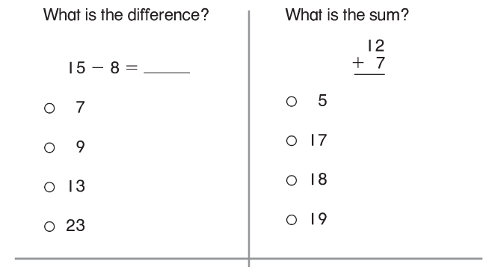
3. Sam finds the sum of 2 + 9. Complete the number sentence to show how Sam can check his answer.

4. Which has the same sum as 5 + 6?

5. 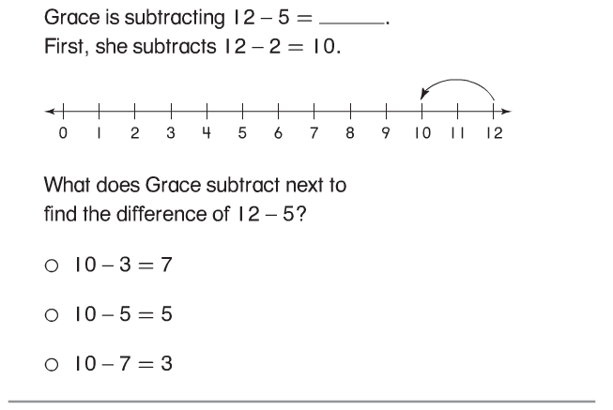

------------------------------------------------------------------------------------------T2
6.
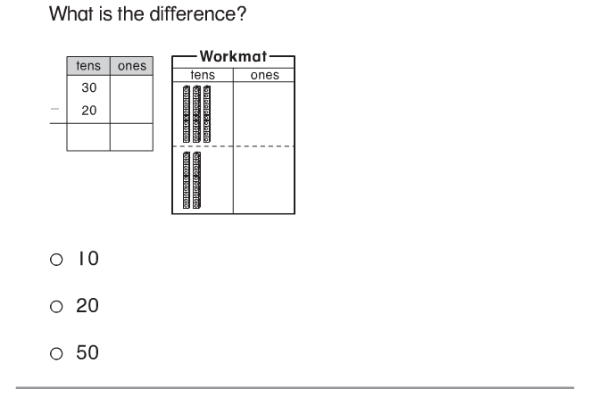
7.
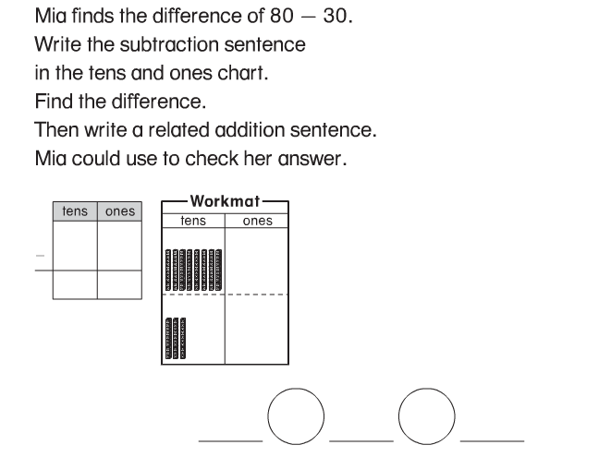

8. What is the difference?
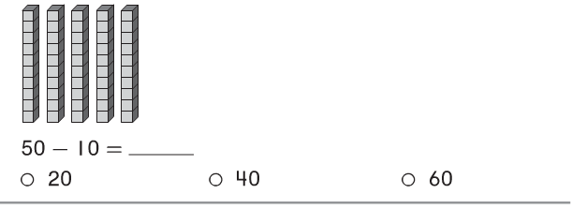
Problems 9 and 10
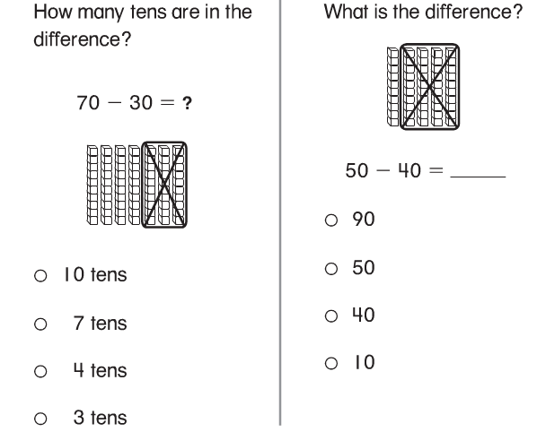

-------------------------------------------------------------------------------------T3
Problems 11 and 12
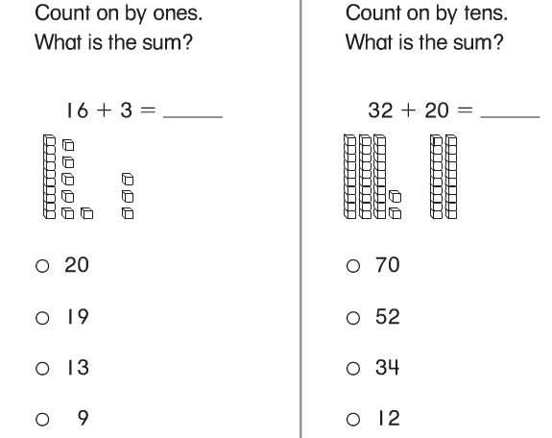
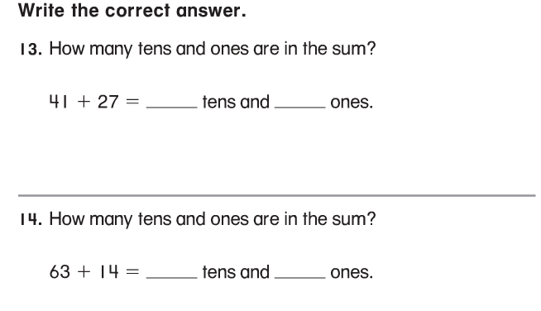
15.
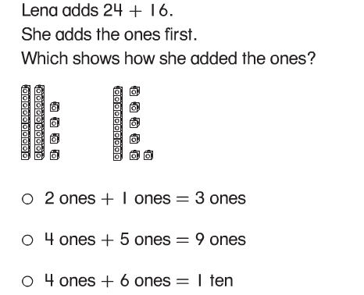

16. Which has the same sum?
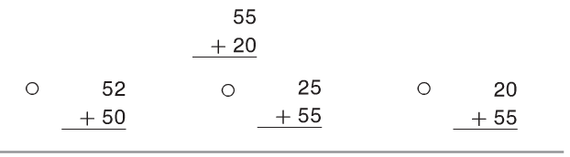

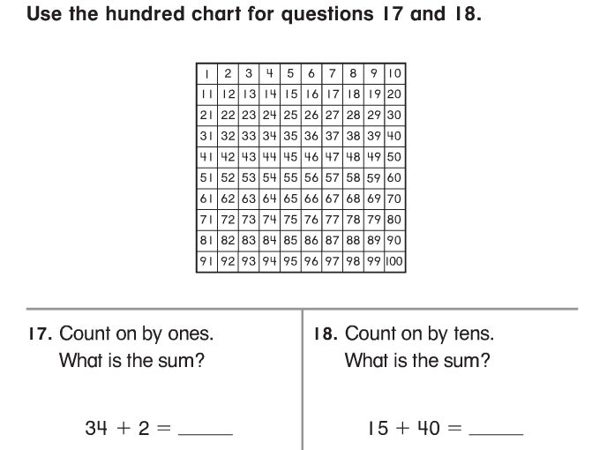

-----------------------------------------------------------------------------------------T4
Problems 19 and 20
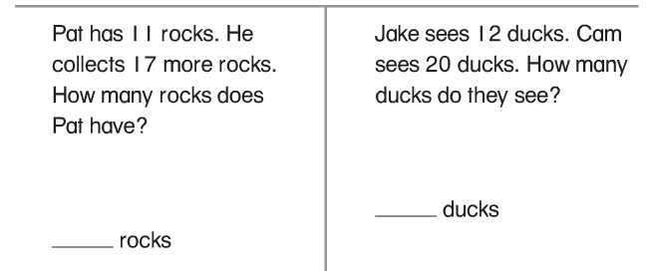

21. Beth adds ones and tens to find the sum. She then writes the number missing from the subtraction sentence. Finish Beth’s work.

22.
