Name ________________________________________Date ________________
Grade 1 Unit 9 Measurement and Data
Targets
A = Achieved Target
NA = Nearly Achieved Target
D = Did Not Meet Target
1 | 2 | 3* | 4 | 5 | 6 | 7
 |  | *

-------------------------------------------------------------------------------------------------- T1
Problems 1 and 2
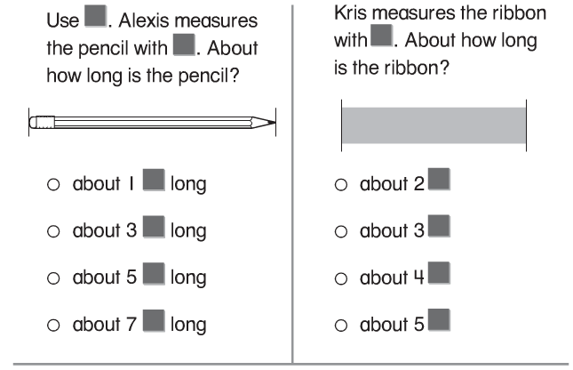

3.
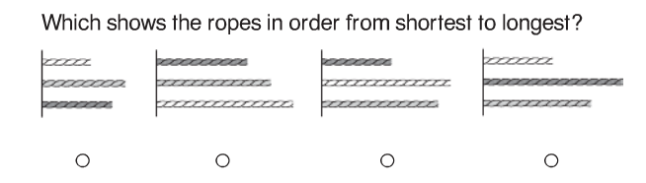

4.
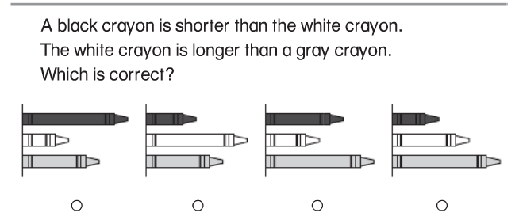

5.
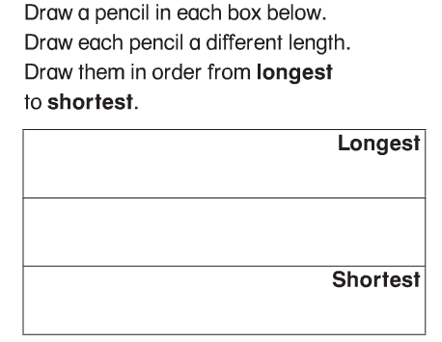
6.
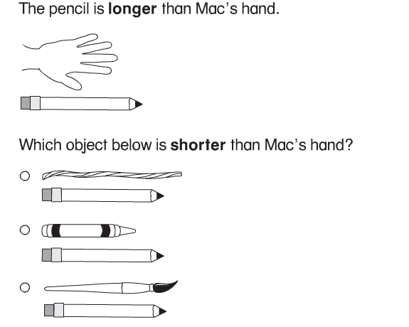
7.
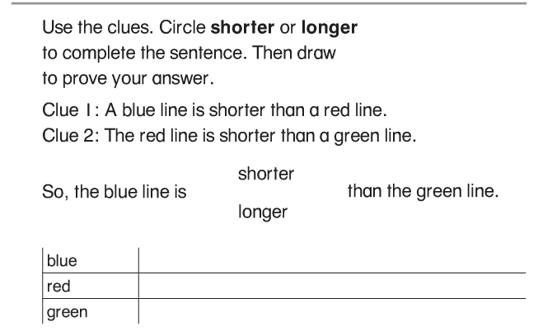
8.
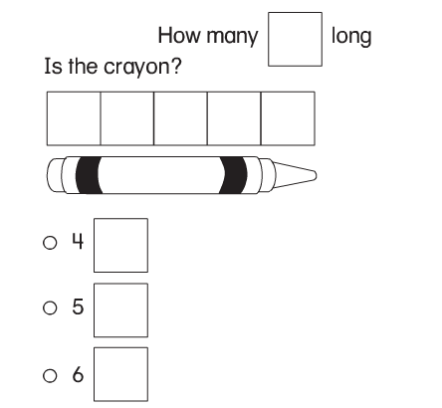
----------------------------------------------------------------------------------------------------T2
9.
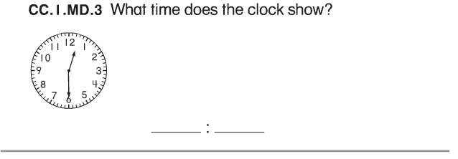
10.
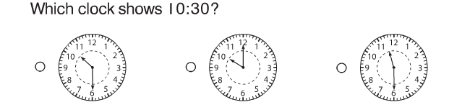

11.
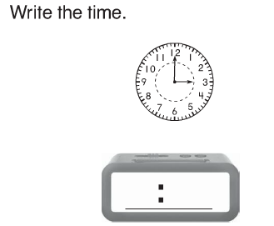
12.
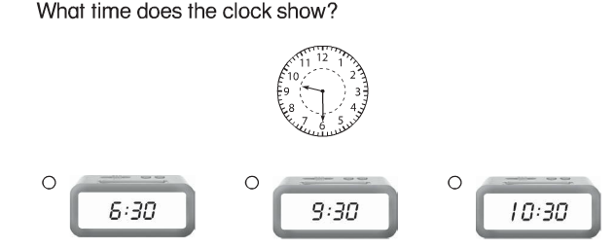

13.
Draw the hour hand and the minute hand to show 1:30.
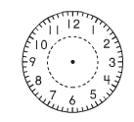

14.
Draw the hour hand and the minute hand to show 4:00.

Problems 15 and 16
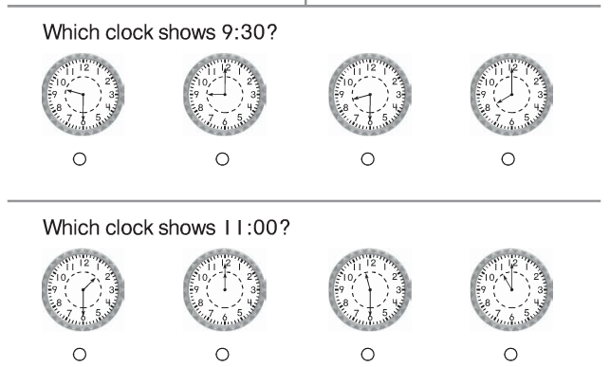

17.
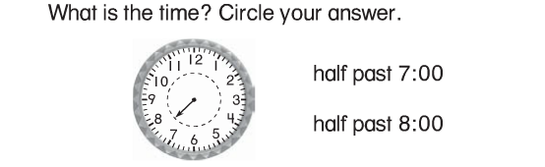

-------------------------------------------------------------------------------------------------T3
18.
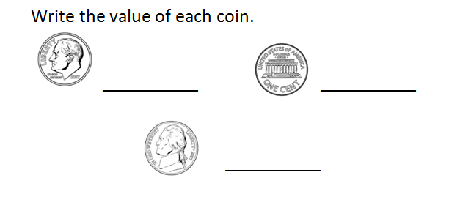

Problems 19-20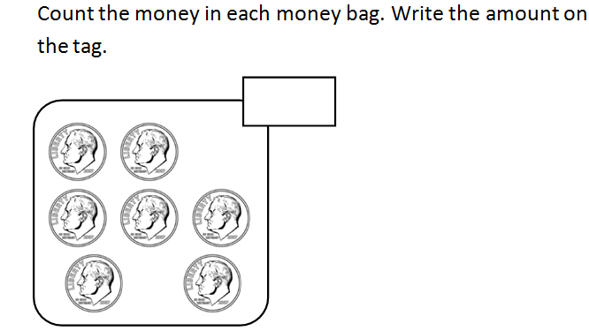

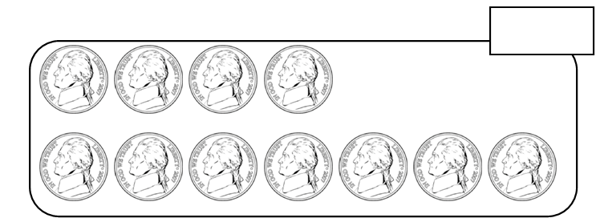

-------------------------------------------------------------------------------------------------------T4
Use the pictograph for problems 21-24
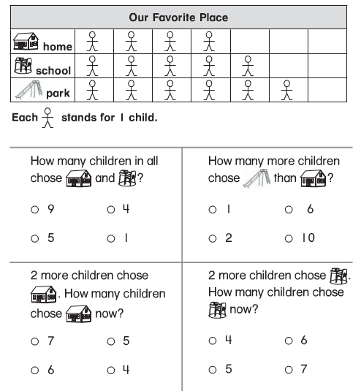

-------------------------------------------------------------------------------------------------------T5
Use the tally chart for problems 25-28
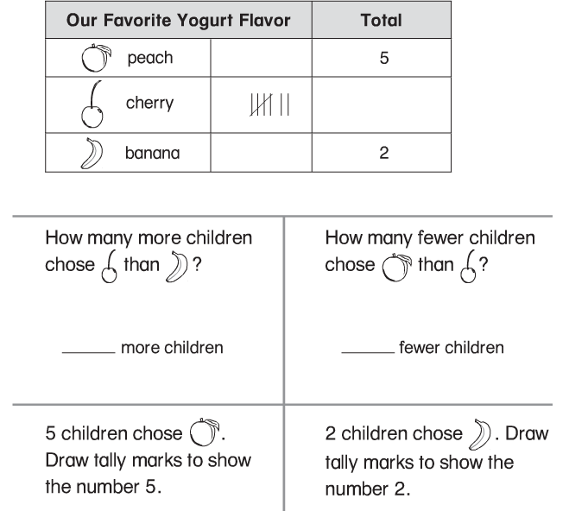

---------------------------------------------------------------------------------------------------------T6
Use the bar graph to answer problems 29-32
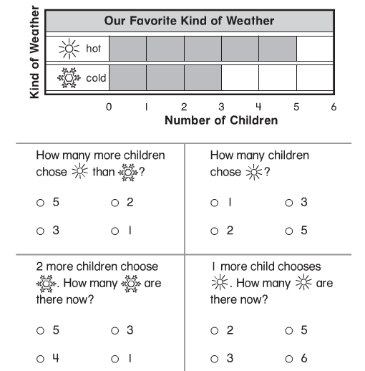

-------------------------------------------------------------------------------------------------------T7
33.
