Name: ____________________________ Date: _________
Grade 2 - Unit 1: Number Concepts

1 | 2 | 3
Targets
A = Achieved Target
NA = Nearly Achieved Target
D = Did Not Meet Target

-------------------------------------------------------Target 1 ------------

1.) Tell whether each number is odd or even.

9 ______________

4 ______________

12 ______________

33 ______________

Using the number 9, show how you
know whether it is odd or even.

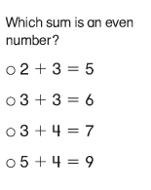
2.)

Show how you know.

3.) Tony shades ten frames to show a number. Is Tony’s number odd or even?

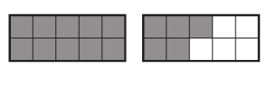

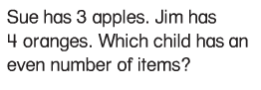
4.)

------------------------------------------------------ Target 2 --------------

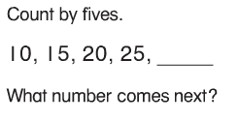
5.)

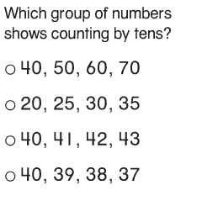
6.)

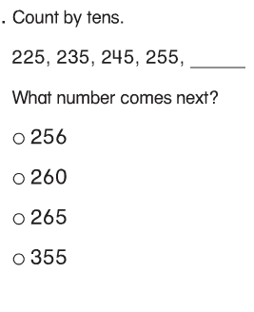
7.)

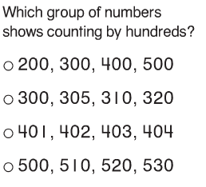
8.)

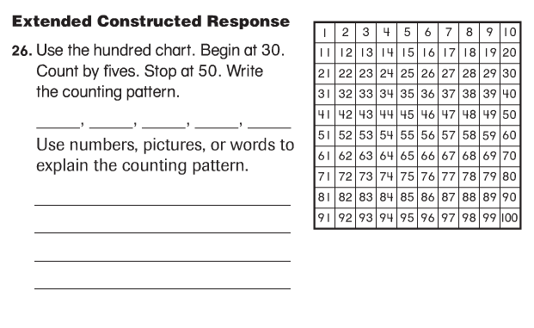
9.)
9.)

---------------------------------------------------------- Target 3 -----------

11.) Write the number.

forty-six _______ ninety-one _________

eighty ________ fifty-five __________

12.) Write in words.

17 _________________________________________________

34 ________________________________________________

13.) Use the information below to write each number.

tens | ones
4 | 2

tens | ones
5 | 12

_________ _________

14.) Write each number.

9 tens + 1 one = __________

6 ones + 2 tens = ___________

5 ones + 1 ten = ___________

15.) Write the number that these blocks show.

= _________________

16.) Write each number in expanded form.

62 = _____ + ______

19 = _____ + ______

40 = ______ + ______

77 = ______ + ______

17.) Use block drawings to show each number.

14
= 10
50
= 1
48

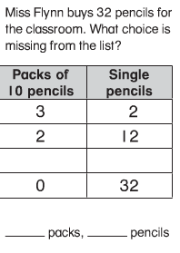
18.)

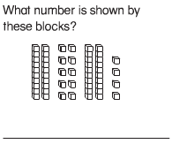
19.)

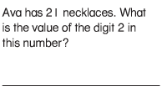
20.)

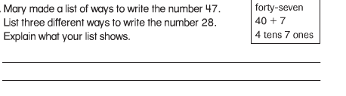
21.)

