Name: ____________________________ Date: _________
Grade 2 - Unit 2: Numbers to 1,000

1 | 2 | 3 | 4 | 5
Targets
A = Achieved Target
NA = Nearly Achieved Target
D = Did Not Meet Target

-------------------------------------------------------Target 1 ------------
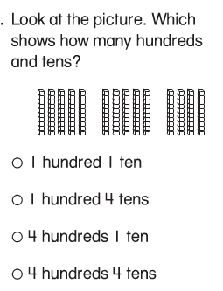
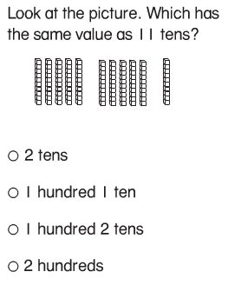
1.) 2.)

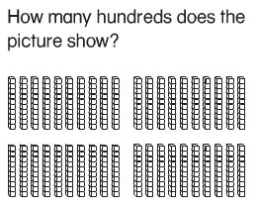
3.)

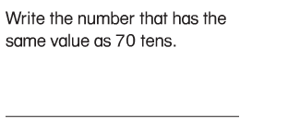
4.)

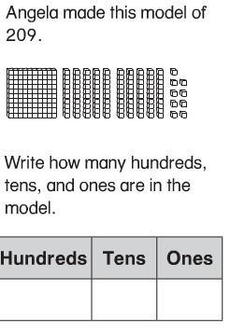
5.)

6.) Write the number.
hundreds | tens | ones
 | 3 | 6

____________

hundreds | tens | ones
 | 1 | 15

_____________

hundreds | tens | ones
 | 12 | 7

____________

hundreds | tens | ones
1 | 7 | 0

_____________

7.) Bob and Mary each used the key below to show the number 124.
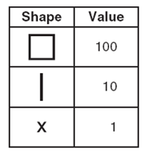
Below are their representations. Are both correct? Explain your
thinking with numbers or words.

Bob Mary

X X X X XXXXXXXXXXXXXX

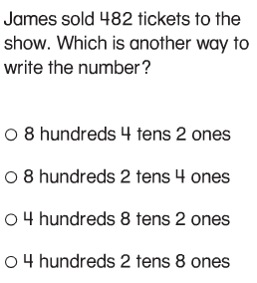
8.)

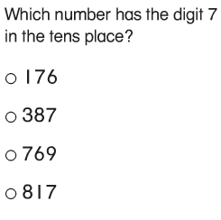
9.)

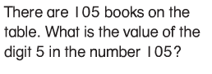
10.)

---------------------------------------------------------------- Target 2 -----
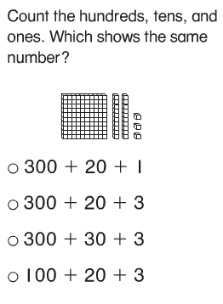
11.)

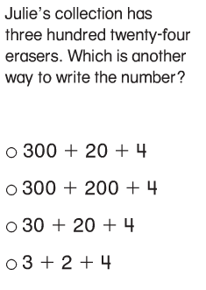
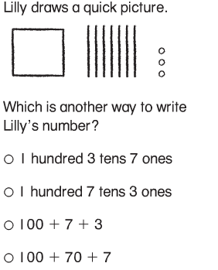
12.) 13.)

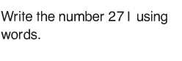
14.)

________________________________________________________________________

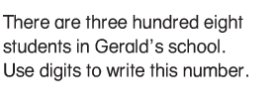
15.)

16.)
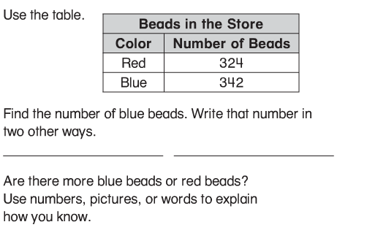

17.) Write the number.

100 + 20 + 7 = _______

400 + 30 + 7 = _______

700 + 10 = _______

800 + 6 = _______

18.) Write each number in expanded form.

62 =

319 =

140 =

777 =

19.) Write in words.

108

_________________________________________________

634

20.) Write the number.

four hundred, forty-six _______

one hundred, nineteen _________

six hundred, eighty ________

three hundred, five __________

----------------------------------------------------------------- Target 3 ----
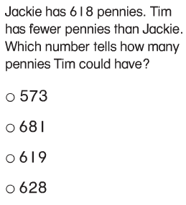
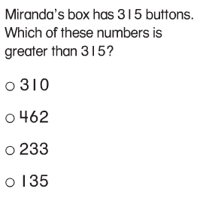
21.) 22.)

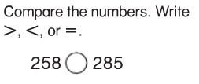
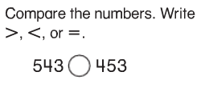
23.) 24.)

Student | Number of Pennies
Joan | 106
Harry | 143
Marla | 94
25.) This chart shows the number of pennies three students saved.

Which list shows the students in order from the student who saved the fewest pennies to the student who saved the most pennies?
- Marla, Joan, Harry
- Harry, Marla, Joan
- Joan, Harry, Marla
- Marla, Harry, Joan
------------------------------------------------------------- Target 4 ------
- This target may require some direct observation by the teacher.

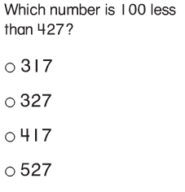
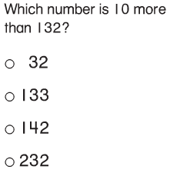
26.) 27.)

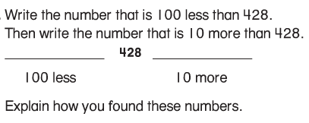
28.)

----------------------------------------------------------- Target 5 --------
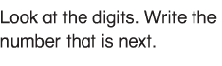
29.)

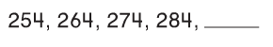

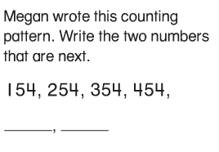
30.)

