Name: ____________________________ Date: _________
Grade 2 - Unit 3: Basic Facts and Relationships

1 | 2 | 3 | 4
Targets
A = Achieved Target
NA = Nearly Achieved Target
D = Did Not Meet Target

-------------------------------------------------------Target 1 ------------
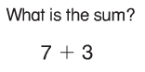
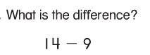
1.) 2.)

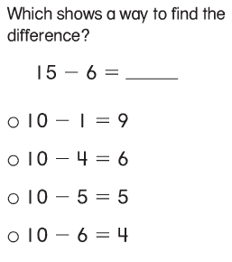
3.)

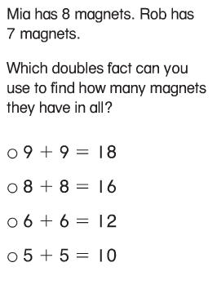
4.)

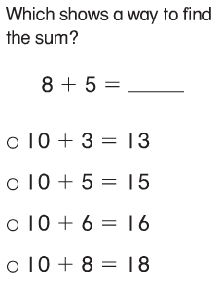
5.)

6.) Explain how you know. Show your reasoning for your
choice in problem number 5 above.

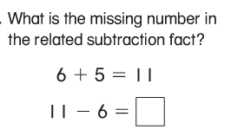
7.)

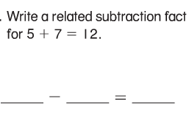
8.)

--------------------------------------------------------Target 2 --------

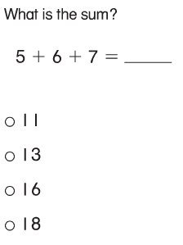
9.)

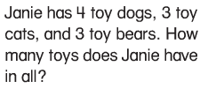
10.)

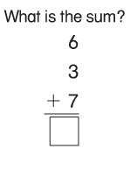
11.)

12.) Find the sum of these numbers: 4, 3 and 6. Add them in an order that makes sense to you. Write them in the number model the way you added them.

_______ + _______ + ________ = ________

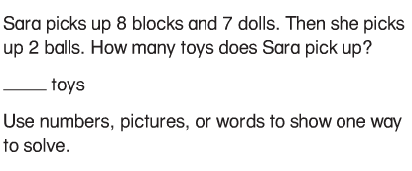
13.)

(Target 3)
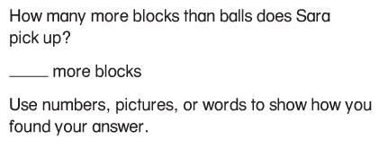

---------------------------------------------------------------Target 3------
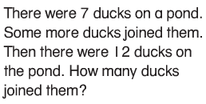
14.)

Show your work.

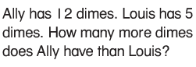
15.)

Show your work.

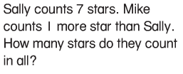
16.)

Show your work.

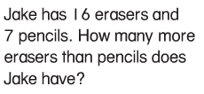
17.)

Show your work.

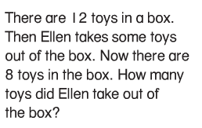
18.)

Show your work.

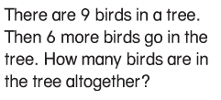
19.)

Show your work.

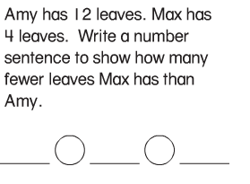
20.)

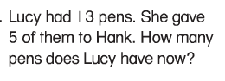
21.)

Show your work.

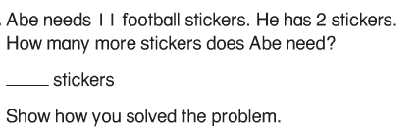
22.)

------------------------------------------------------------------Target 4---
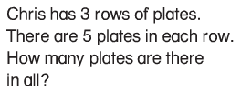
23.)

Show how you solved the problem.

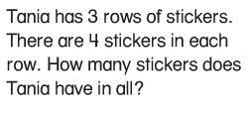
24.)

Show how you solved the problem.

25.) Draw a picture that represents the number model below
and then write a number story to go with the picture.

2 + 2 + 2 + 2 = 8

