Name: ____________________________ Date: _________

Grade 2 - Unit 4: **Two-Digit Addition**

|  |  |  |  |
| --- | --- | --- | --- |
| **1** | **2** | **3** | **4** |
|  |  |  |  |

**Targets**

A = Achieved Target

NA = Nearly Achieved Target

D = Did Not Meet Target

-------------------------------------------------------Target 1 ------------

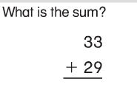1.) 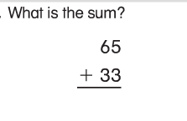 2.)

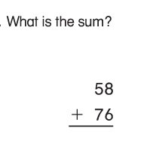

3.) 4.) 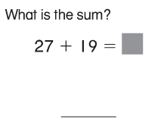

57

+ 26

5.) 6.) 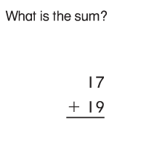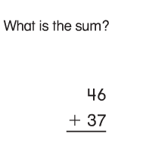

----------------------------------------------------------- Target 2 & 3----

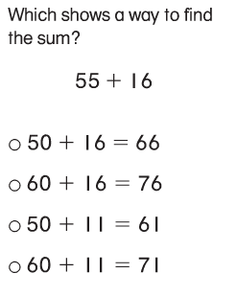7.) 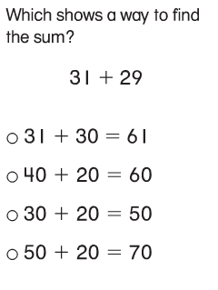 8.)

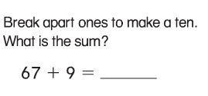

9.)

You must show your thinking on this problem.

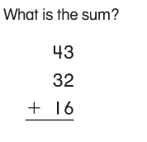10.) 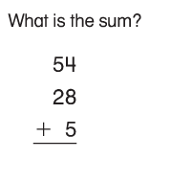 11.)

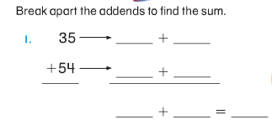

12.)

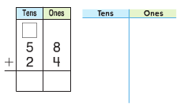

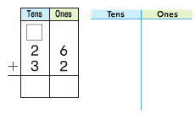13.) 14.)

----------------------------------------------------------- Target 4 --------

Show your thinking.

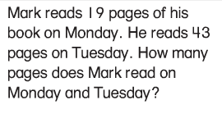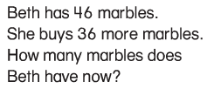15.) 16.)

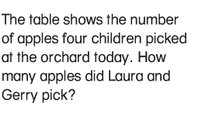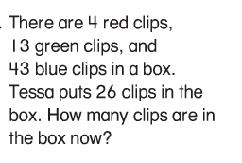

17.) 18.)

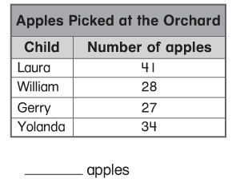

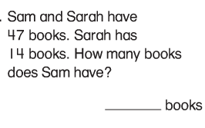19.)

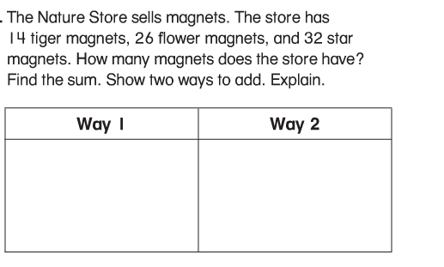20.)

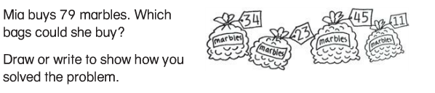21.)

22.)