Name _________________________ Date ________________
Grade 3 Unit 1 Addition and Subtraction Within 1,000
Targets
A = Achieved Target
NA = Nearly Achieved Target
D = Did Not Meet Target
1 | 2 | 3 | 4 | 5 | 6 | 7 | 8 | 9 | ER

-------------------------------------------------------------------------------------------------- T1
1. . Malcolm draws arrows on his number line to make a number pattern.
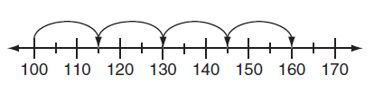
Describe the pattern Malcolm is counting by. _________________________
________________________________________________________________

What is the next number an arrow should point to on the number line?
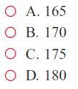

2. Holly started this table to show how much money she earns walking dogs.
Holly always earns the same amount of money for each dog she walks.

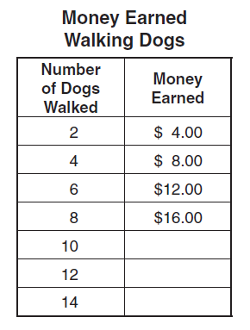
- Complete the table.

- How much money will Holly earn if she walks 13 dogs?

------------------------------------------------------------------------------------------------------- T2
3. Use the chart to answer the questions.
The Flower Garden
Flower Types | Number of Flowers
Roses | 196
Tulips | 303
Zinnia | 525
Buttercup | 291
Honeysuckle | 84

In the garden, which flower numbers about 300? _______________
To the nearest ten, about how many Zinnia flowers are in the garden? ________
To the nearest hundred, about how many Roses are in the garden? _______
Estimate to the nearest hundred the total number of Buttercup and Honeysuckle flowers in the garden? Show your work.

4.
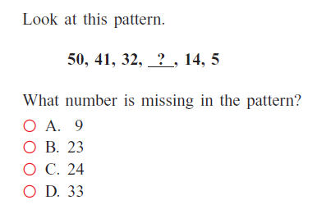
5. Fill in the chart by rounding the numbers.
Number | Round to the Nearest Ten | Round to the Nearest 100
434
188
65

6. Estimate the sums by rounding to the nearest hundred
345 + 266 =
561 + 229=
399 + 101=
7. Estimate the sums by rounding to the nearest ten
45 + 31=
66 + 12=

------------------------------------------------------------------------------------------------------ T3
8. Count by tens and ones to find the sum. Use a number line to show your thinking. 64 + 29 =

9. Use mental math to find the sum. Draw or describe the strategy your thinking. 146 + 254 =

-------------------------------------------------------------------------------------------------- T4
10. Mary writes a number sentence that shows the Commutative Property of Addition. Which number sentence did Mary write?
a. 37 = 36 + 1
b. 0 + 23 = 23
c. 37 + 13 = 13 + 37
d. 7 + (13 + 8) = (7 + 13) + 8

11. Hector bought fruit at the farmer’s market. He bought 34 pears, 26 melons and 44 plums. How much fruit did Hector buy at the farmer’s market? Show your work below.

12. Complete the equations and label the name of the property shown using words from the box. Identity Property of Addition
Associative Property of Addition
Commutative Property of Addition
Odd + Odd = Even
Even + Even = Even
Odd + Even = Odd

odd + _____ = even ______________________________
a + b = b + ____ ______________________________
(x + y) + z = x + (___ + z) ______________________________
------------------------------------------------------------------------------------------------T5 and 9
13. The number of campers at Camp Yawgoog in July was 414. The number in August was 443. How many campers were at Camp Yawgoog in July and August combined? Solve with a bar diagram below.

14. Lynn drove to Pennsylvania over two days. On day one she drove 346 miles. On day two she drove 100 miles more than she drove on day one.
How many miles did she drive on day two? Solve with an equation below.

How many miles did she drive in all over the two days? Solve with an equation below.

----------------------------------------------------------------------------------------------------- T5
15. Use the break-apart strategy to solve the equations below.
654
+ 123__ ________________________

727
+ 235__ ________________________

16. Solve
291
+ 355__

555
+ 278__

17.
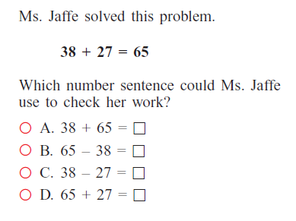

------------------------------------------------------------------------------------------------------ T6
18. Estimate the differences by rounding to the nearest hundred.
457 – 123 =
689 – 315 =

19. Estimate the differences by rounding to the nearest ten.
56 – 23 =
691 – 135 =

------------------------------------------------------------------------------------------------ T7
20. Count by tens and ones to find the difference. Use the number line to show your thinking. 485 – 57 =

21. Use the break-apart strategy to solve the equation below.
549
− 435_ _______________________

------------------------------------------------------------------------------------------------ T8 and 9
22.
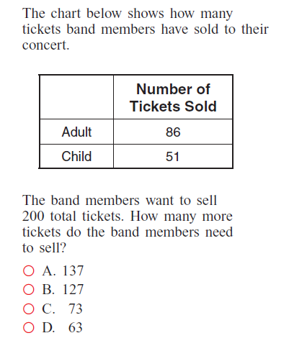
23. A class needs to earn 100 stars to have a pizza party. The class earned 27 stars in March. How many more stars does the class need to earn to have a pizza party? Solve with a bar diagram.

24. The Smoothie Shop sold 248 banana smoothies and 197 peach smoothies. How many more banana smoothies than peach smoothies were sold? Solve with an equation.

------------------------------------------------------------------------------------------------- T8
25. Solve
727 900
− 235_ − 367 _

26.
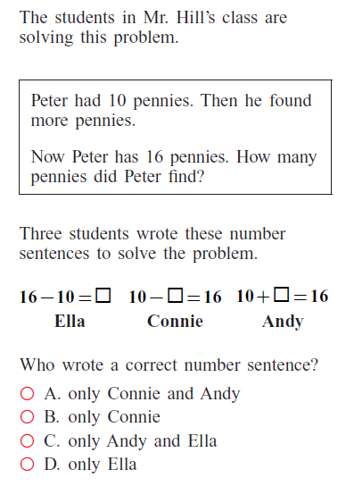

----------------------------------------------------------------------------------------- unit 1 targets
Extended Constructed Response
Ben played a video game. He scored 134 points in the first round of the game and 158 points in the second round. In the third round, Ben scored 16 fewer points than in the first round.
How many more points did Ben score in the second round than in the first round of the game? Use any strategy you choose to find the answer and be sure to show your thinking and work. Check to be sure you have answered the question.

How many points did Ben score in all three rounds of his game? Think about what information you need to gather first in order to solve this question and then solve the question. Be sure to show all your work. Use any strategy you choose for your thinking. Check to be sure you have answered the question.

