Name _________________________ Date ________________
Grade 3 Unit Represent and Interpret Data
A = Achieved Target
NA = Nearly Achieved Target
D = Did Not Meet Target
Targets
1 | 2 | 3 | 4
-------------------------------------------------------------------------------------------------- T1
1..Directions: Sue collected flowers in her backyard. Make a table for the data represented in the picture graph below.
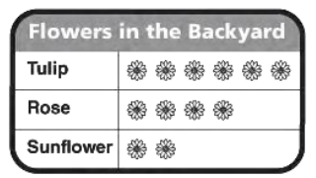

2. Martin did sit-ups for 5 weeks. Each week, Martin increased the number of sit-ups he did by 3. In week 1, Martin did 60 sit-ups. Create a table that could show Martin’s Sit-Ups for 5 weeks.

3.
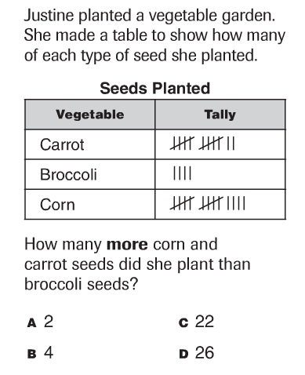

------------------------------------------------------------------------------------------------------ T2
4.
5. 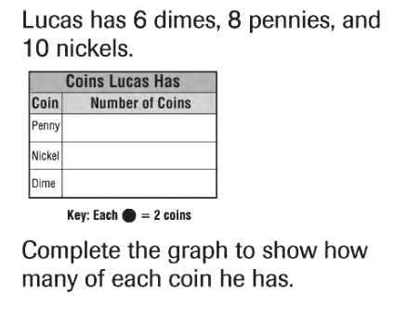
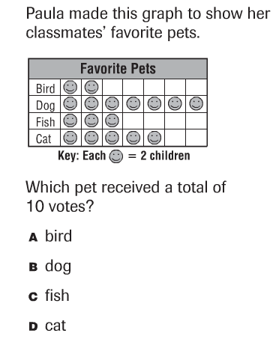

6.
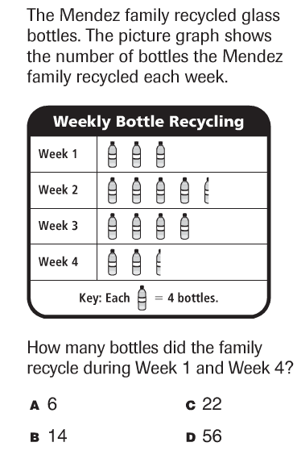

7.
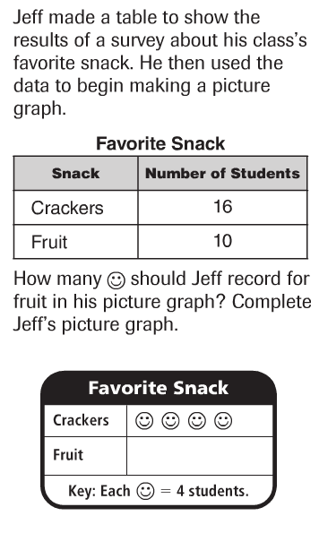

8.
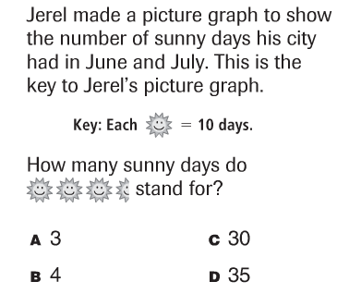

------------------------------------------------------------------------------------------------------ T3
9.
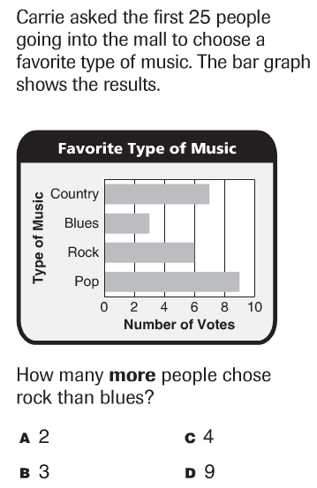

10.
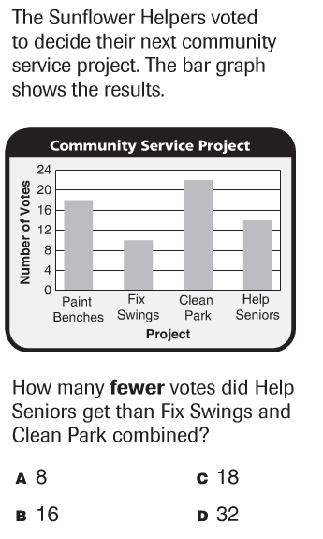

11.
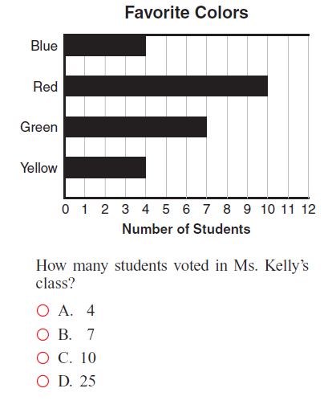
How do you know you are correct? Show your thinking below.

----------------------------------------------------------------------------------------------------T4
12. Look at this line plot.
Number of Times Playing Video Games Last Month

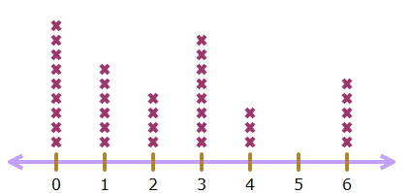

x represents one boy

- How many boys played video games 3 times last month?

- What is the most frequent number of times video games were played? ____________

- How many people never played video games last month?
____________

d. How many more boys played video games 3 times than played video games 1 time? ______________

13.
