Name _________________________ Date ________________
Grade 3 Unit 3 Understanding Multiplication and Developing Multiplication Fact Strategies and Fluency
Targets
A = Achieved Target
NA = Nearly Achieved Target
D = Did Not Meet Target
1 | 2 | 3 | 4

-------------------------------------------------------------------------------------------------- T

- a. Draw Xs to make an array for the sum of 5 + 5 + 5.

b. Write a multiplication sentence that matches your array. Be sure to include the answer to your multiplication sentence.

2. Look at the bees.

Which equation(s) tell about the bees.
- 3 + 3 + 3 + 3 + 3 + 3
- 3 × 6
- (3 x 3) + (3 x 3)
- 3 x (5 + 1)
- 6 × 3
- 18 × 3
- 18 – 3

- Equations m, n, s, and p
- Equations m, n, o, p and q
- Equations n, q, and r
- All of the above

3. Bob and Sue are solving this problem.

There are 5 bags of cookies for sale. Each bag has 4 cookies in it. If a boy buys all the bags of cookies, how many cookies will he have in all?

Bob writes 4 + 4 + 4 + 4 + 4 =

Sue writes 5 x 4 =

Who has written a correct number sentence? Explain how you know.

4.
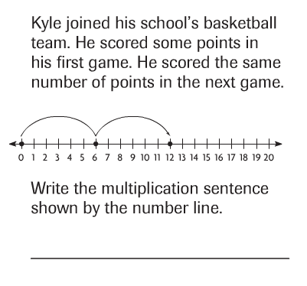

5.
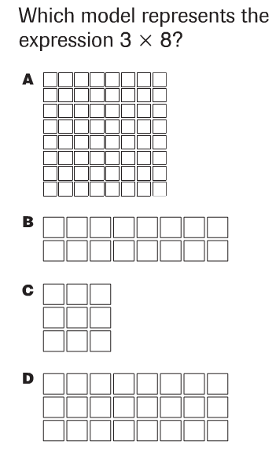

6. Mrs. Bennett sorted spools of colored thread into 4 groups. She put 5 spools of thread in each group. Draw sets to show how many spools of thread she sorted.

Write an addition equation to solve the problem. _____________________
Write a multiplication equation to solve the problem. _____________________

-------------------------------------------------------------------------------------------------------T2
7. Lori bought gifts for her 3 brothers and 6 cousins. She bought 4 toy cars for each of her brothers, and 2 toy puzzles for each of her cousins.
Write an equation using g for the total number of gifts. Solve to find how many gifts Lori bought in all.

8. There are 8 pies at the bakery. Each pie is cut into 8 slices.
How many slices of pie are there? Show your work using a table to solve the problem.

9. Logan has 5 pet rabbits. He gave each rabbit 3 carrots. How many carrots did Logan give to his rabbits in total? Using a model diagram solve the problem.

10. Dora bought 3 CDs and 4 books. The CDs cost $8 each and the books cost $4 each. How much did Dora spend in all? Show your work with a strategy of your choice.

-----------------------------------------------------------------------------------------------------T3
Problems 11-12
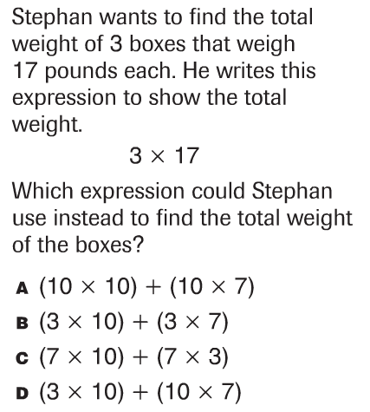

13. Solve the following equations.

- x 1 = ____ 1 x 100 = ___ _____ x 25= 25 1 x _____= 39

14. Solve the equations below.

a x c = ___x a c x ___ = b x c 50 x 4 = 4 x ____

15.
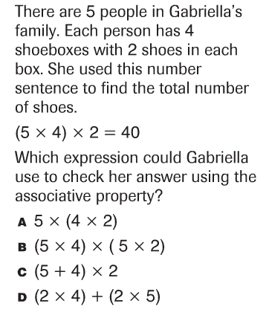

16. A bank makes rolls of 40 nickels. How many nickels would be in 9 rolls?

17. Hawk Bluff’s 4 third grade classes collect food for a food drive. Each class collects 50 cans of food. How many cans of food are collected?

Problems 18 and 19
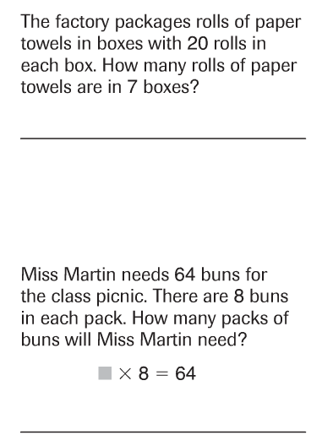

20.
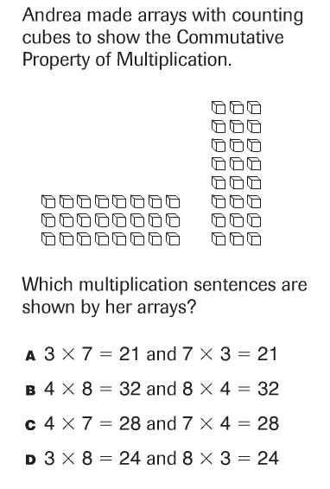

---------------------------------------------------------------------------------------------------------T4
Solve.
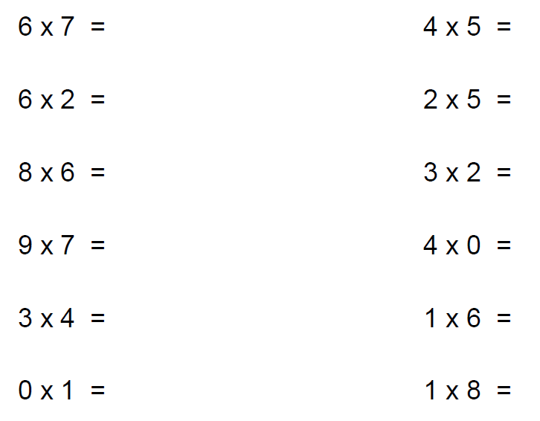

21.
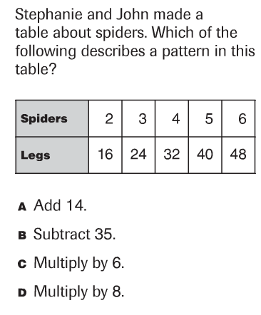

Extended Constructed Response
