Name _________________________ Date ________________
Grade 3 Unit 4: Understanding Division and Developing Division Strategies and Fact Fluency
Targets
A = Achieved Target
NA = Nearly Achieved Target
D = Did Not Meet Target
1 | 2 | 3 | 4 | 5

-------------------------------------------------------------------------------------------------- T1
1. Using the number line below, show how to divide 45 into groups of five. Then tell how many groups of five are in forty-five.

0 10 20 30 40 50
How many groups of five can you make? _______________

2. Silvia is baking cookies. She used 36 eggs to make all the batches of cookie dough. Each batch calls for 6 eggs. How many batches of cookies did she make? Show how you know with an array, model drawing, and/or number models.

3. Diana is in charge of setting up the library for an after-school meeting. She needs to set-up 36 chairs into equal rows. Give 4 different ways Diana can set-up the chairs in the library. For each way, write the number of rows and the number of chairs in each row. Use number line, model drawing, repeated subtraction or an array to show how you know.

4. Carly needs to divide 45 sheets of paper into 9 stacks. Using c for the unknown, what division equation could Carly write to solve her problem?
________________________________________

5. Mr. Harold wants to divide his marching band into equal rows. He has 56 players and is able to make rows with 6 players in each row. He divides them by subtracting. Show his thinking.

6. Luis uses 36 marbles to play a game. There are 6 players playing the game. Each player gets the same number of marbles. How many marbles does each player get? Show how you know.

7. Keith has arranged 40 toy cars in equal rows. How many cars are in each row? Show your work.

---------------------------------------------------------------------------------------------------------T2
8. Carla sells homemade pretzels with 9 pretzels in a bag. In the morning she sells 27 pretzels. In the afternoon she sells 18 more. How many bags of pretzels did she sell by the end of the day? Show your work below.

9. George had 6 sheets of animal stickers. Each sheet had the same number of stickers. A friend gave him 4 more animal stickers. Now George has 40 animal stickers. How many animal stickers were on each sheet? Show your work below.

---------------------------------------------------------------------------------------------------------T3
10. Carlos uses the number 3, 7 and 21 to write a set of related facts. Write one multiplication and one division equation that is part of the set of related facts Carlos writes.
_____________________ ____________________

11. Tina buys 64 hamburger buns for the soccer party. The hamburger buns come in packages of 8. Write a related multiplication fact that could be used to solve this problem.
_________________________________________
12. Sandy divided a batch of muffins into 4 bags to sell at the bake sale.
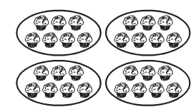
Write a multiplication and a division equation represented by the picture.
_____________________________ ________________________________

13. Look at the multiplication problem below and write a related division number model.
If a x b = c then ___ ÷ ___ = ___

-------------------------------------------------------------------------------------------------------T4
14. Solve each of these problems.
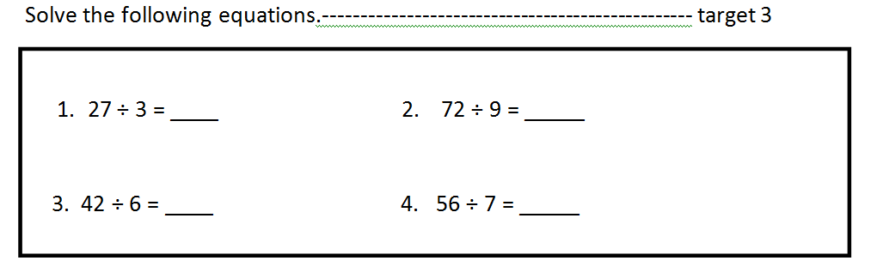
5. 81 ÷ 9 = 6. 64 ÷ 8 =

7. 100 ÷ 10 = 8. 24 ÷ 4 =

-------------------------------------------------------------------------------------------------------T5
15. Kayla uses the order of operations to solve the equation below:
78 – 54 ÷ 6 = b
Which is the unknown number?
A. b = 4 C. b = 69
B. b = 24 D. b = 70

16. Derick uses the order of operations to solve for the unknown number.
3 + 7 x 3 = c
What is the unknown number? ______

Constructed Response
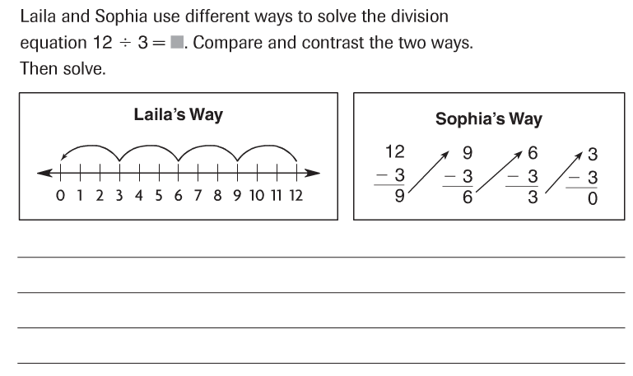

Extended Response
