Name _________________________ Date ________________
Grade 3 Unit 5
Targets
A = Achieved Target
NA = Nearly Achieved Target
D = Did Not Meet Target
1 | 2 | 3

-------------------------------------------------------------------------------------------------- T1
1. Sue talked to her friend on the phone for ⅝ of an hour. Which point on the number line represents ⅝?
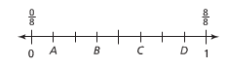
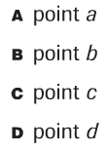

2. Which fraction is equal to 1?
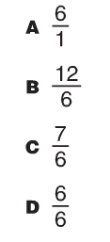
3. Which rectangle shows one equal part of the whole shape? _____
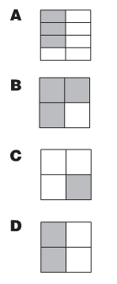
4. Look at the plane figures. What fraction of the group is NOT a triangle? _____

5. What fraction names the point on the number line? ______

6. Name the fraction for the shaded part in each rectangle.
_______
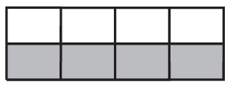 ________
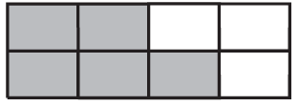 ________

7. What fraction names the point on the number line?
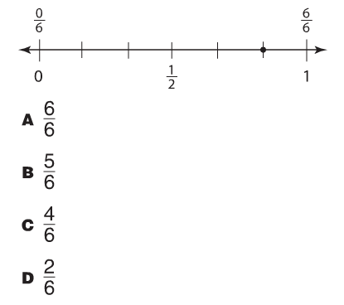
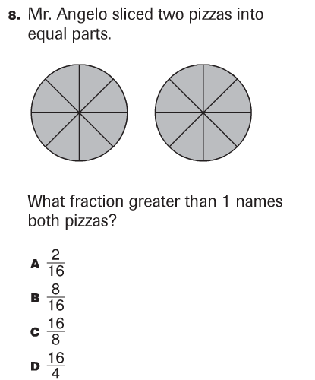

9. Show the fractions the following ways. Use the guide lines to help cut the shape.
Fraction to represent  ex.  4 eighths | Fraction of the Whole | Fraction of the Set | Fraction as a numeral  4/8
one half

two sixths

six eighths

two thirds

10. John ate three eighths of the pizza.
Jim ate one eighth of the pizza.
Ray ate four eighths of the pizza.
Shade to show the amount of pizza each boy ate. Write the fraction in the box.

John’s share of pizza Jim’s share of pizza Ray’s share of pizza

11. One third of the dogs in the kennel are spotted.
If there are 12 dogs in the kennel, how many dogs are spotted?
Draw a diagram to show how you know.

12. One third of the band room can hold 10 chairs.
How many chairs can fit in the whole band room?
Draw a diagram to show how you know.

Problems 13-14
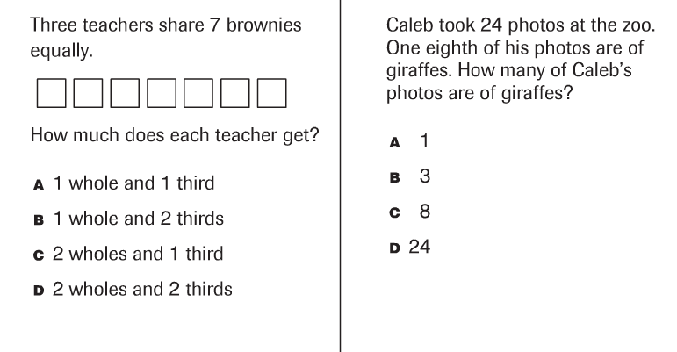

Problems 15-16
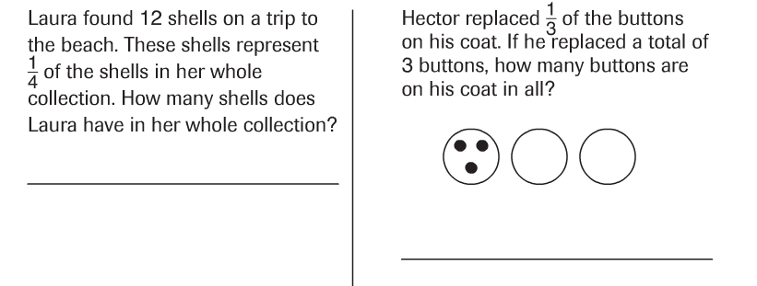

Problems 17-18
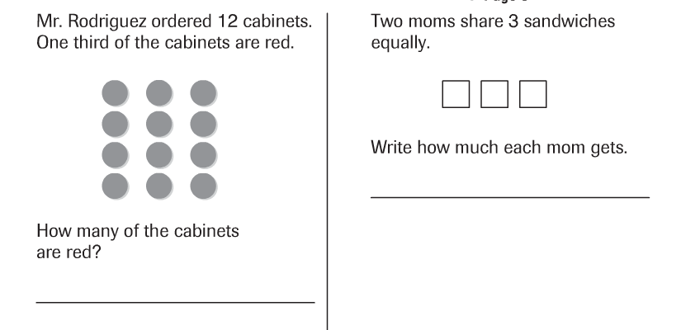

---------------------------------------------------------------------------------------------- T2
Problems 19-20
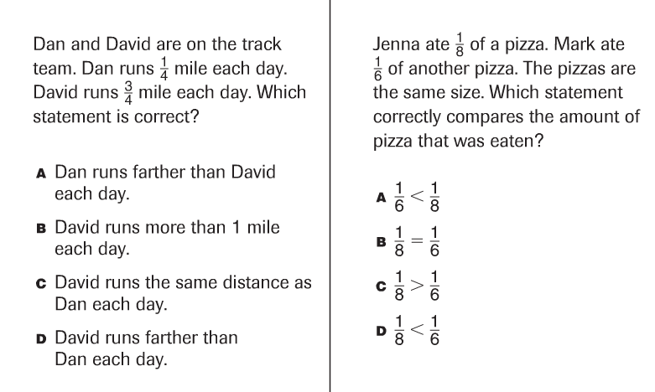

Problems 21-22
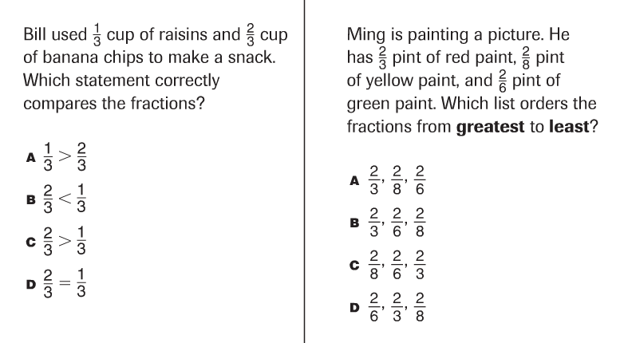

Problems 23-24
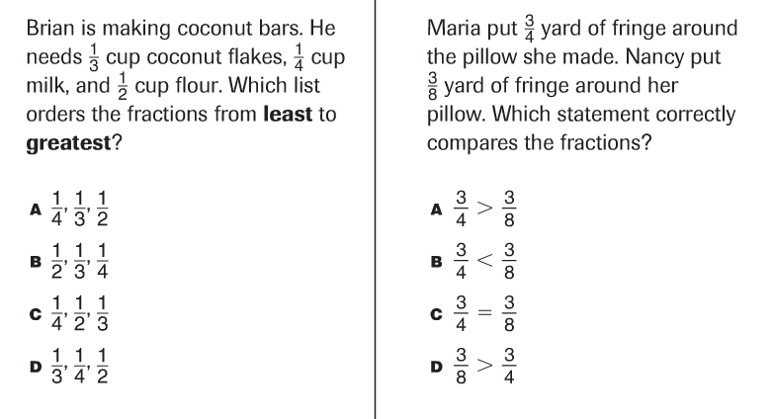
Problems 25-26
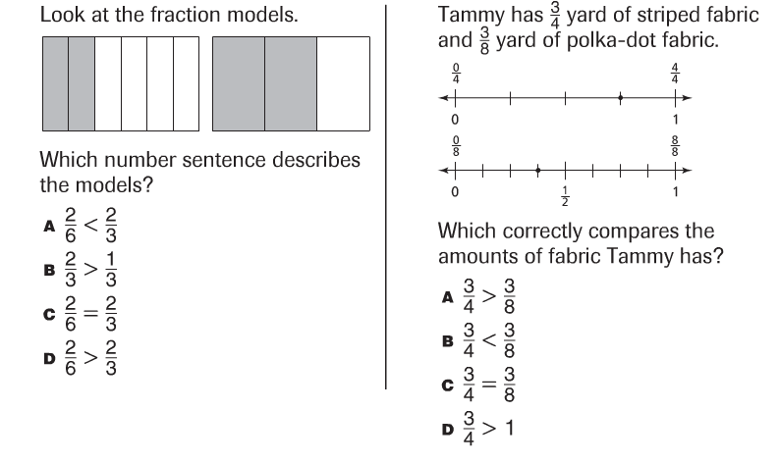

Problems 27-28
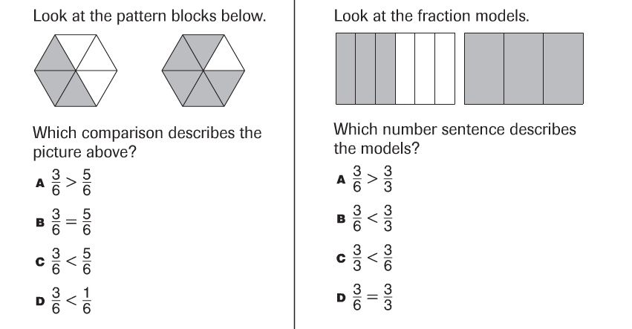

Problems 29-30
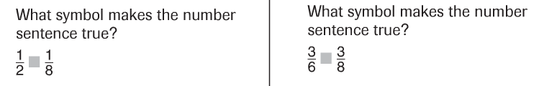

-------------------------------------------------------------------------------------------------- T3
Problems 31-32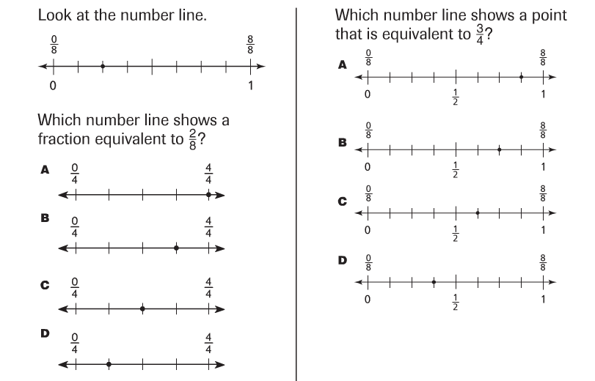

Problems 33-34
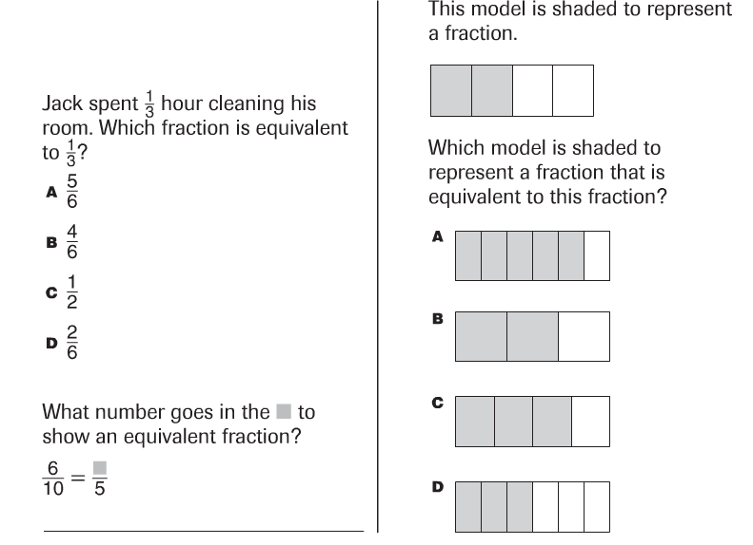

Problems 35-36
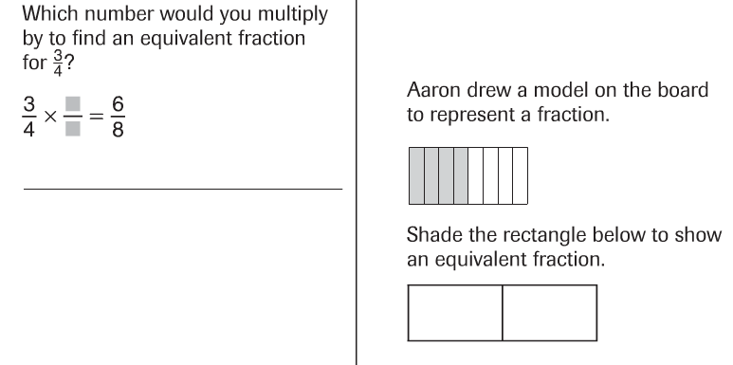

Problem 37
Name an equivalent fraction for each of the following fractions below:
⅓
½
¼
⅙

Problems 38-40
