Name _________________________ Date ________________
Grade 3 Unit 6
Targets
A = Achieved Target
NA = Nearly Achieved Target
D = Did Not Meet Target
1 | 2 | 3 | 4 | 5 | 6 | 7 | 8 | 9

-------------------------------------------------------------------------------------------------- T1
1. Tell the time on the clocks. Add AM or PM based on the activity.

gym class sleeping in bed cooking dinner

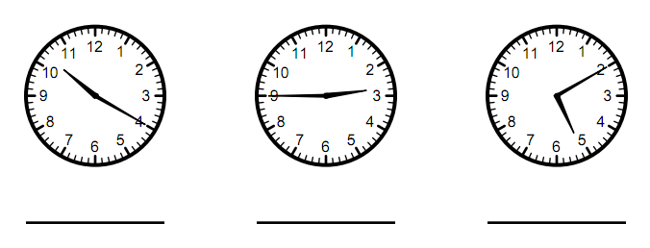

What time will it be 48 minutes after “gym class”? __________________
What time will it be 4 hours and 15 minutes after “sleeping in bed”? ___________
What time will it be 22 minutes after “cooking dinner”? ____________

2. Draw the hands on the clocks to show the time. Add AM or PM next to the time based on the activity.
eating lunch leaving school finishing soccer practice

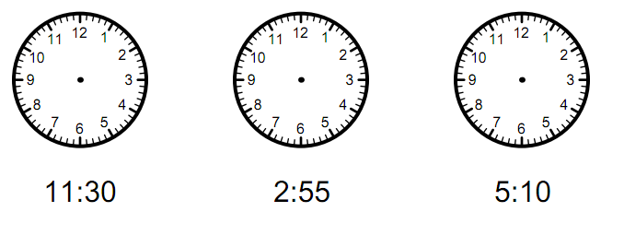

3. John takes a walk each day. He begins his walk at 4:15 sharp. He walks 10 minutes to the park and sits to watch ducks for 10 minutes. He walks 15 minutes further to the playground where he plays for 30 minutes. Finally, he goes to the ball-field which is right next to the playground and practices his batting in the batting cage for 10 minutes. He takes a shortcut and is home in 10 minutes. What time is it when John arrives home? Draw a diagram to show your thinking.

4. Mike plans on visiting all the animals in the zoo on his list. He plans on spending 15 minutes at each animal before beginning to walk to the next animal. To help keep Mike on track, record the times to complete Mike’s schedule.
Animal | Arrival Time | Departure Time
Penguin | 9:00
Tiger | 9:25
Bear |  | 10:20
Elephant |  | 11:00
Monkey | 11:50

5. Use a number line to show the elapsed time (change of time) for each problem below.
Rebecca ends practice at 5:45. She practices for 45 minutes. What time does she start practice? ___________________

Susan begins practicing oboe at 3:30. She practices for 40 minutes. What time does she end practice? _________________________

6.
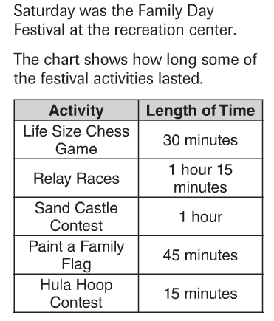
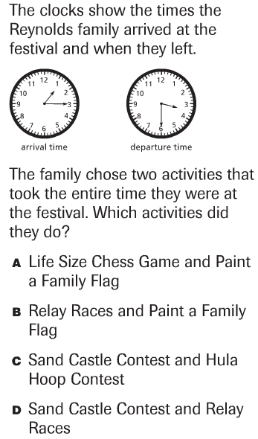
-------------------------------------------------------------------------------------------------------- T2
7. Measure each of the bolded line segments to the nearest half inch. Record your measure using the correct unit of measure.
b
a
c

- __________ b.__________ c.__________

8. Record the measure to the nearest ½ inch.
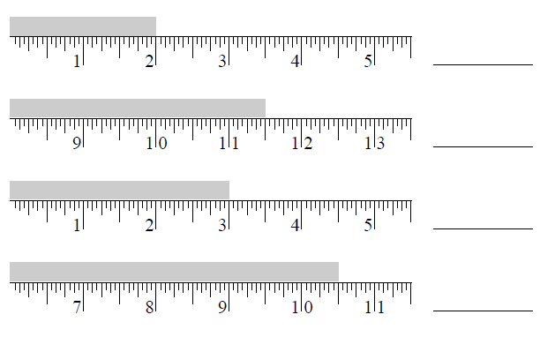

9.
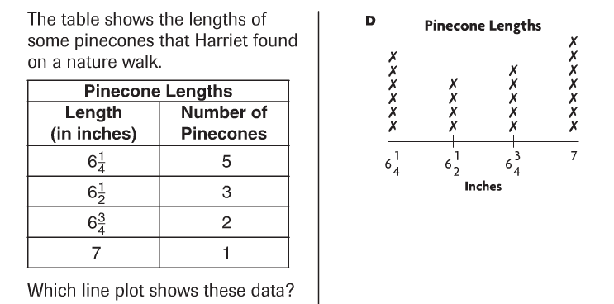
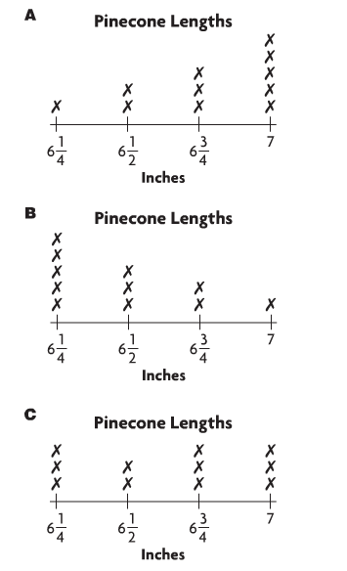
---------------------------------------------------------------------------------T3 Problems 10-13
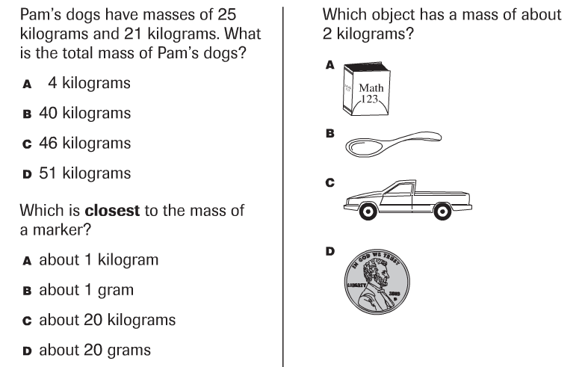

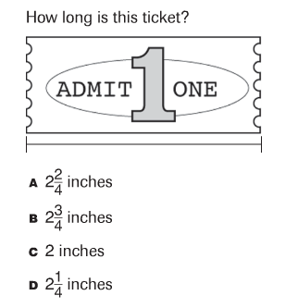

Problems 14-16
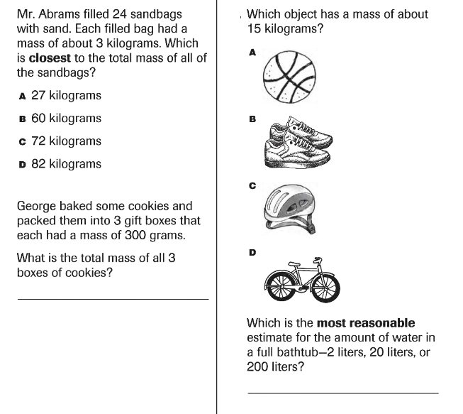

------------------------------------------------------------------------------------------------------- T4
17. Find the perimeter if each side of the hexagon is 4cm.

Perimeter = _______________
18.
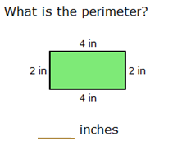
19.
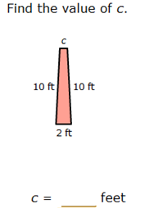

20.
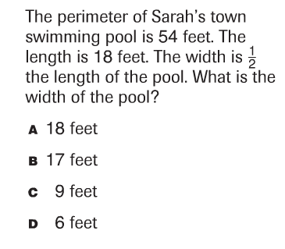
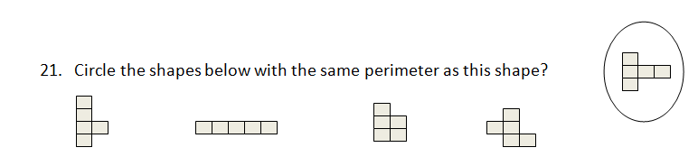

22. The cover of Mario’s library book has 4 equal sides. The total perimeter of the book is 32 inches. What is the length of one of the sides? _____ Show how you know.

23.
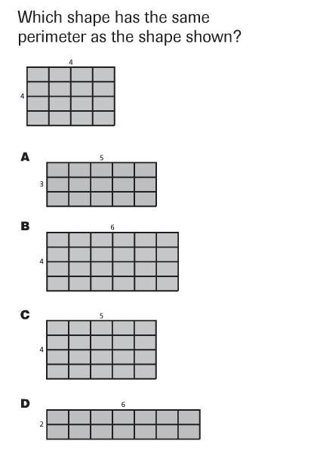
24. The area of a square is 25 feet. The length of one side is 5 feet. What is the perimeter of the square? _________ Show how you know.

---------------------------------------------------------------------------------------------------T5
25. Find the area of this rectangle.

Area = __________ sq. cm.

26.
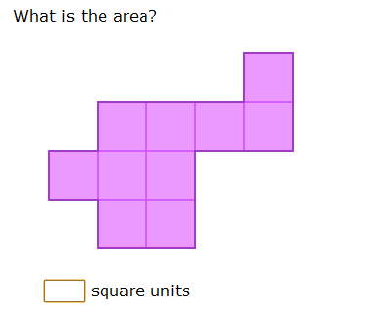

27.
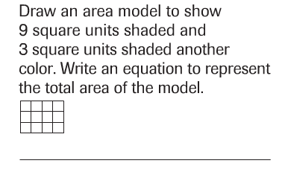

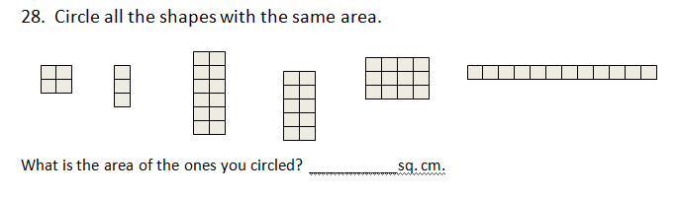

Problems 29-30
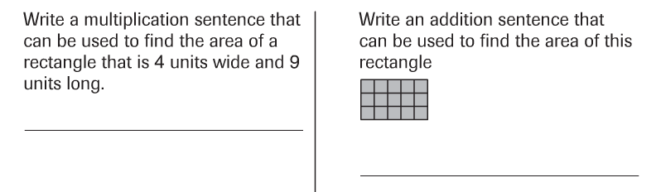

Problems 31-32
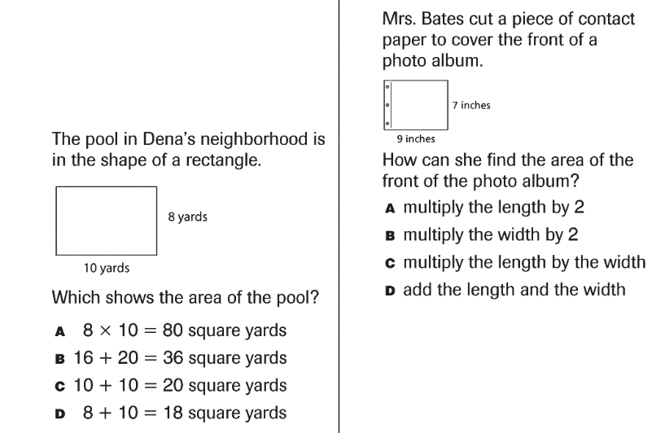

Problems 33-34
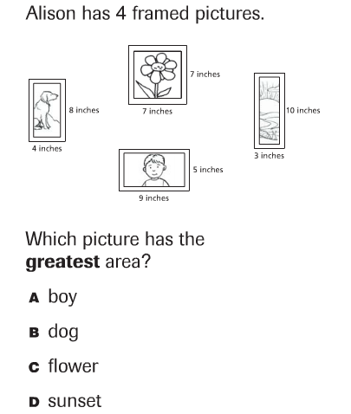

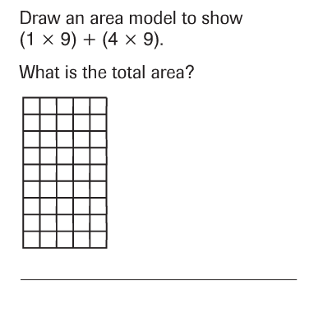

Problems 35-36
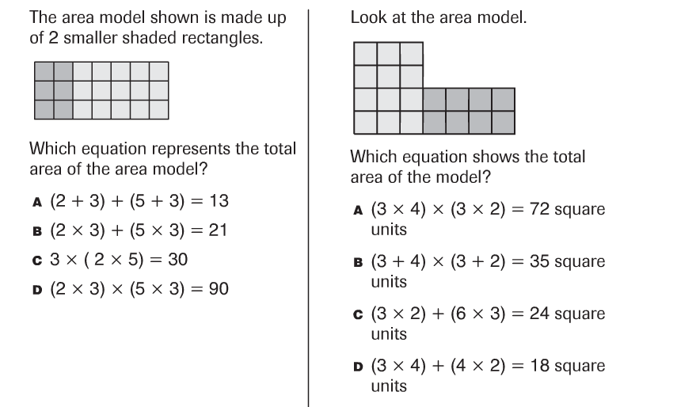

------------------------------------------------------------------------------------------------T6
37. On the grid below, create 3 polygons all with the same perimeter. Be sure to label the perimeter for each polygon. Be sure the perimeters are the same.
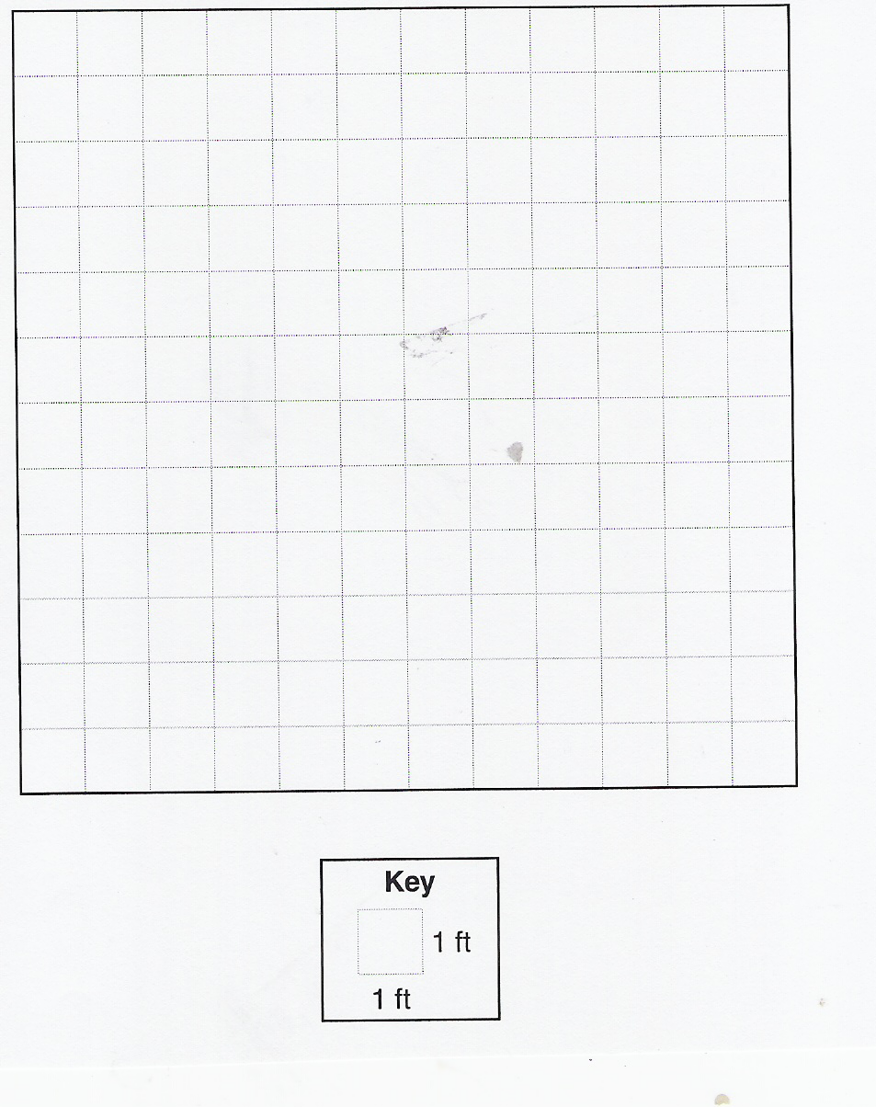

38. On the grid below, create 3 rectangles with the same area. Be sure to label the area for each. Be sure the areas are the same.

-------------------------------------------------------------------------------------------------- T7
39. The third grade teacher gave clues about shapes. Read each set of clues and write the name of the shape she is talking about. Use the words in the word box.

hexagon triangle rhombus square rectangle trapezoid circle

The shape has 4 right angles.
The shape has 4 equal sides.
The shape is a quadrilateral.

The shape has 6 sides.
The shape has 6 angles.
The shape is a regular polygon.

The shape is not a polygon.
The shape is a closed shape.

The shape has 4 sides.
The shape has 2 pairs of parallel sides.
The shape can be made from 2 triangles.

40. Draw the following shapes:
a quadrilateral with 2 pairs of parallel sides

a quadrilateral with no right angles

a quadrilateral with 4 right angles but does not have all sides equal

problems 41-42
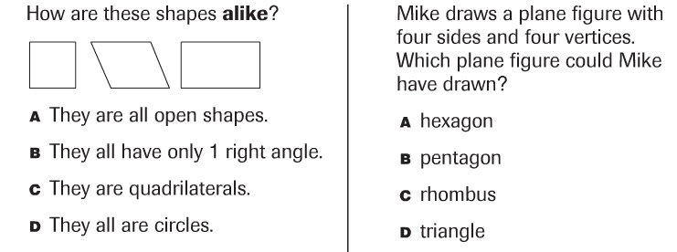

43. Fill in the information about each shape in the chart.
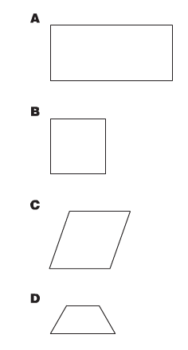
Name of shape | Number of pairs of parallel sides | Number of right angles
a.
b.
c.
d.

44.
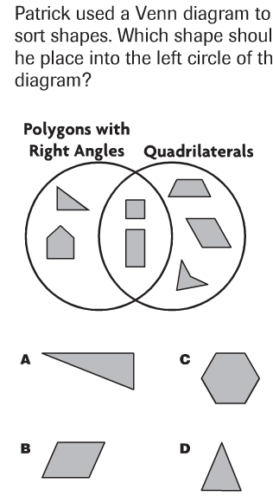

45.
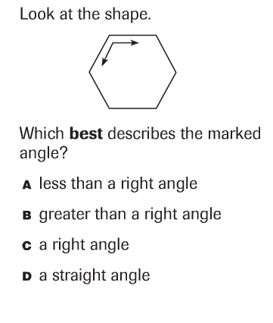
-------------------------------------------------------------------------------------------------- T8
46.
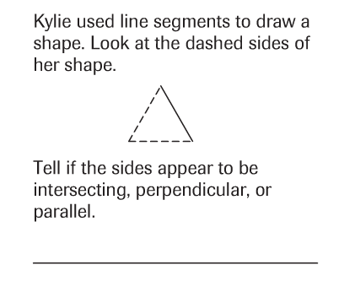

47.
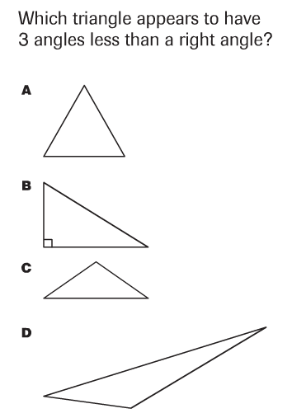

48.
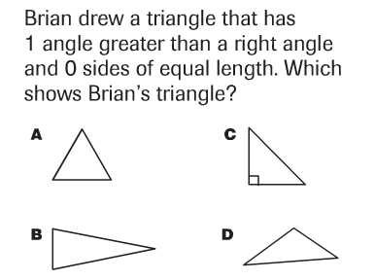

49.
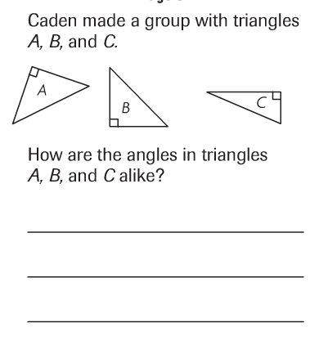

50.
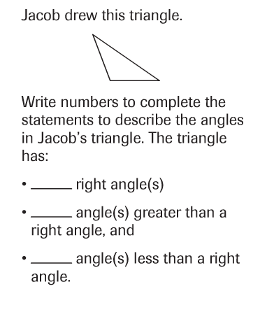
------------------------------------------------------------------------------------------------- T9
51. Complete each of the following statements with fractions. Draw a picture if you need to help yourself decompose the shape.
An equilateral triangle is ___________ of a hexagon.
A trapezoid is ___________ of a hexagon.
A rhombus is ____________ of a hexagon.
An equilateral triangle is _________ of a square.
A rectangle is _______ of a square.
A triangle is ____________ of a rhombus.

52.
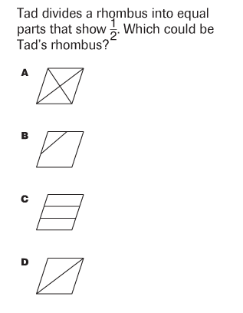

Problems 53-54
