Name ______________________________________ Date ________________
Grade K Unit 7 Represent, Count and Write Numbers to 20 and Beyond
Targets
A = Achieved Target
NA = Nearly Achieved Target
D = Did Not Meet Target
1 | 2 | 3

--------------------------------------------------------------------------------------------T1 Directions: Mark under the set that models the number at the beginning of the row.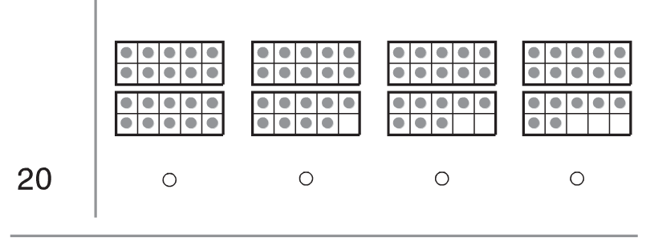
- Directions: Count the number of smiles. Write how many.
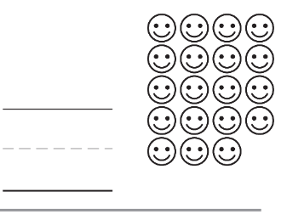

Directions: Count the number of stars. Write how many.

- Directions: Count the fireflies in each jar. Circle the jar that has 20.
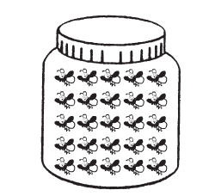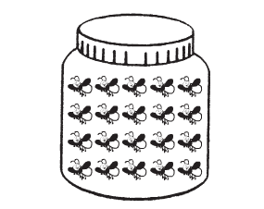

Directions: Count the insects. Write the number. 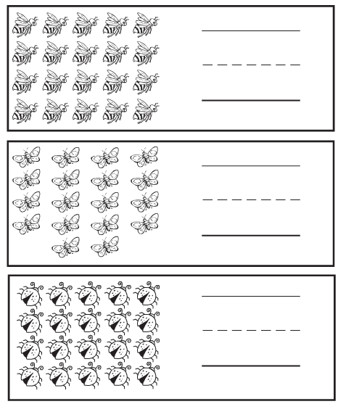

-------------------------------------------------------------------------------------------T2
Directions: Count the cherries by tens. Mark under the number that shows how many.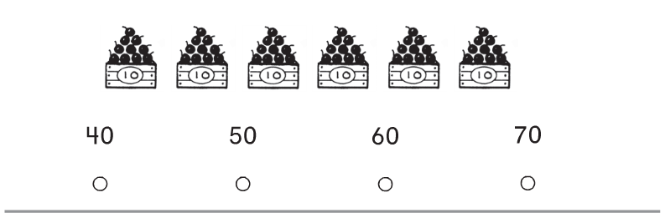
- Directions: I am greater than 17 and less than 19. What number am I? Circle the number.
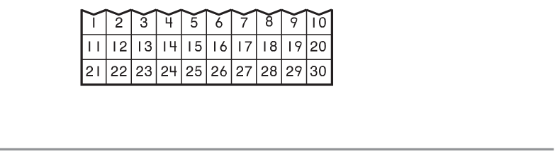
Directions: Begin at 71 and count to 100. Mark the number that completes the counting order.
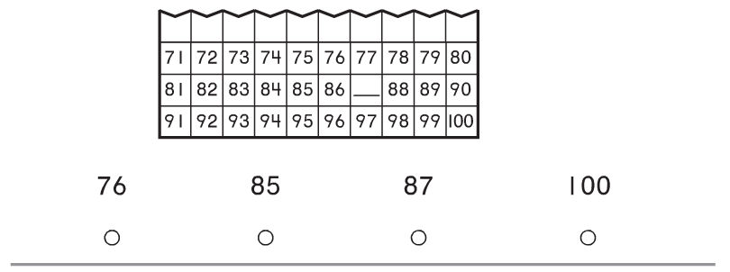
Directions: Evan counts by tens and colors those numbers on the chart. Mark under the number he will color next.
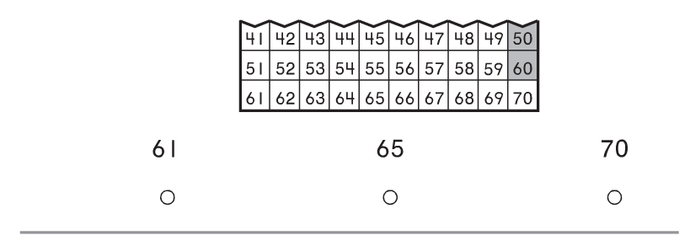
- Directions: Begin at 11 and count forward to 40. Mark under the number that completes the counting order.
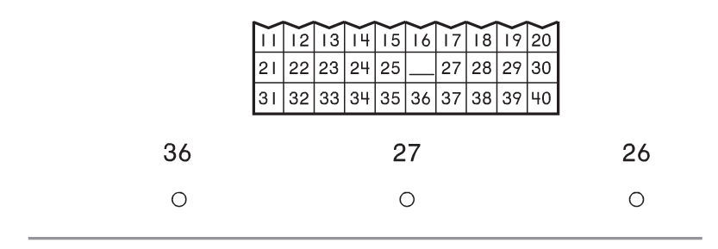
Directions: Count the spoons by tens. Mark under the number that shows how many.
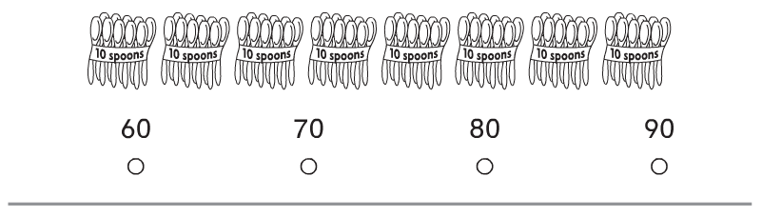

Directions: Mark under the numbers that show them in order.
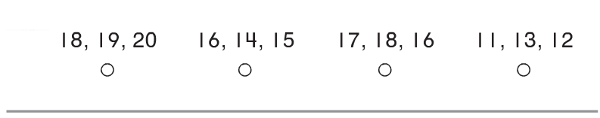

- Directions: John sees 30 yellow flowers. Count by tens and color the sets of flowers John sees.
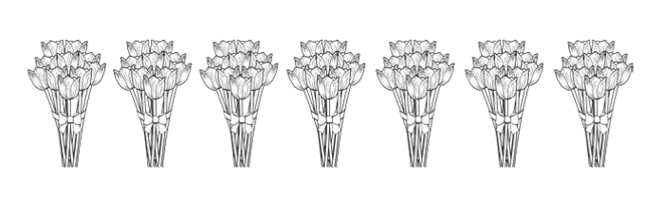

--------------------------------------------------------------------------------------------------T3
Directions: Beth has 15 counters. Draw a set that shows two more counters than 15. Write the number.

Directions: Draw 16 circles. Write how many. Draw 14 circles. Write how many. Circle the greater number.

