Name _________________________ Date ________________
Grade K Unit 8 Identifying and Describing Two and Three Dimensional Shapes
Targets
A = Achieved Target
NA = Nearly Achieved Target
D = Did Not Meet Target
1 | 2 | 3 | 4 | 5

-------------------------------------------------------------------------------------------------- T1
Directions: Color the square yellow. Color the triangle red.
Directions: Write how many sides the shape has. Write how many vertices or corners the shape has.

sides vertices

Directions: Mark under the circles.
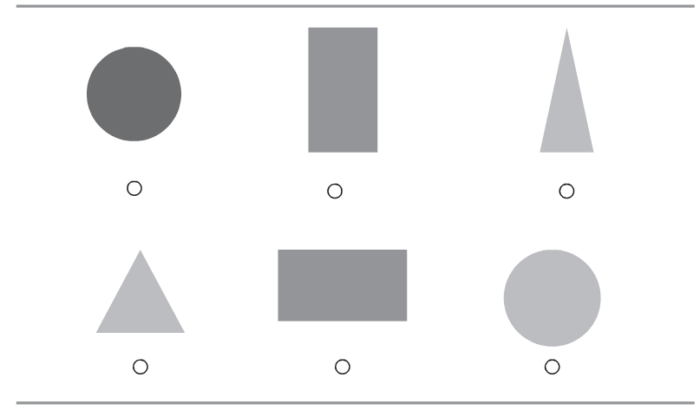
Directions: Mark under the triangles.
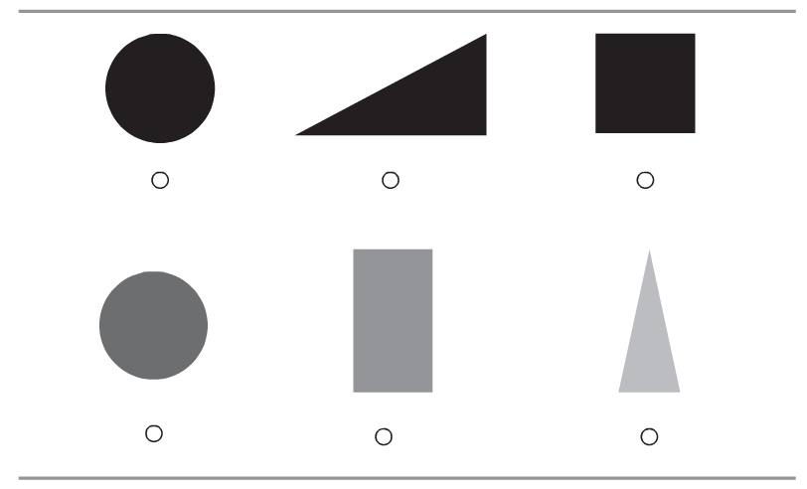
------------------------------------------------------------------------------------------------------T2
Directions: Mark under the cylinder. Mark an X on the cube.
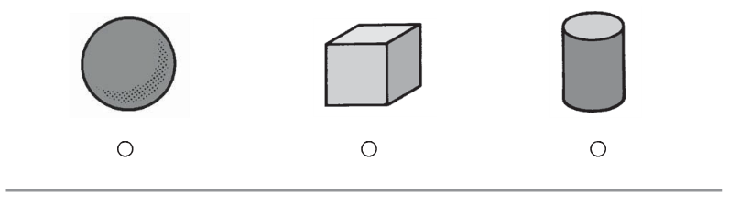
Directions: Mark under the sphere. Mark an X on the cone.
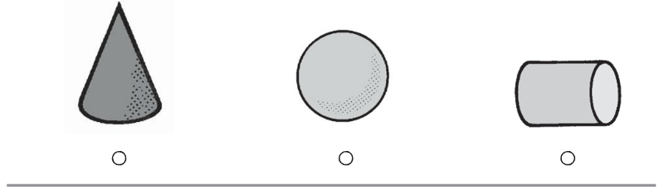
Directions: Mark under the shape that has one flat surface and one curved surface.
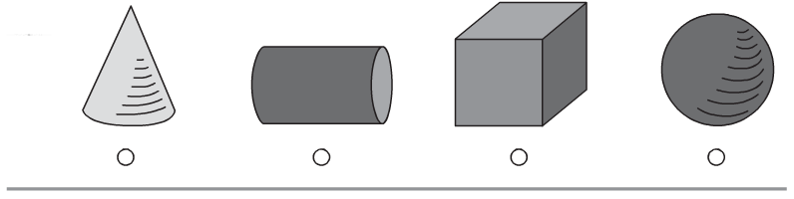

Directions: Mark under the shape that does not slide.
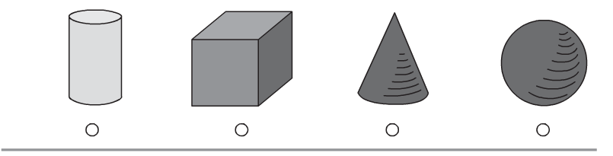

Directions: Mark under the shape that has no flat surfaces.
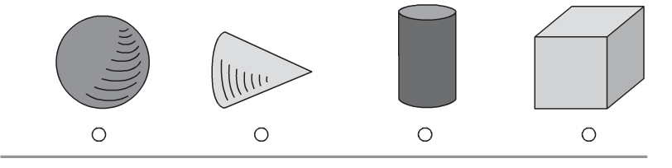

Directions: Mark beside the number that shows how many flat surfaces the cube has.
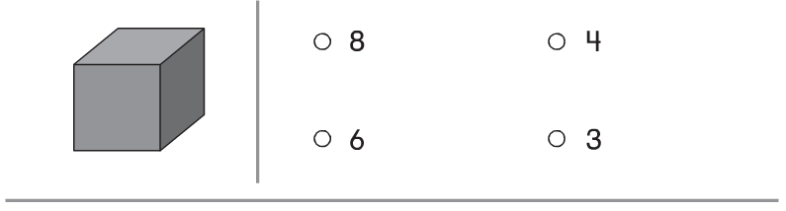

Directions: Mark an X on the shapes that roll but do not stack.
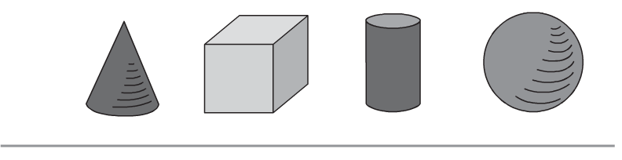
-----------------------------------------------------------------------------------------------------T3
Directions: Color all the shapes that are alike because they have 4 sides and 4 vertices.
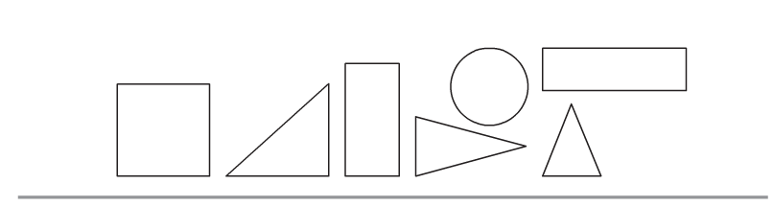
Directions: Mark under the set of shapes that are alike because they all shapes in the set have curves.
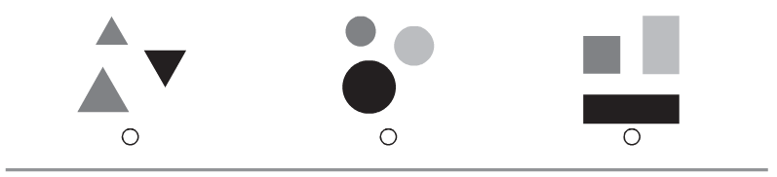

Directions: Mark an X on all the three- dimensional (solid) shapes.
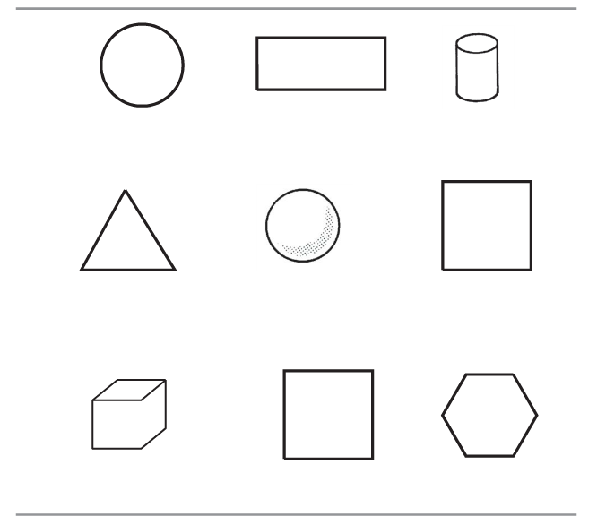

-------------------------------------------------------------------------------------------T4
Directions: Which shape is made by joining the shapes at the beginning of each row? Mark under the shape.
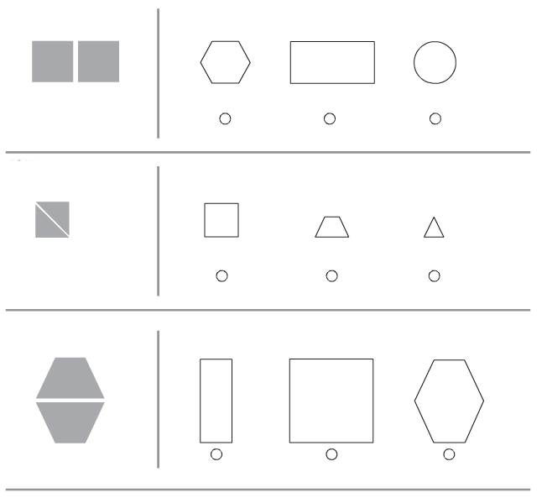

-------------------------------------------------------------------------------------------T5
Directions: Mark the object that is shaped like a sphere below the table in the picture at the beginning of the row.
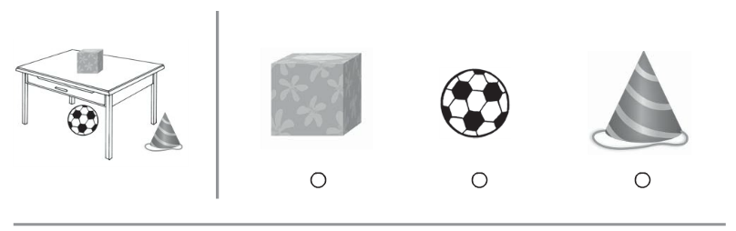
Directions: Mark the object that is above the cylinder in the picture at the beginning of the row.
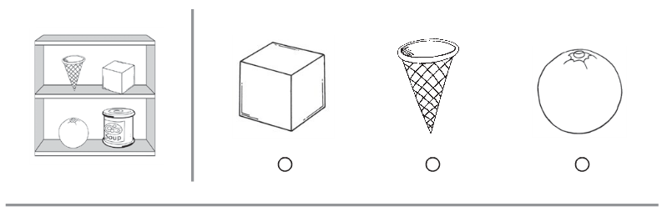
Directions: Put an X on the shape behind the square. Circle the shapes beside the cylinder.
