Name _________________________ Date ________________
Grade K Unit 9 Measurement and Data
Targets
A = Achieved Target
NA = Nearly Achieved Target
D = Did Not Meet Target
1 | 2

-------------------------------------------------------------------------------------------------- T1
Directions: Circle the object that is both short and light.
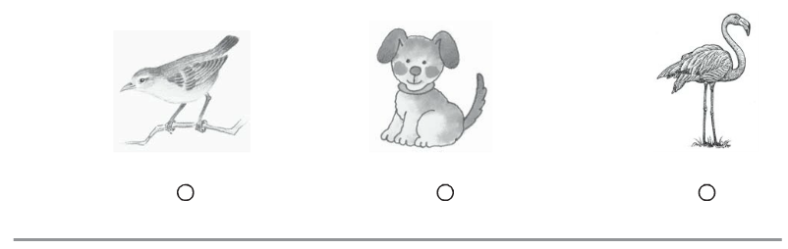
Directions: Mark under the object that is heavier than the object at the beginning of the row.
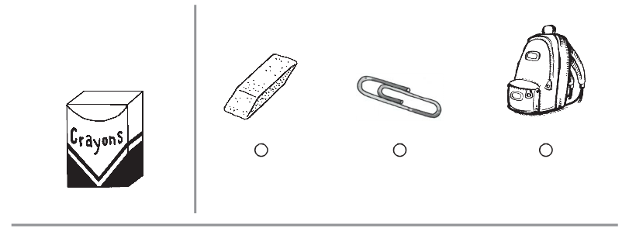

Directions: Circle the object that is both long and heavy.
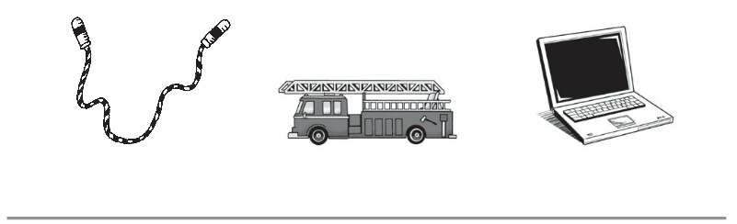

Directions: Mark under the set that shows the white cube tower taller than the gray cube tower.
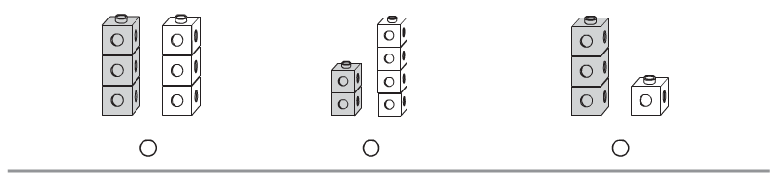

Directions: Mark under the set that shows the white cube train shorter than the gray cube train.
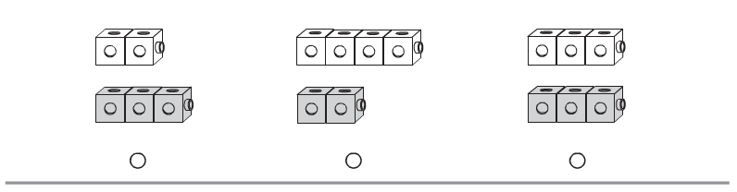

Directions: Mark under the picture that has a line that shows how to measure length.
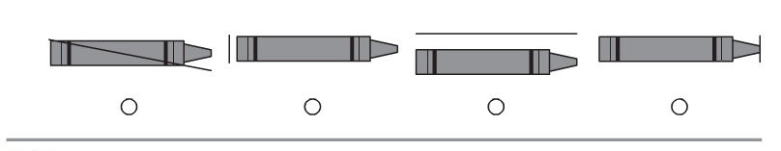
Directions: Mark under the picture that has a line that shows how to measure height.
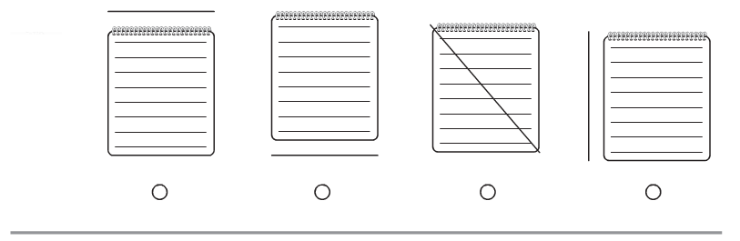
Directions: Look at the math book. Trace the line that measures the length. Look at the glue bottle. Trace the line that measures the height.

Directions: Column 1. Circle the objects that are lighter than the object at the top of the row. Column 2. Circle the objects that are heavier than the object at the top of the row.
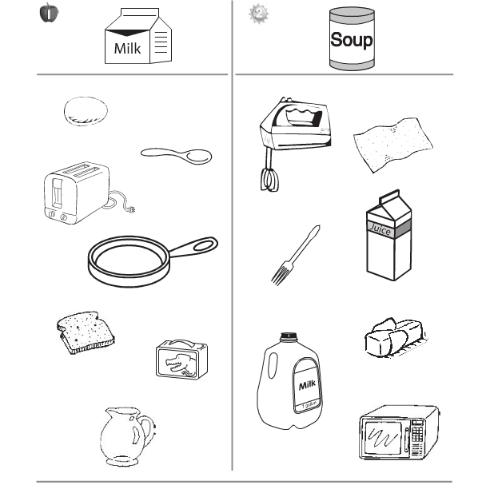

note: Place bins of cubes on the tables for student use.
Directions: Look at the cube train. Build a cube train that is longer than the cube train. Draw your cube train.
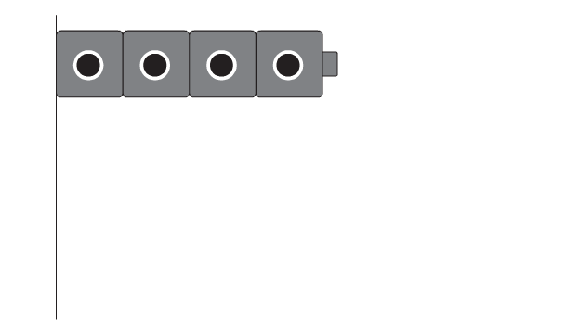
Directions: Look at the cube tower. Build a cube tower that is shorter than the cube tower. Draw your cube tower.
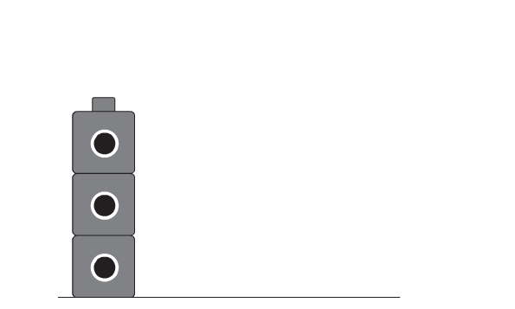
---------------------------------------------------------------------------------------------------T2
Directions: Look at the set of shapes at the beginning of the row. Mark under the shape that belongs in the set.
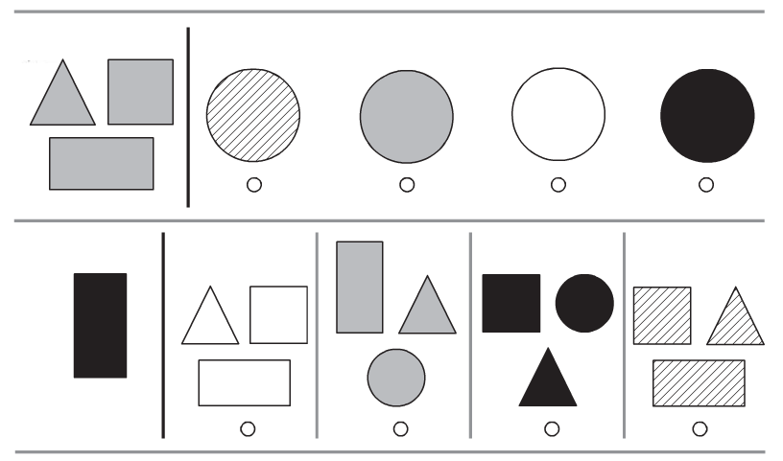

Directions: Look at the graph. Write the number that tells how many squares there are.
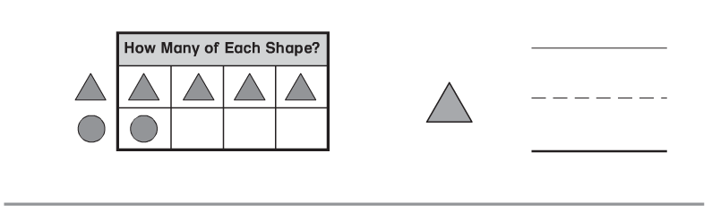

Directions: Look at the graph. Write the number that tells how many counters are gray and how many counters are white.
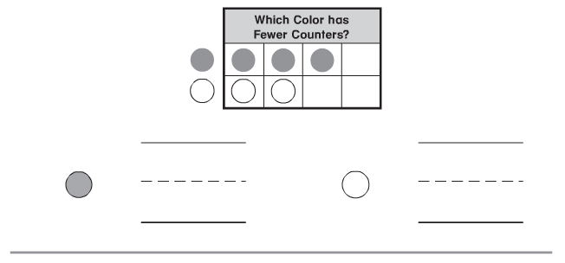

Directions: Circle the shapes that go with the circled square in the center.
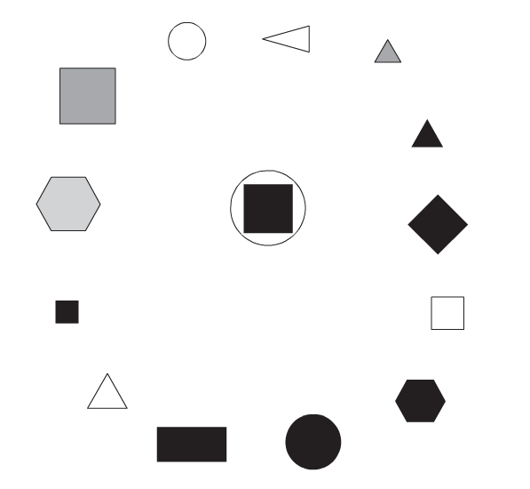
Directions: Give the student five circles and four triangles. Have the student graph the circles and triangles by shape. Have the student draw the shapes on the graph. Have the student write how many of each shape are on the graph. Have the child circle the shape that there are more of on the graph.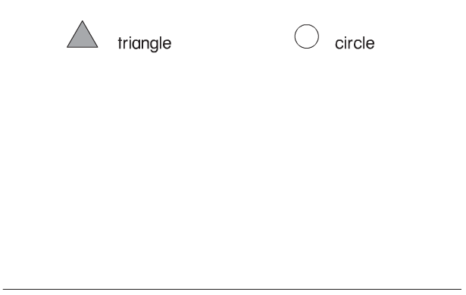
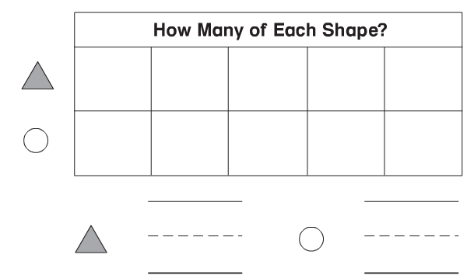

Directions: 1. Look at the shapes on the sorting mat. Count the number of big shapes. Write the number that tells how many. Count the number of small shapes. Write the number that tells how many.
2. Write the addition sentence to tell how many shapes are on the sorting mat in all.
