Name _________________________ Date ________________
Grade K Unit 1 Representing, Counting and Writing Numbers 0-5
Targets
A = Achieved Target
NA = Nearly Achieved Target
D = Did Not Meet Target
1 | 2 | 3 | 4

-------------------------------------------------------------------------------------------------- T1
Directions: Circle the number that shows how many are in the box.
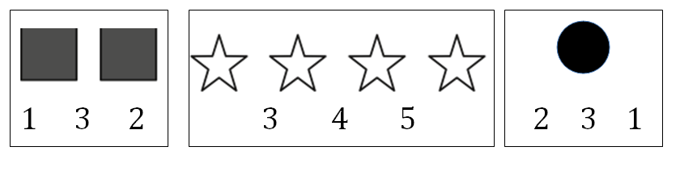
Directions: Count how many stars are on the plate. Write the number.

Directions: Count how many carrots are on the plate. Write the number.
Directions: Mark the word that tells the number of frogs.
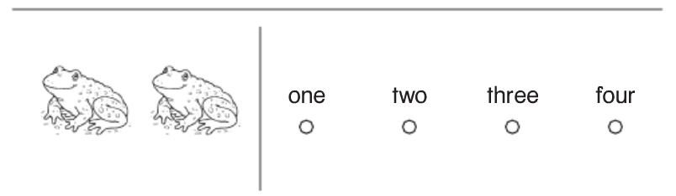
Directions: Mark under the number that matches the word.

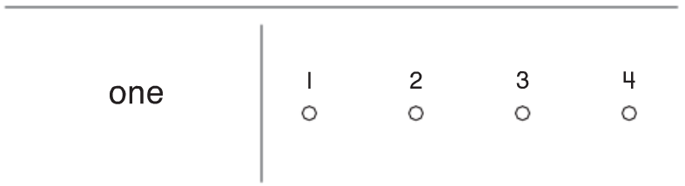

------------------------------------------------------------------------------------------------------- T2
How many dots are needed to complete the frame? Write the number.
________________

________________

---------------------------------------------------------------------------------------------------- T4
Directions: Circle the box with the same amount.
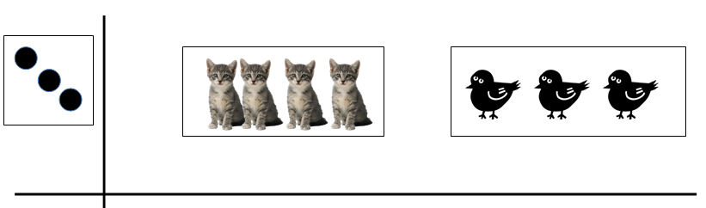

Directions: Circle the box that has more.

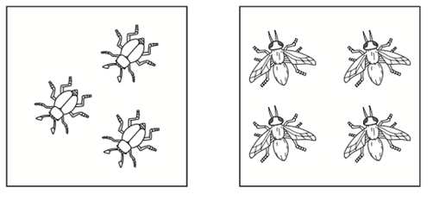
Directions: Circle the box that has less.

Directions: Draw a set of counters that is greater than the number of bees.

Directions: Write a number that is less than the number of turtles.

--------------------------------------------------------------------------------------------- T3
Constructed Student Response
Directions: Give the child 15 connecting cubes.
Have the child-
- Build cube trains to show the numbers 1 through 5
- Place the cube trains in counting order on the workmat.
- Record the number to the left of each train.
- Remove each cube train. Draw a picture of the cube train next to the number shown.

Extended Response Workspace

