Name _________________________ Date ________________

**Grade** K **Unit 2 Representing, Counting and Writing Numbers 6-9**

Targets

A = Achieved Target

NA = Nearly Achieved Target

D = Did Not Meet Target

|  |  |  |
| --- | --- | --- |
| **1 and 4** | **2** | **3** |
|  |  |  |

--------------------------------------------------------------------------------------------- **T1 and T4**

**Directions: Mark under the set that shows the number at the beginning of the row.**

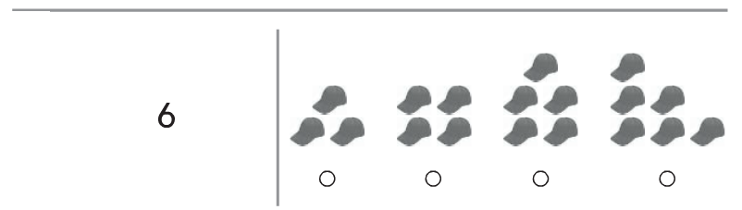

**Directions: Mark under the word that matches the number of objects.**

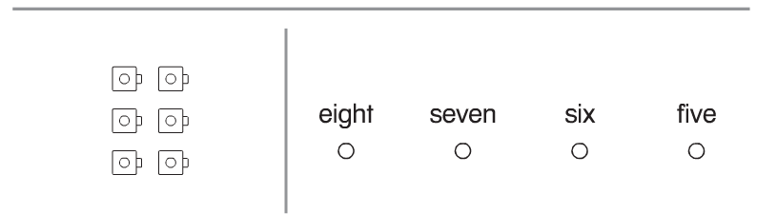

**Directions: Mark under the set that shows nine butterflies.**

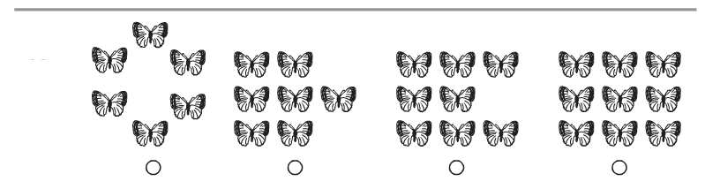

**Directions: Mark under the set that shows a way to make 7.**

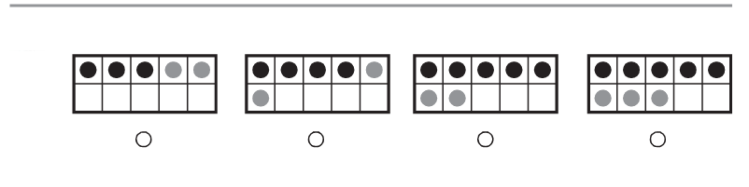

**Directions: Count the baseballs in each set. Mark under the baseballs that show 8.**

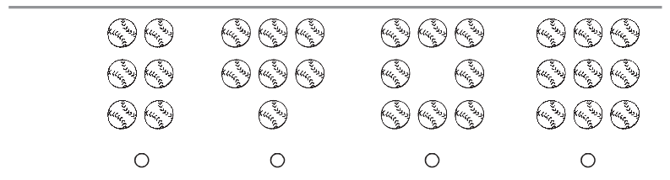

**Directions: Count how many in the set and write the number**

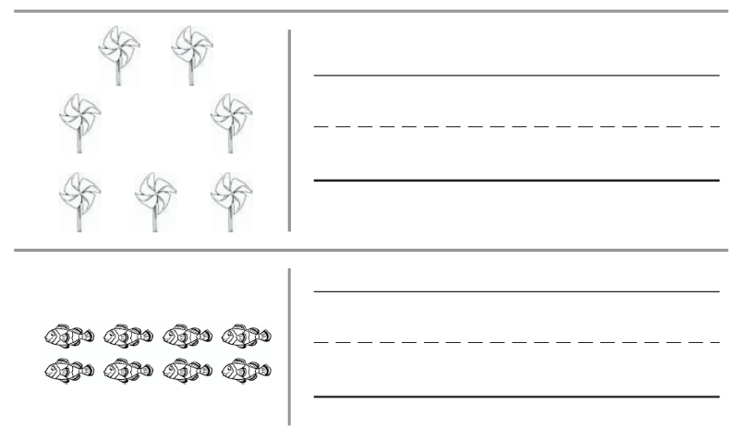

**Directions: Write the number**

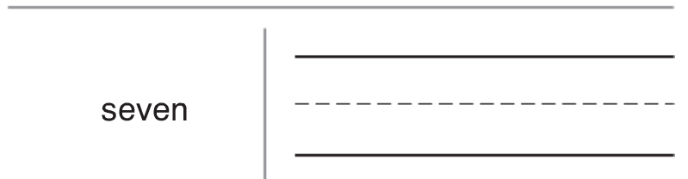

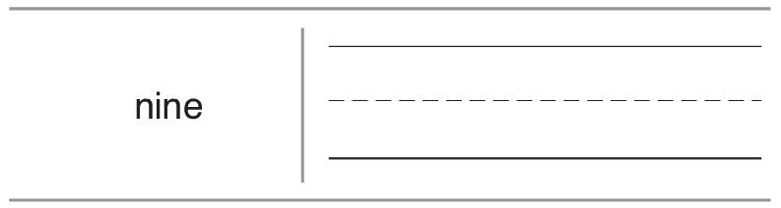

**--------------------------------------------------------------------------------------------------- T3**

**Directions: Circle the one that is more.**

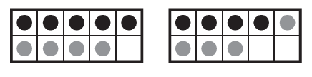

**Directions: Circle the one that is less.**



**Directions: Mark the set that is equal to the one at the beginning of the row.**

**C:\Users\diana\AppData\Local\Microsoft\Windows\Temporary Internet Files\Content.IE5\WZ80KV70\MC900297917[2].wmfC:\Users\diana\AppData\Local\Microsoft\Windows\Temporary Internet Files\Content.IE5\WZ80KV70\MC900297917[2].wmfC:\Users\diana\AppData\Local\Microsoft\Windows\Temporary Internet Files\Content.IE5\WZ80KV70\MC900297917[2].wmfC:\Users\diana\AppData\Local\Microsoft\Windows\Temporary Internet Files\Content.IE5\WZ80KV70\MC900297917[2].wmf** C:\Users\diana\AppData\Local\Microsoft\Windows\Temporary Internet Files\Content.IE5\WZ80KV70\MC900297917[2].wmf**C:\Users\diana\AppData\Local\Microsoft\Windows\Temporary Internet Files\Content.IE5\WZ80KV70\MC900297917[2].wmf C:\Users\diana\AppData\Local\Microsoft\Windows\Temporary Internet Files\Content.IE5\WZ80KV70\MC900297917[2].wmf C:\Users\diana\AppData\Local\Microsoft\Windows\Temporary Internet Files\Content.IE5\WZ80KV70\MC900297917[2].wmfC:\Users\diana\AppData\Local\Microsoft\Windows\Temporary Internet Files\Content.IE5\WZ80KV70\MC900297917[2].wmfC:\Users\diana\AppData\Local\Microsoft\Windows\Temporary Internet Files\Content.IE5\WZ80KV70\MC900297917[2].wmfC:\Users\diana\AppData\Local\Microsoft\Windows\Temporary Internet Files\Content.IE5\WZ80KV70\MC900297917[2].wmfC:\Users\diana\AppData\Local\Microsoft\Windows\Temporary Internet Files\Content.IE5\WZ80KV70\MC900297917[2].wmfC:\Users\diana\AppData\Local\Microsoft\Windows\Temporary Internet Files\Content.IE5\WZ80KV70\MC900297917[2].wmf**C:\Users\diana\AppData\Local\Microsoft\Windows\Temporary Internet Files\Content.IE5\WZ80KV70\MC900297917[2].wmfC:\Users\diana\AppData\Local\Microsoft\Windows\Temporary Internet Files\Content.IE5\WZ80KV70\MC900297917[2].wmfC:\Users\diana\AppData\Local\Microsoft\Windows\Temporary Internet Files\Content.IE5\WZ80KV70\MC900297917[2].wmf C:\Users\diana\AppData\Local\Microsoft\Windows\Temporary Internet Files\Content.IE5\WZ80KV70\MC900297917[2].wmfC:\Users\diana\AppData\Local\Microsoft\Windows\Temporary Internet Files\Content.IE5\WZ80KV70\MC900297917[2].wmfC:\Users\diana\AppData\Local\Microsoft\Windows\Temporary Internet Files\Content.IE5\WZ80KV70\MC900297917[2].wmf C:\Users\diana\AppData\Local\Microsoft\Windows\Temporary Internet Files\Content.IE5\WZ80KV70\MC900297917[2].wmfC:\Users\diana\AppData\Local\Microsoft\Windows\Temporary Internet Files\Content.IE5\WZ80KV70\MC900297917[2].wmfC:\Users\diana\AppData\Local\Microsoft\Windows\Temporary Internet Files\Content.IE5\WZ80KV70\MC900297917[2].wmf

**Directions: Count the number of hats. Draw a set that is one more than the number of hats.**

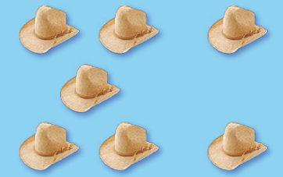

**---------------------------------------------------------------------------------------------------- T2**

**Extended Constructed Response**

**Directions: Give the child 21 counting cubes.**

**Have the child-**

* **make cube trains for the numbers 6 through 8**
* **record the number of each cube train to the left**
* **remove the trains and make a picture for each train**
* **circle the number that is one less than 7**

**Extended Response Workmat**

