Name _________________________________________Date ________________
Grade K Unit 3 Represent and Compare Numbers to 10
Targets
A = Achieved Target
NA = Nearly Achieved Target
D = Did Not Meet Target
1 | 2 | 3

-------------------------------------------------------------------------------------------------- T
Directions: Count the objects in each set. Mark under the set that shows 10.
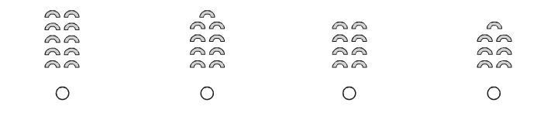
Directions: Write the number that shows how many butterflies.
Directions: Count forward. Write the number that is missing.

Directions: Mark under the cube train that shows a way to make 10.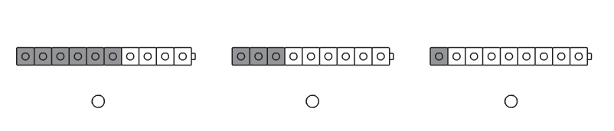
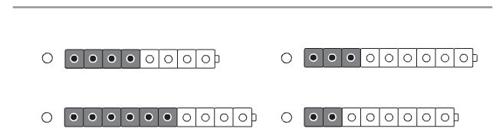

Directions: Count forward. Write the missing number in each row.
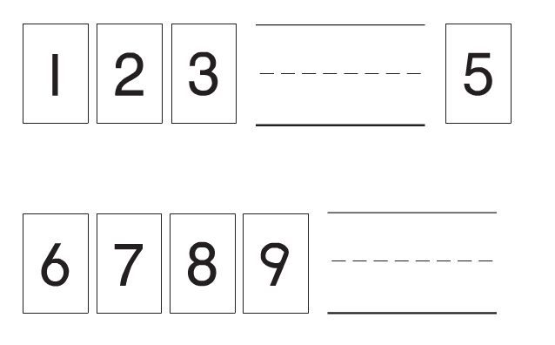

Directions: Write the number that makes 10.
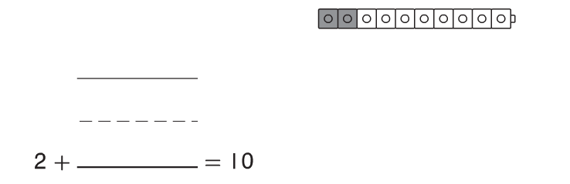

--------------------------------------------------------------------------------------------------------- T2
Directions: Mark under the set that shows the number of helmets greater than the number of bicycles.
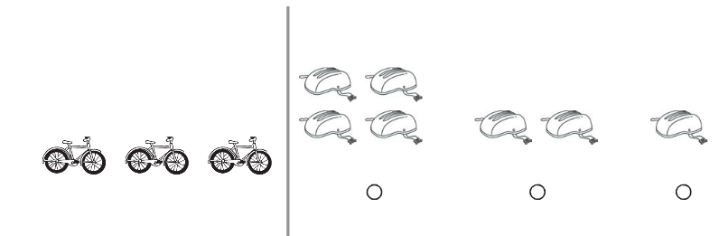

Directions: Compare the sets by counting. Mark under the set of berries that is equal to the set at the beginning of the row.
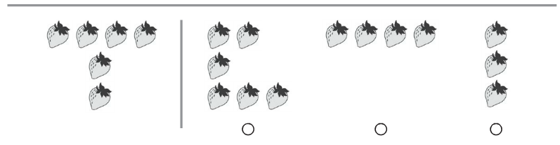
Directions: Compare the sets by counting. Mark under the set that has a greater number of flowers than the leaves at the beginning of the row.
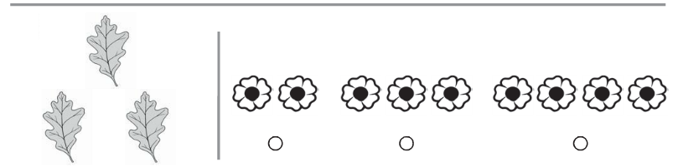

Directions: Compare the sets by counting. Mark under the set that has less number of counters than the counters at the beginning of the row.
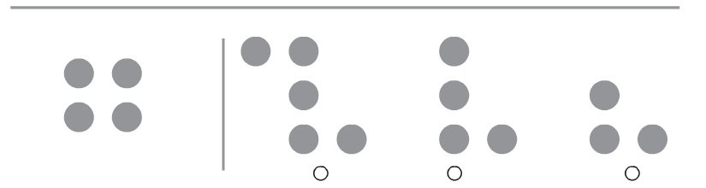

Directions: Compare the numbers in each pair. Circle the number that is greater.
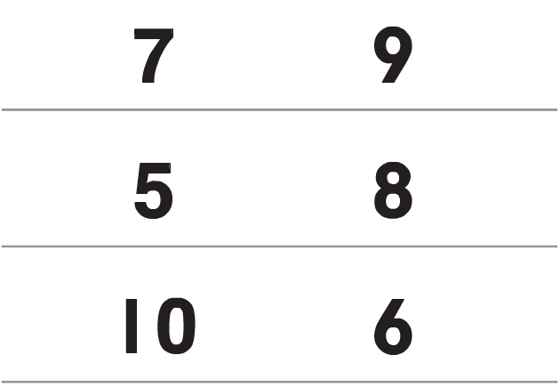

Directions: Compare the number in each pair. Circle the number that is less.
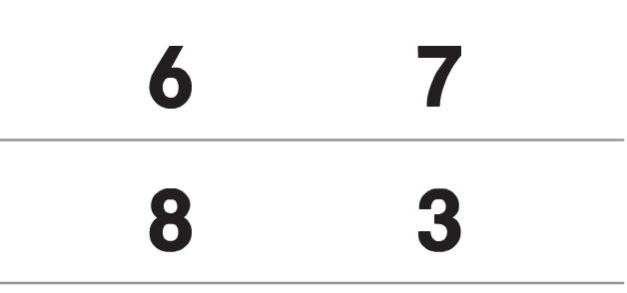

---------------------------------------------------------------------------------------------------------T3
Extended Constructed Response Directions
Give the child 20 cubes, 10 of one color and 10 of another color. Give children a copy of the work mat.
Portion:
- make cube trains for any 2 numbers 1 to 10 using different color cubes for each train.
- record the number for each cube train, then draw a picture of each.
- circle the number that is less.

Second Portion:
- make two different cube trains for numbers that will add to 10.
- record the number for each cube train, then draw a picture of each.
- write the addition equation to match the model

