Name ________________________________________Date ________________
Grade K Unit 4
A = Achieved Target
NA = Nearly Achieved Target
D = Did Not Meet Target
Targets
1 | 2 | 3 | 4 | 5
---------------------------------------------------------------------------------------------- Directions: Mark under the addition that shows how many fingers are being put together.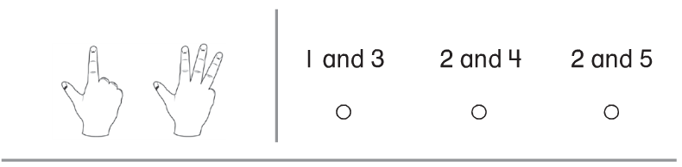
Directions: Mark under the addition that shows the counters being put together.
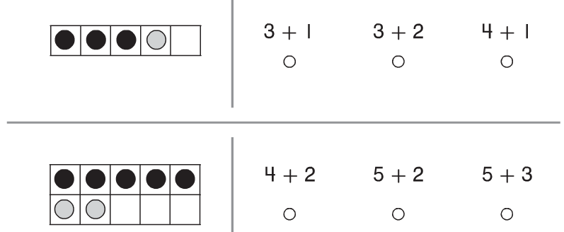

Directions: Count how many of each color. Write the numbers to show the addition equation.
----------------------------------------------------------------------------------------------------- T2
Directions: Solve each of the equations
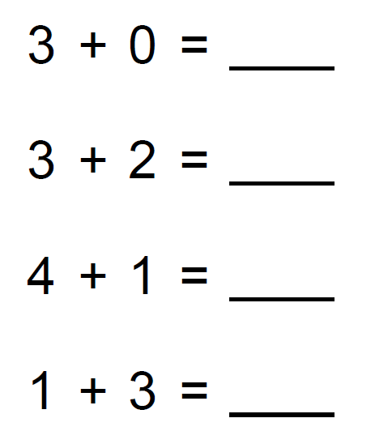

--------------------------------------------------------------------------------------------------- T3
Directions: Sara had 2 balloons. Then she got more balloons. Now she has 4 balloons. How many balloons did Sara get?
Directions: There are some butterflies. Three more butterflies come to join them. Now there are 6. How many butterflies were there to start? Mark under the number that completes the addition sentence.
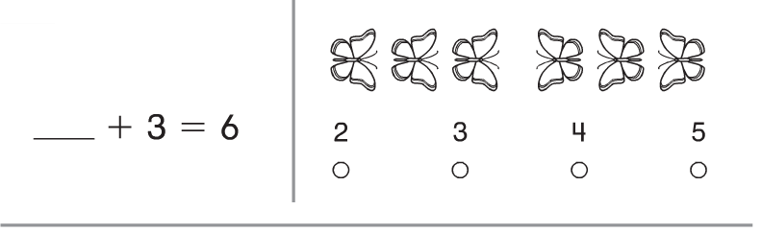

Directions: Draw in the box below to represent and solve the problem.
Bob had 4 balls. Ben gave him 3 more. How many balls does Bob have now? Draw a picture to tell the story. Write the number of balls Bob has now.

Directions: Draw in the box below to represent and solve the problem.
Pam has some apples. Her mom gives her 2 more. Now she has 5 apples. How many apples did Pam have at the start? Draw a picture to show the problem. Write the addition number sentence below.

------------------------------------------------------------------------------------------------------- T4
Directions: Mark under the number that makes 10 when put together with the beginning number.
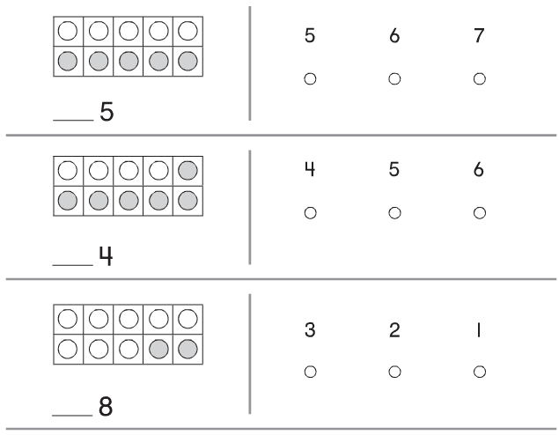

Directions: Write the number that completes the addition sentence to show how many cubes in all.
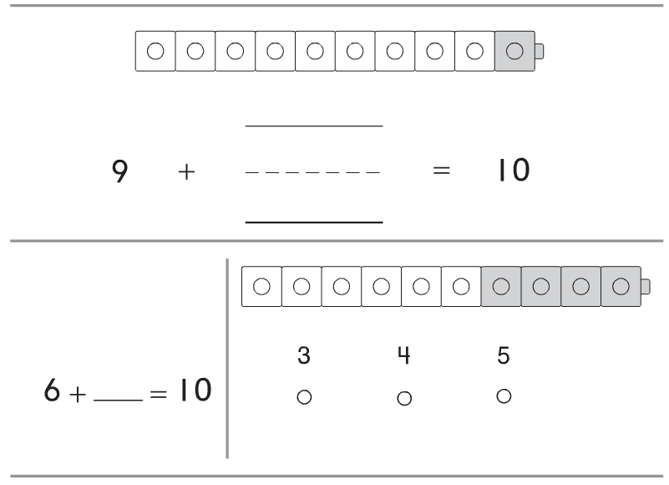
Directions: Mark under the cube train that shows a way to make 10.
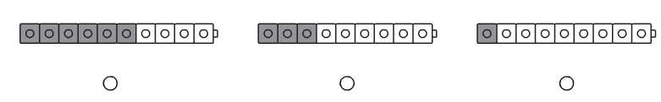

------------------------------------------------------------------------------------------------------- T5
Directions: Mark under the addition sentence that shows the number pair for the cube train.
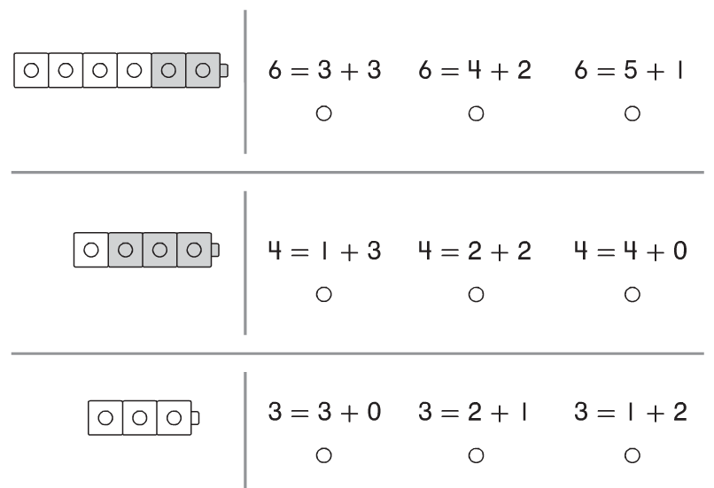

Directions: Complete the addition sentence to show a number pair for 10.
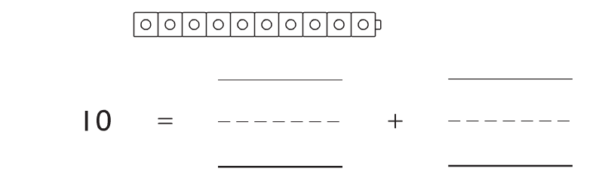

Directions: Complete the addition sentence to show a number pair for 7.
