Name ________________________________________Date ________________
Grade K Unit 5 Subtraction
Targets
A = Achieved Target
NA = Nearly Achieved Target
D = Did Not Meet Target
1 | 2 | 3 | 4
X

-------------------------------------------------------------------------------------------------- T2
Directions: Mark under the subtraction that shows how many children in all and how many children are leaving.
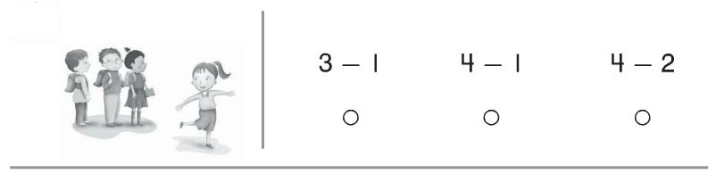
Directions: Mark under the subtraction that shows how many counters are white.

Directions: Mark under the picture that shows how many stars you started with.

Directions: Mark under the number that completes the subtraction sentence.

Directions: There are five cubes. Two cubes are white, the rest are gray. How many cubes are gray? Mark under the number that completes the subtraction sentence.
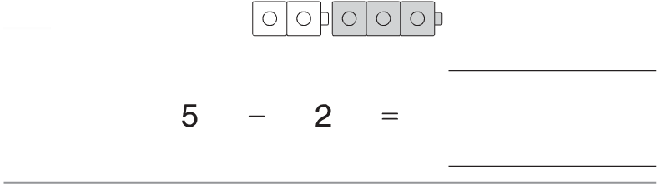

Directions: Write the number that shows how many children there are. Write the number that shows how many children are leaving.

--------------------------------------------------------------------------------------------------------T3
Directions: Mark under the number that completes the subtraction sentence.
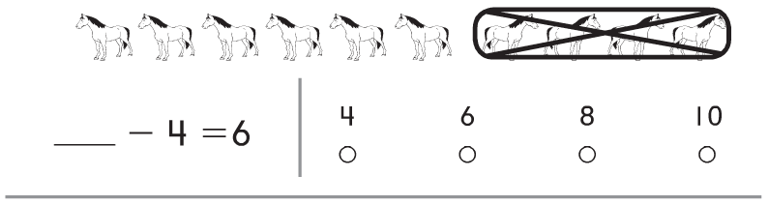
Directions: Mark next to the subtraction sentence that matches the picture.
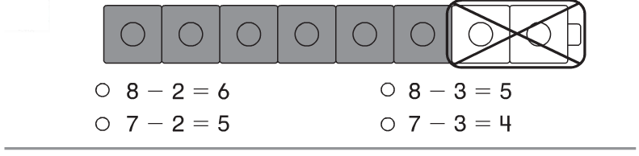

Directions: Write the number that shows how many counters in all. Write the number that shows how many counters are gray.

Directions: Write a subtraction sentence to match the picture.
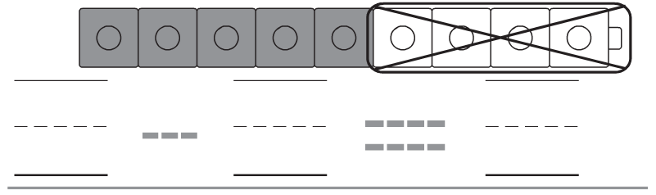

Directions: Draw a picture to tell the following story. Write the subtractions sentence to match the story.

Sam has 8 red balloons. Some of the balloons pop. Sam has only 3 balloons left now. How many balloons popped.

-----------------------------------------------------------------------------------------------------T4
Directions: Solve each subtraction problem.
