Name _________________________ ________________Date ________________
Grade K Unit 6 Representing, Counting and Writing Numbers 11-19
Targets
A = Achieved Target
NA = Nearly Achieved Target
D = Did Not Meet Target
1 | 2 | 3

-------------------------------------------------------------------------------------------------- T1
Directions: Count and write the number of baseballs.

Directions: Count and write the number of counters in the frames.

Directions: Mark under the number that shows the number of cubes.
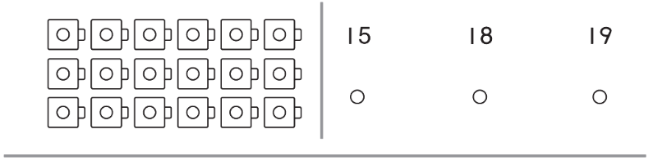
Directions: Mark under the set that shows 12.
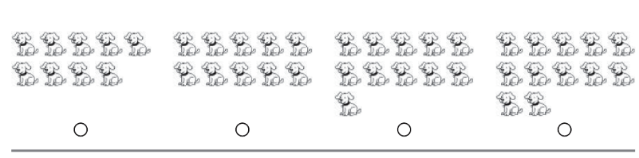
Directions: Count the number of objects. Write the numeral.
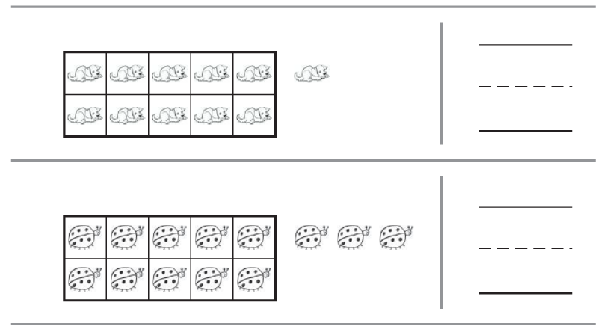
----------------------------------------------------------------------------------------------------T2
Directions: Mark under the set of counters that shows 18.
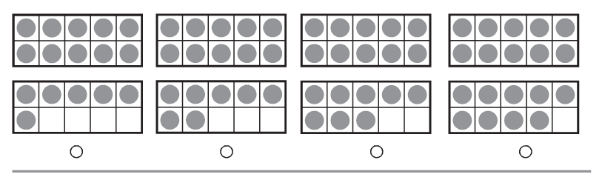
Directions: Look at the ten ones and some more ones. Mark under the addition sentence that matches.
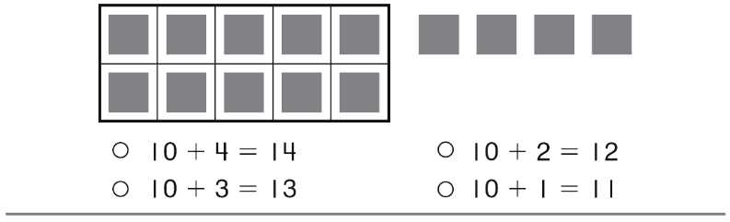
Directions: Look at the counters. How many ones are in the bottom ten frame. Write the number.
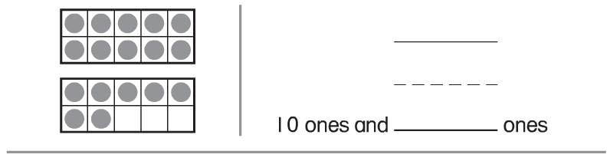

Directions: Look at the ten frames. Write the addition sentence to match.
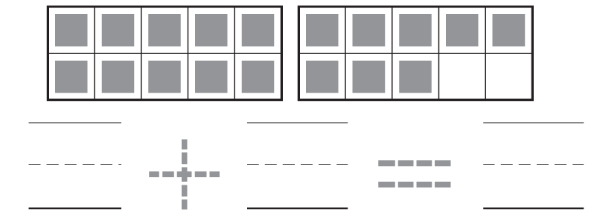

Directions: Look at the counters. How many ones are in the top ten frame? How many ones are in the bottom ten frame? Mark next to your answer.
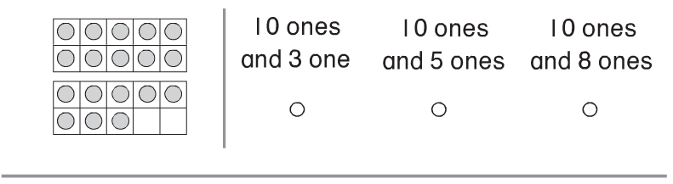

------------------------------------------------------------------------------------------------------T3
Directions: Circle a number. Draw more pumpkins to show that number. Write the addition sentence to match the picture.
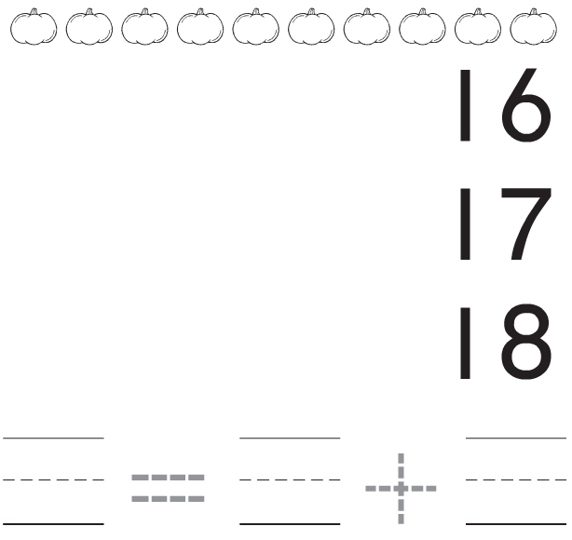

Directions: Circle a number. Draw counters in the ten frames to show that number. Write the addition sentence that matches.

13 14 15

